**MAXWELL’S EQUATIONS AND  
 ELECTROMAGNETIC WAVES**

**Exercises**

**Section 29.2 Ambiguity in Ampère’s Law**

**13. Interpret** In this problem, we are asked to find the displacement current through a surface.

**Develop** As shown in Equation 29.1, Maxwell’s displacement current is

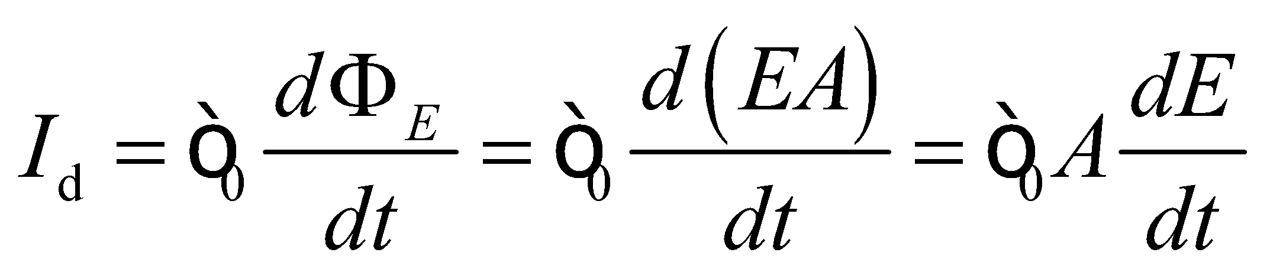

**Evaluate** The above equation gives



**Assess** Displacement current arises from changing electric flux and has units of amperes (A), just like ordinary current.

**14. Interpret** This problem involves finding the displacement current across a parallel-plate capacitor given the rate at which the voltage is changing.

**Develop** The electric field is approximately uniform in the capacitor, so 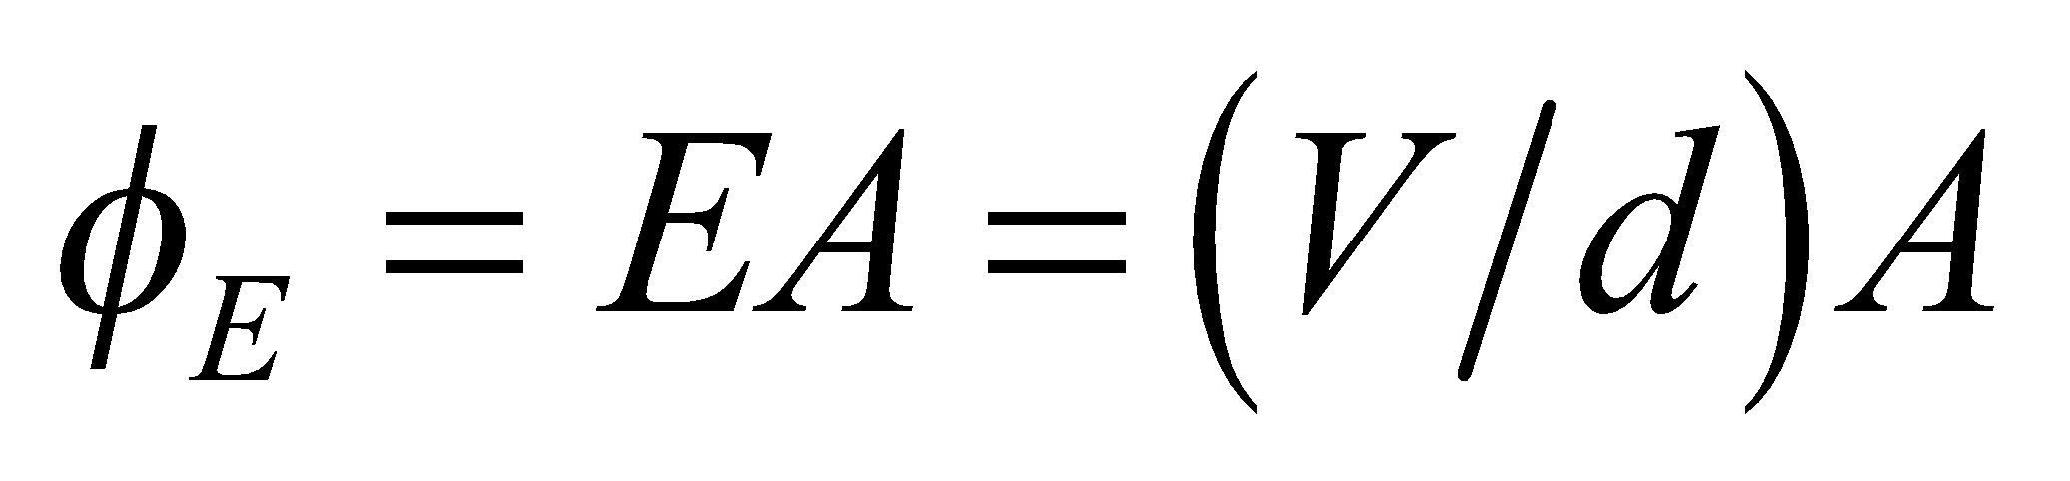. Differentiate this with respect to time to find the displacement current.

**Evaluate** The displacement current is

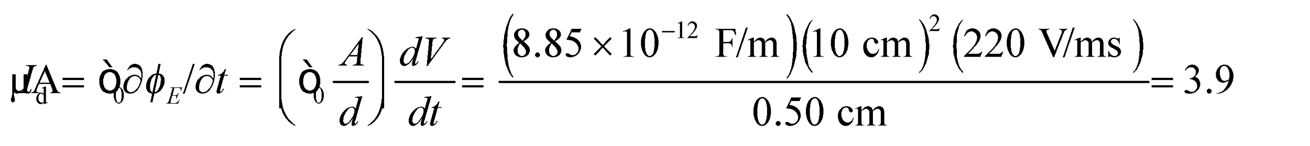

**Assess** The units of the displacement current work out to be (with the help of Appendix B)

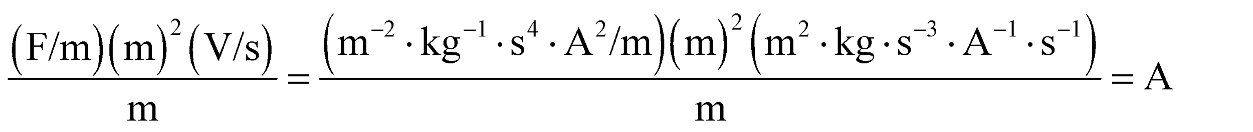

as expected.

**Section 29.4 Electromagnetic Waves**

**15. Interpret** We are given the electric and magnetic fields of an electromagnetic wave and asked to find the direction of propagation in terms of a unit vector.

**Develop** The direction of propagation of the electromagnetic wave is the same as the direction of the cross product 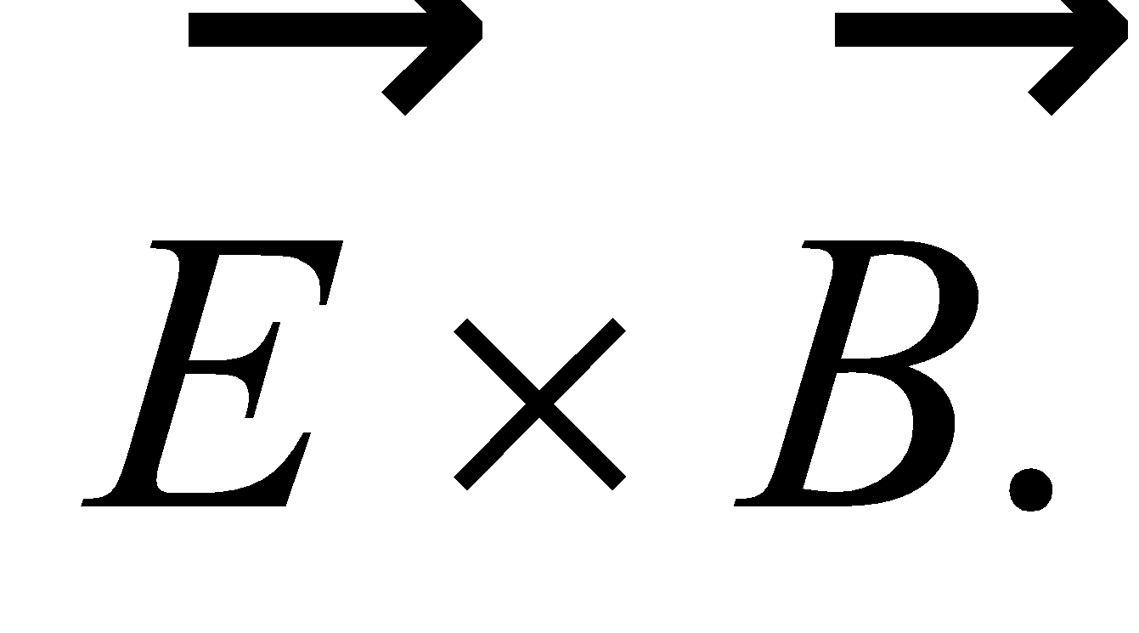

**Evaluate** When 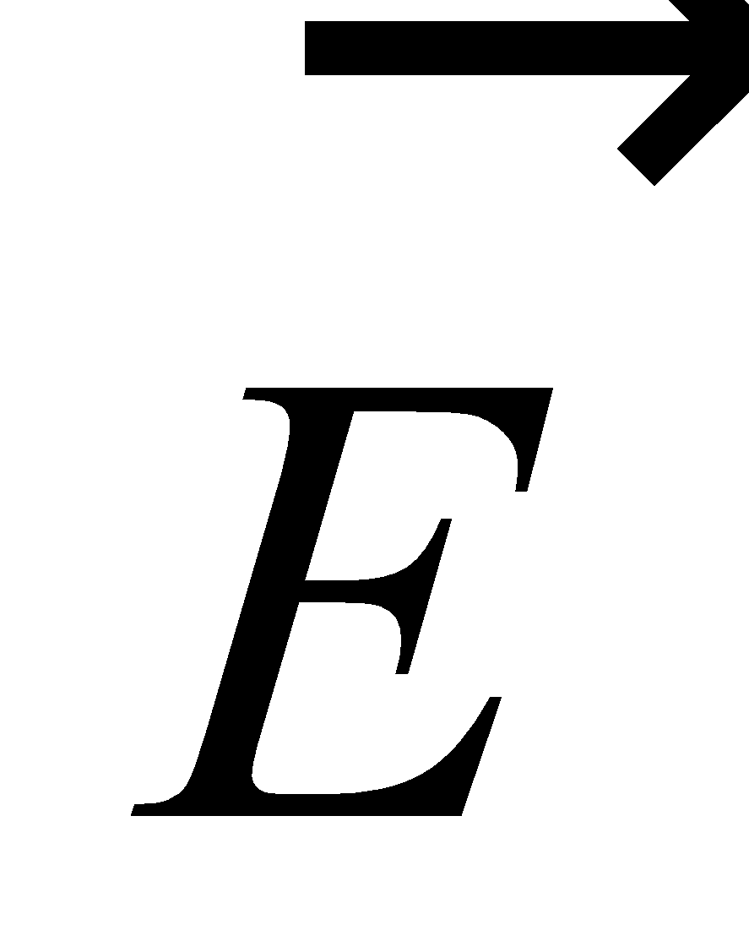 is parallel to 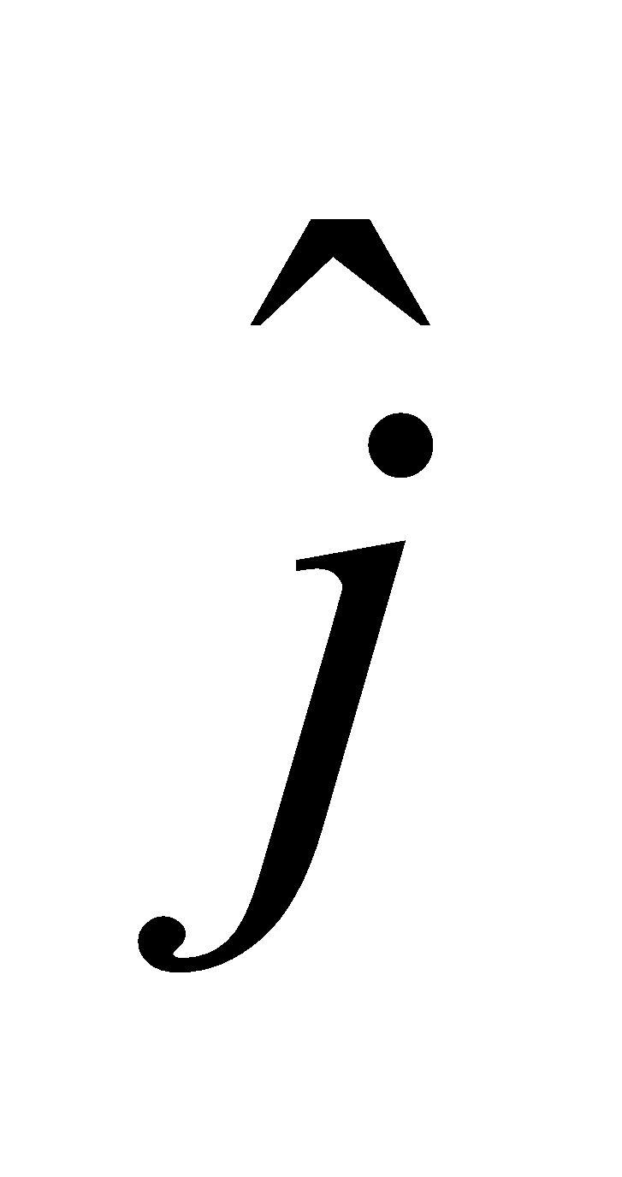 and  is parallel to 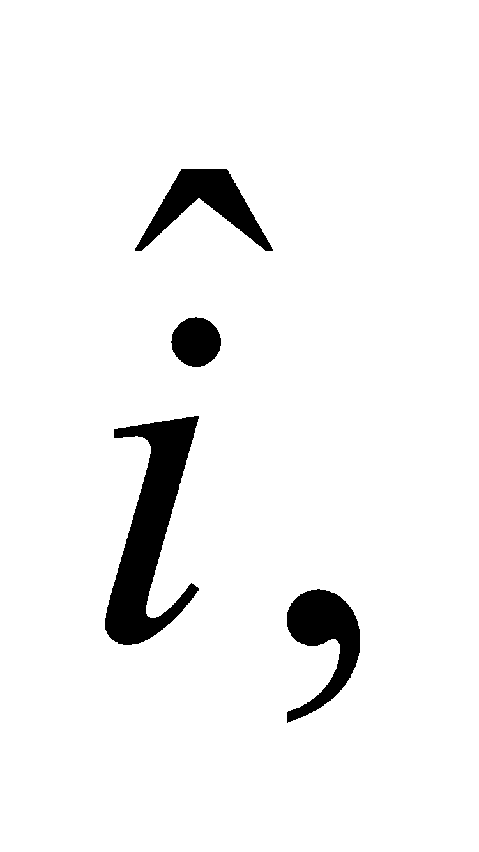 the direction of propagation is parallel to 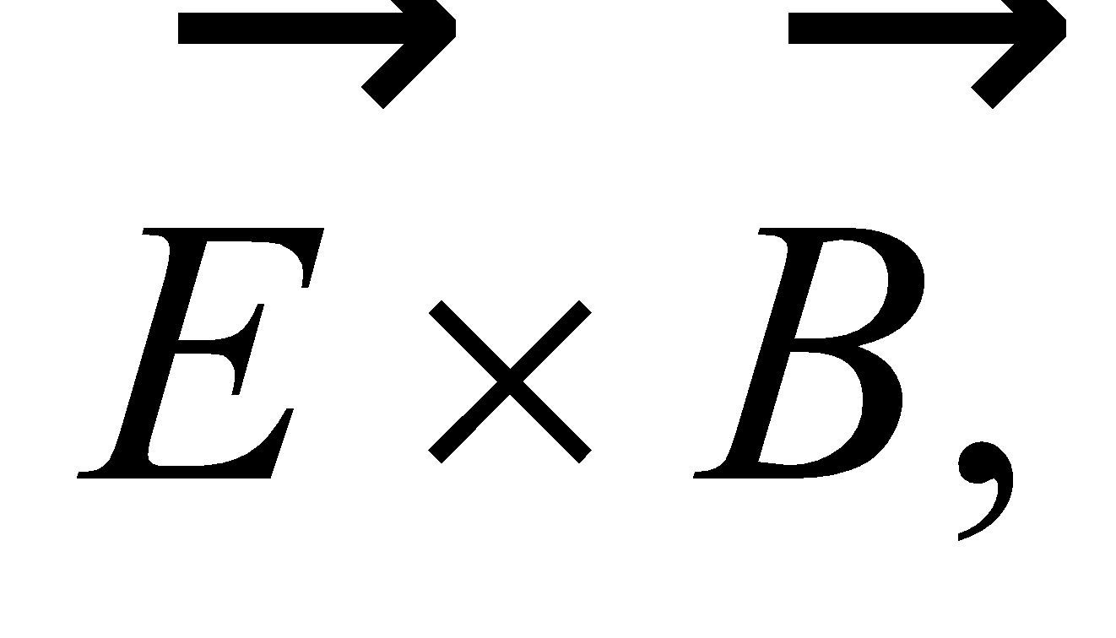 or

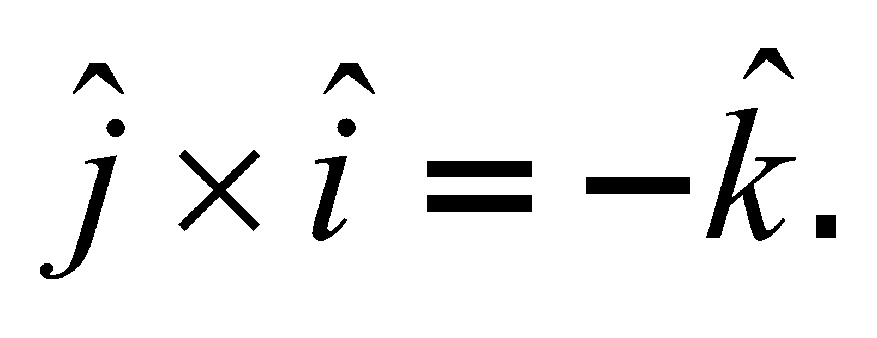

**Assess** For electromagnetic waves in vacuum, the directions of the electric and magnetic fields, and of wave propagation, form a right-handed coordinate system.

**16. Interpret** We are given the description of the electric field of a radio wave and are asked to characterize it by finding the peak electric field and the direction of propagation.

**Develop** The maximum of the sine function is unity, so the prefactor of the sine function gives the peak electric field. In vacuum, the magnetic field must be perpendicular to the electric field. The latter is oriented at 45° above the *x*-axis for 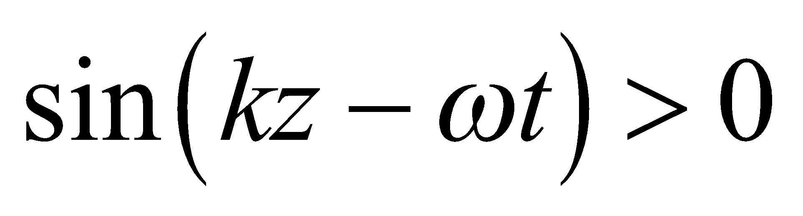, so we can find possible directions for the magnetic field.

**Evaluate** (**a**) When the sine function is unity, the electric field is 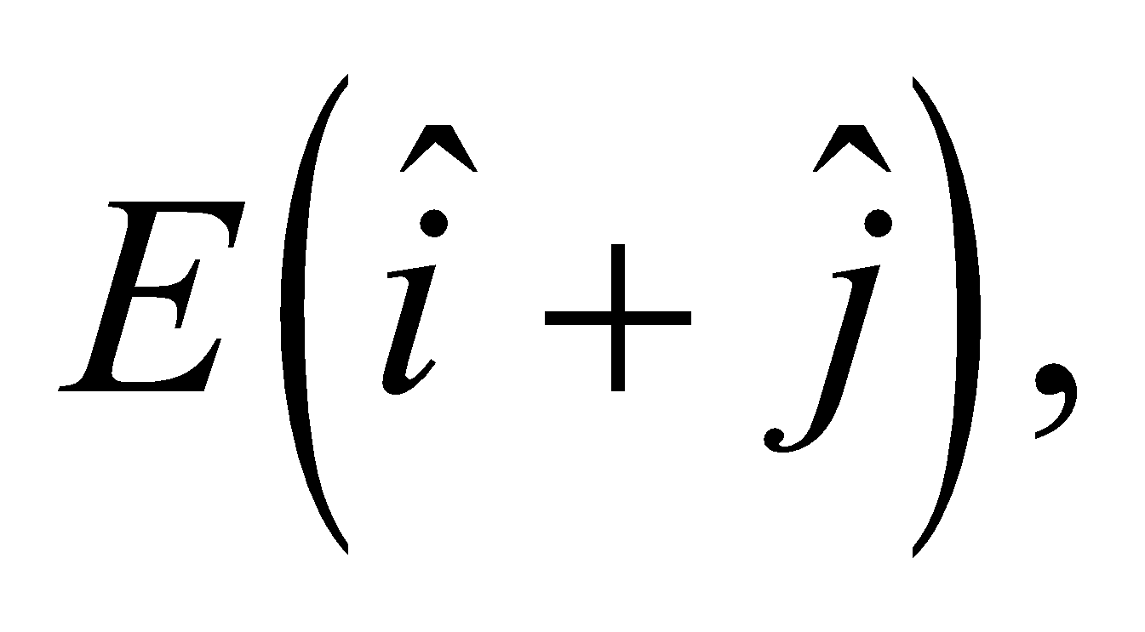 so its peak magnitude is 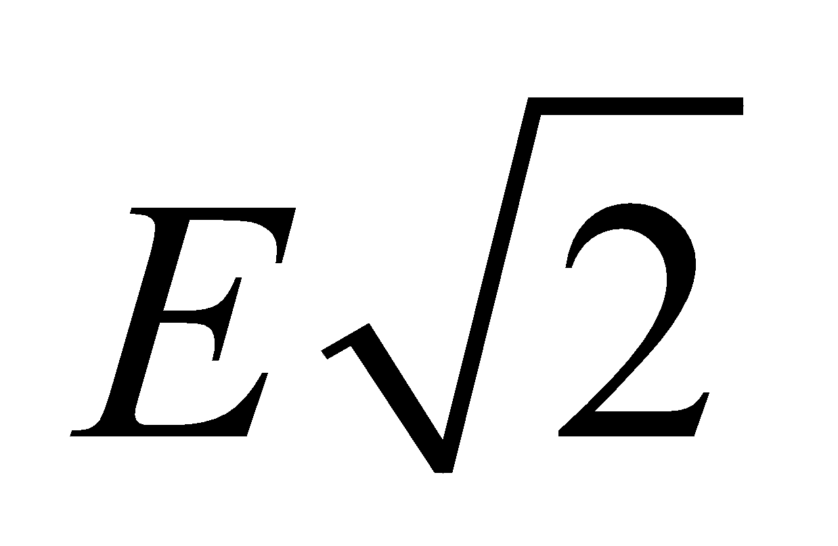 and it direction is 45° above the *x*-axis.

(**b**) To be perpendicular to the electric field, the magnetic field may either be in the +135° from the *x*-axis (i.e., second quadrant), or −45° from the *x*-axis (i.e., fourth quadrant). These fields would have unit vectors of 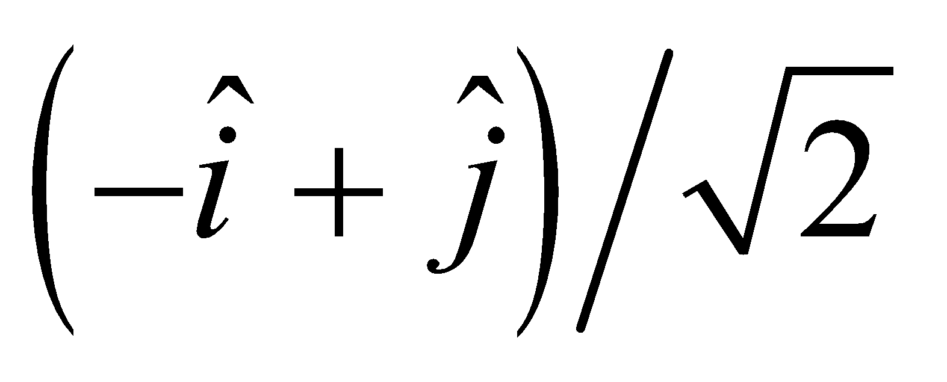 and 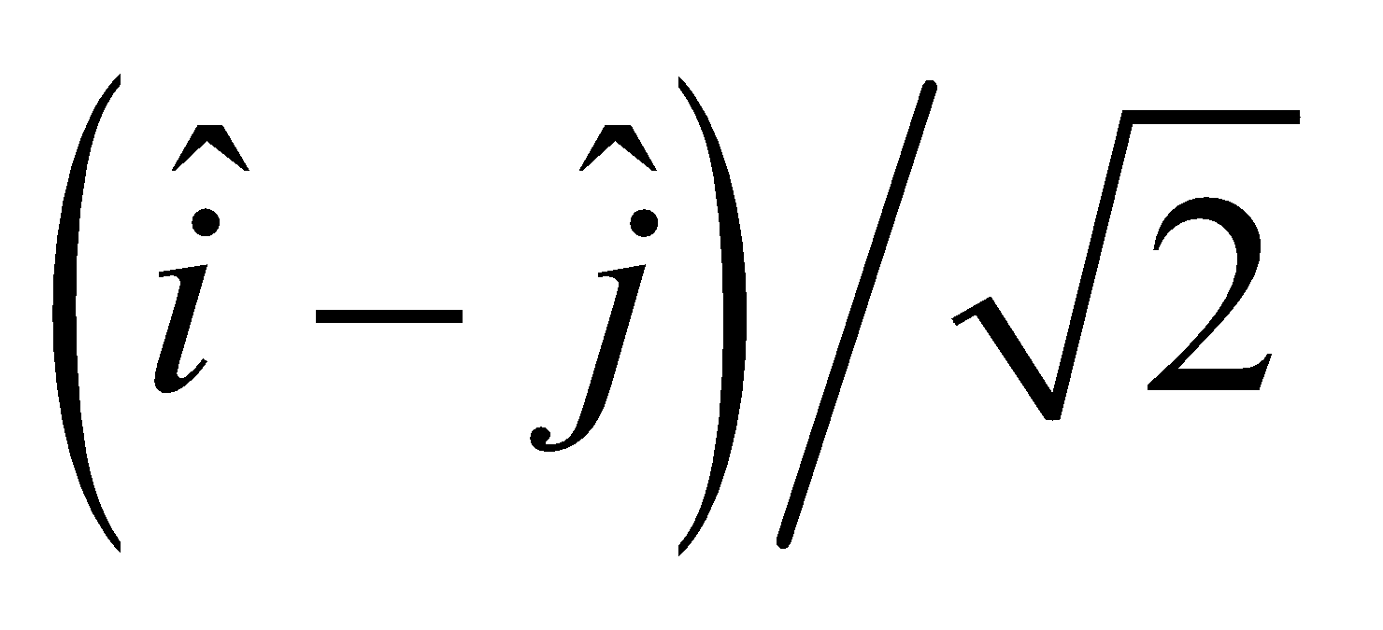, respectively.

**Assess** Without knowing the direction of propagation of the electromagnetic wave, we cannot determine absolutely the direction of the magnetic field. The direction of propagation of the electric field is in the direction of 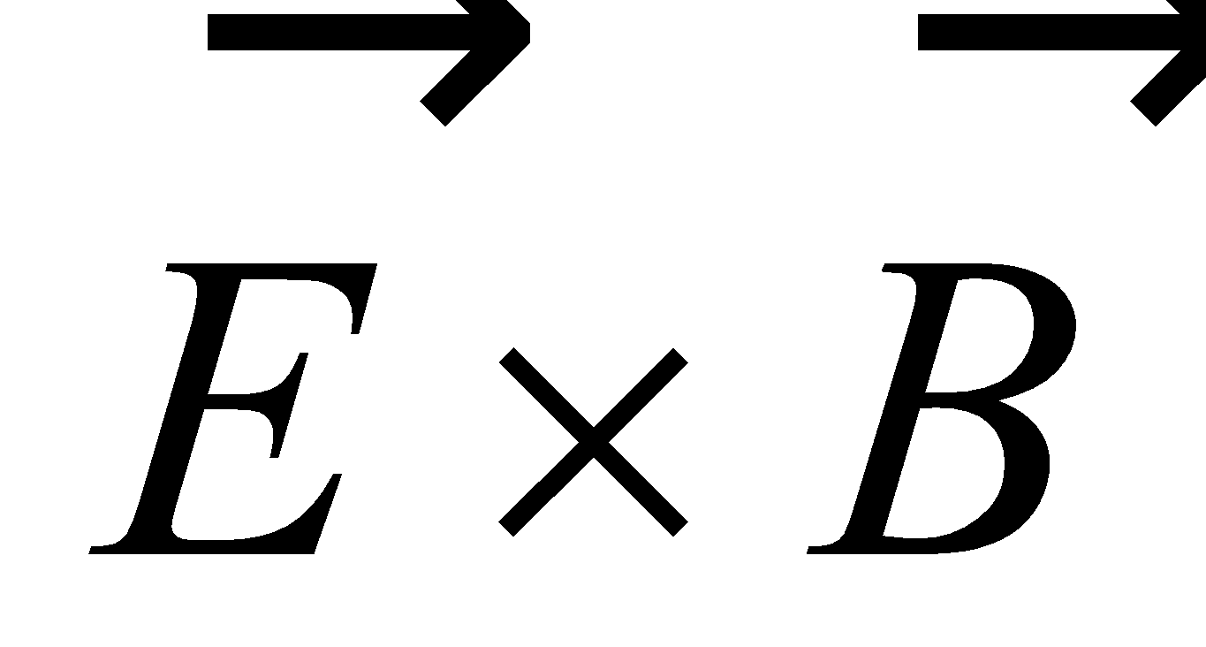, and so would be in either the 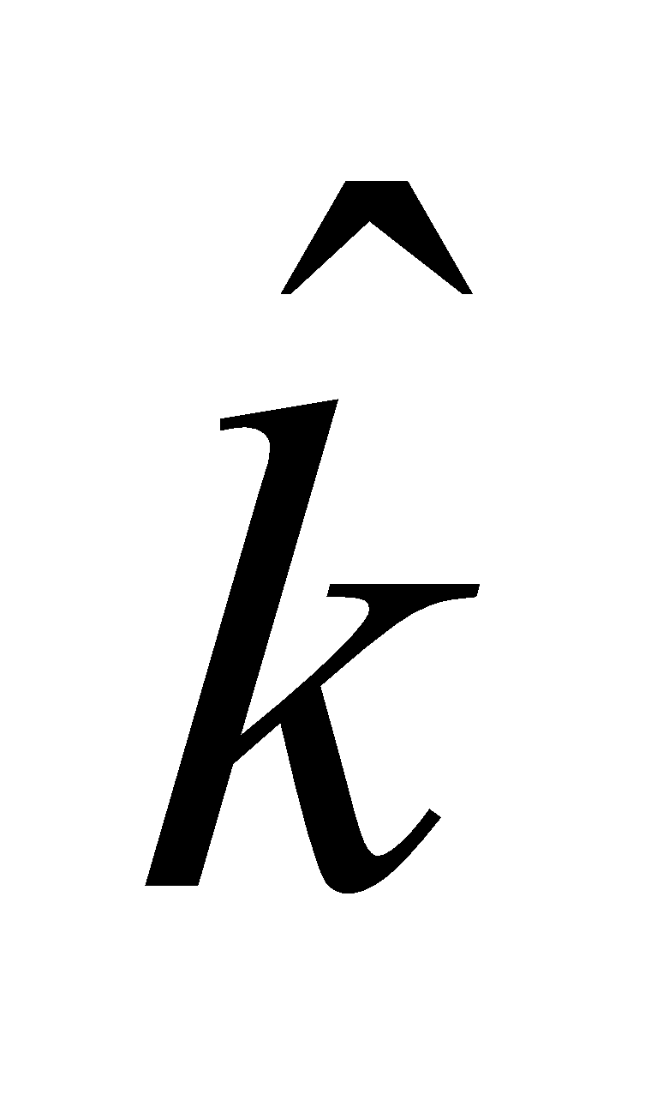 or 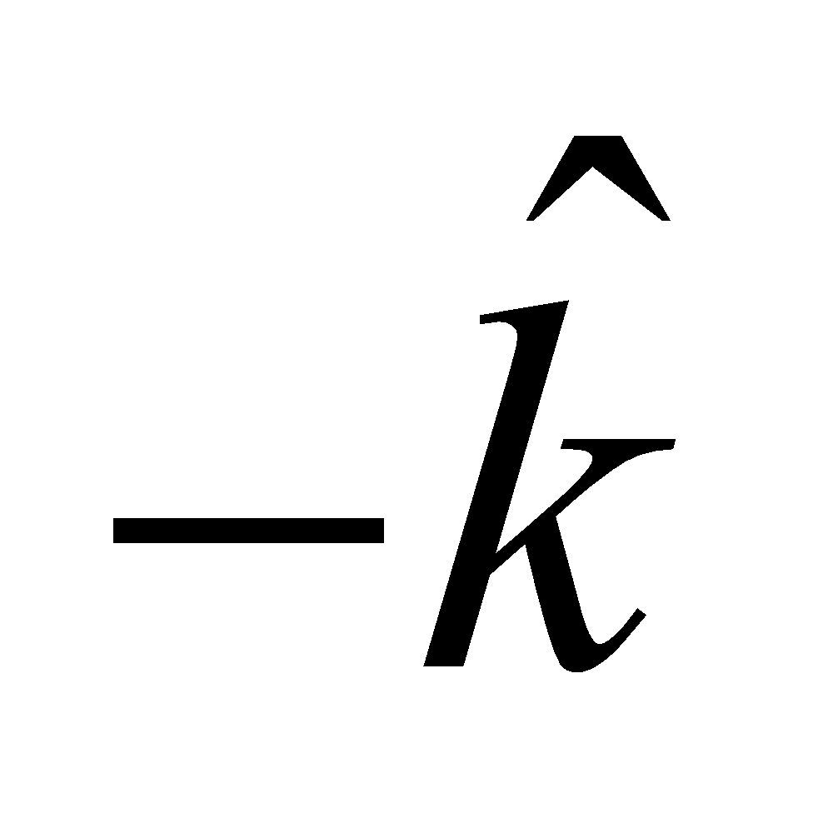 direction, respectively.

**Section 29.5 Properties of Electromagnetic Waves**

**17. Interpret** This problem involves expressing the distance between the Sun and the Earth in terms of light minutes.

**Develop** A light minute (abbreviated as c-min) is approximately equal to

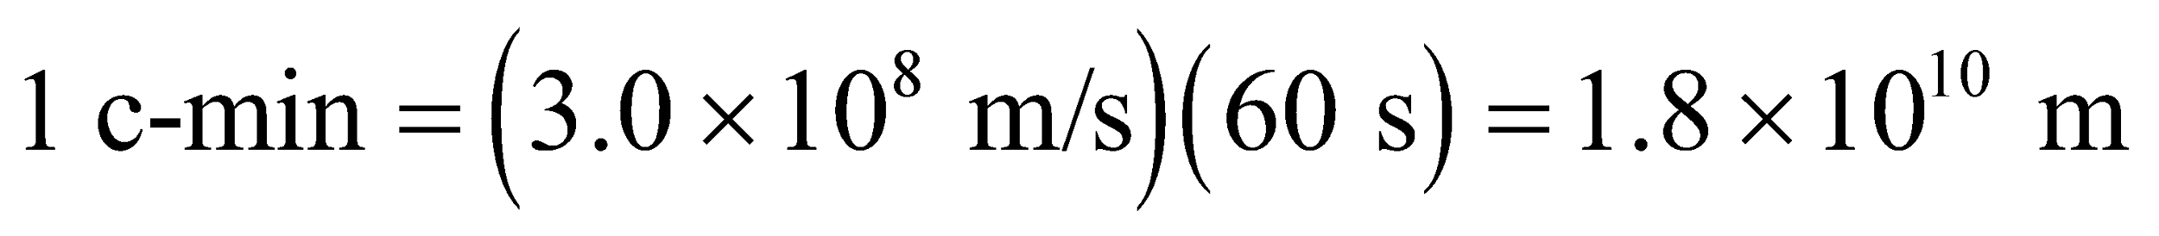

On the other hand, the mean distance of the Earth from the Sun (an astronomical unit) is about 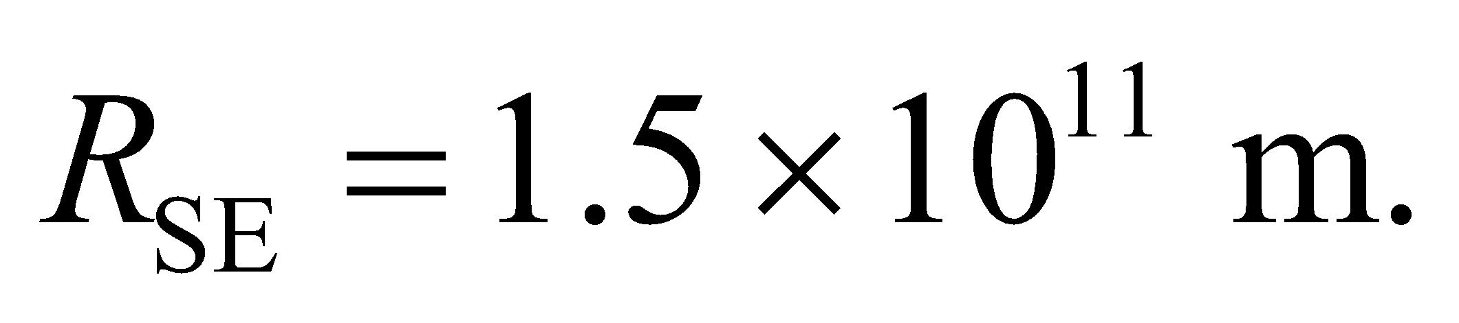

**Evaluate** In units of c-min,  can be rewritten as

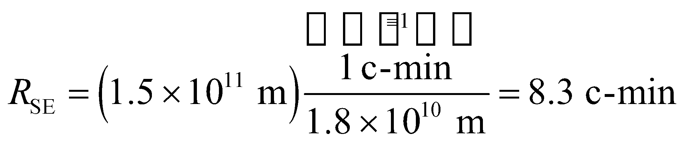

**Assess** The result implies that it takes about 8.3 minutes for the sunlight to reach the Earth.

**18. Interpret** This problem is to give you a “feel” for the speed of light. You are to find the approximate time it would take for an electromagnetic signal to travel to a satellite and back.

**Develop** Assuming the satellite is approximately overhead, we can estimate the round-trip travel time by 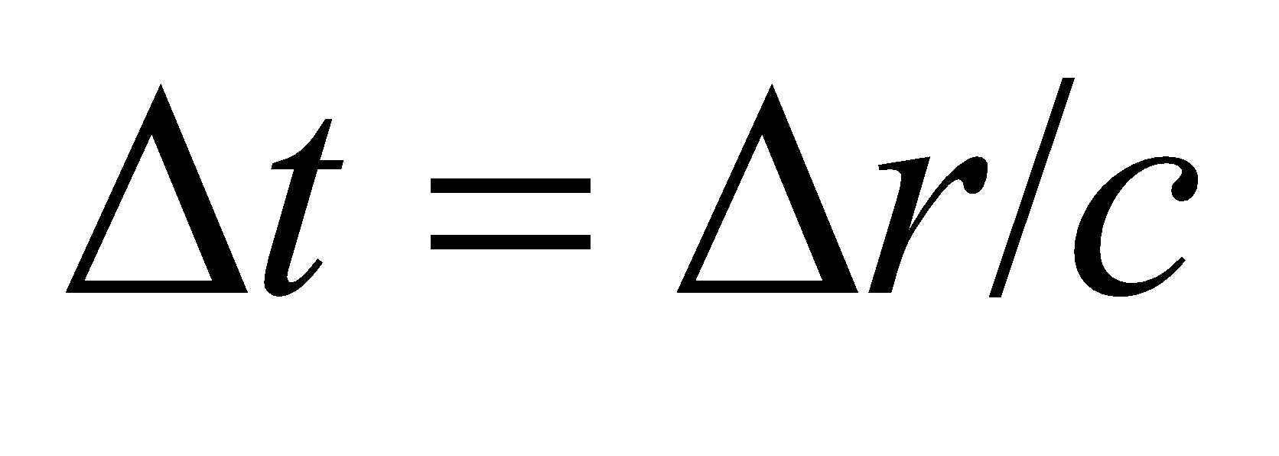, where c = 3.00 × 108 m/s is the speed of light in vacuum.

**Evaluate** The approximate round-trip time is 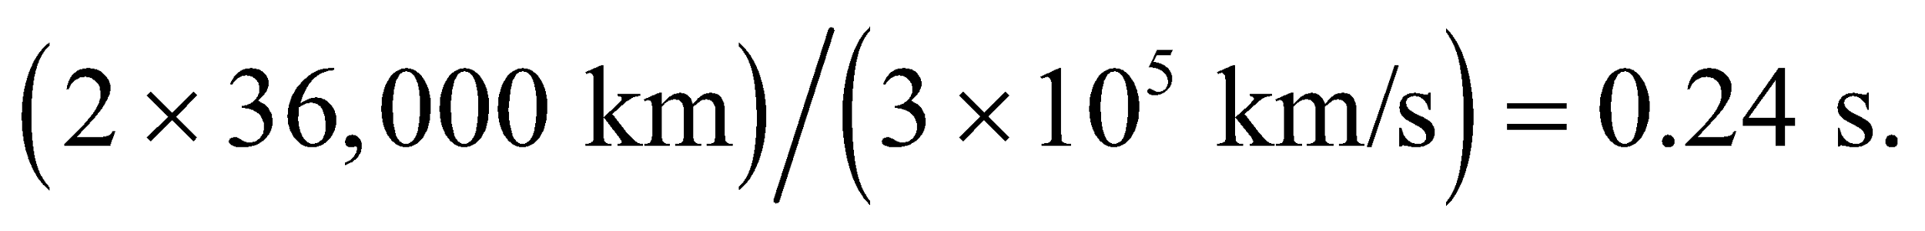

**Assess** This explains the very slight delay one may notice in intercontinental phone calls.

**19. Interpret** In this problem we want to deduce the airplane’s altitude by measuring the travel time of a radio wave signal it sends out. The logic of this method is the same as that of the preceding problem.

**Develop** The speed of light is 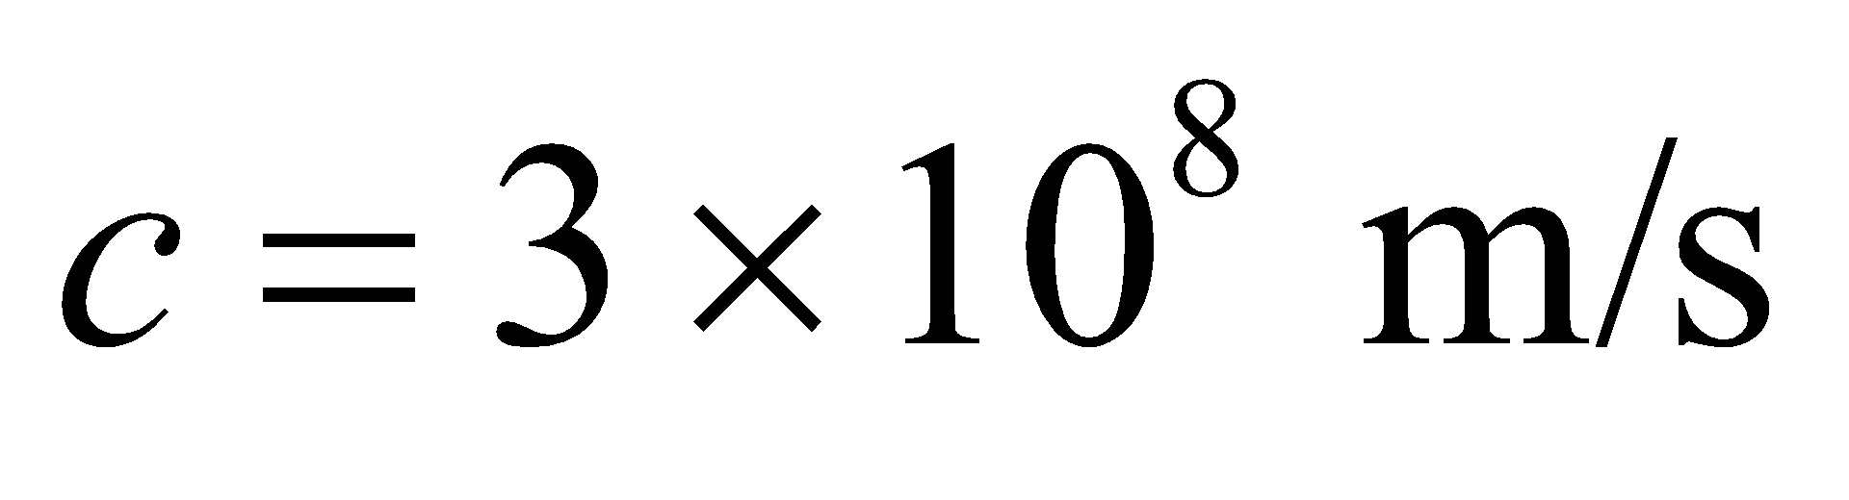 and the total distance traveled is 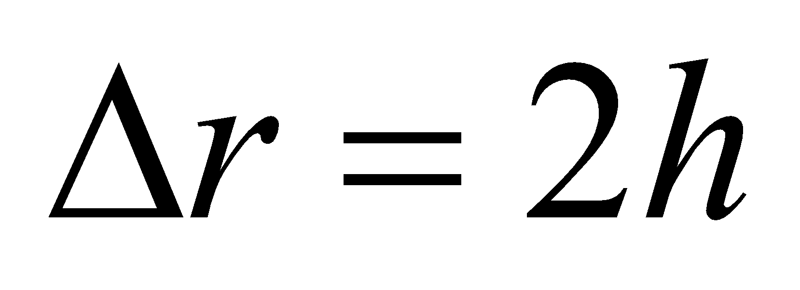 (neglecting the distance traveled by the plane during the transit time of the signal).

**Evaluate** Since 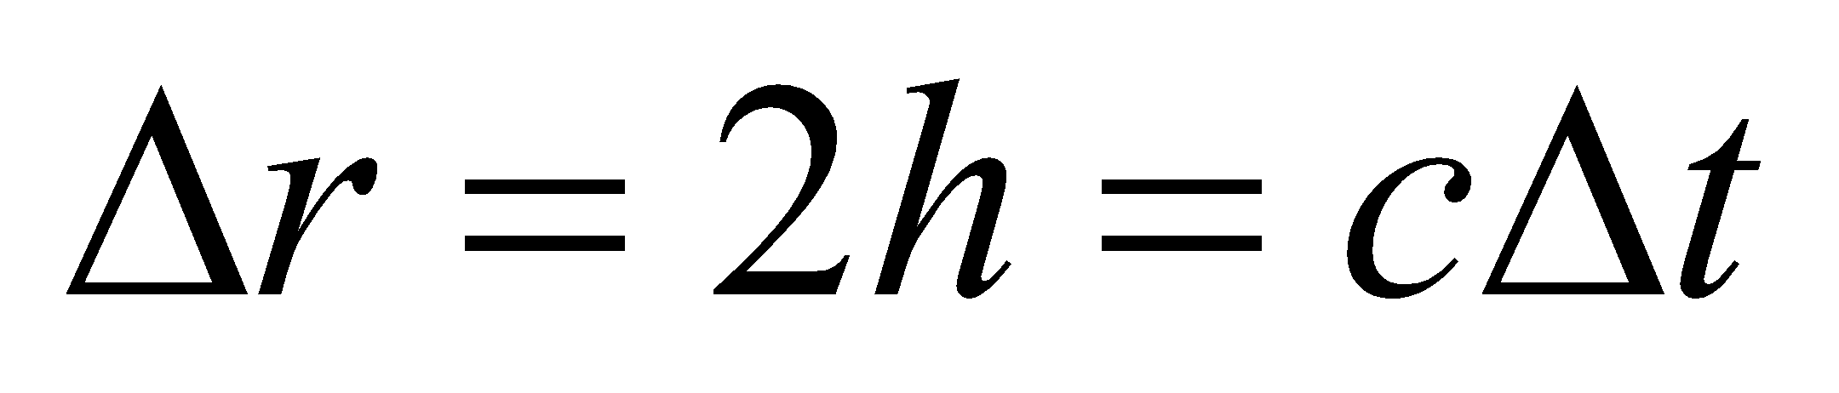 (for waves traveling with speed *c*), the altitude *h* is

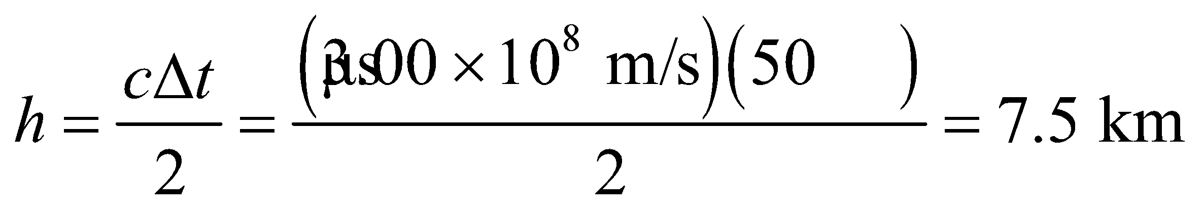

**Assess** The airplane is flying lower than the typical cruising altitude of 12,000 m (35,000 ft) for commercial jet airplanes.

**20. Interpret** This is another problem designed to give a “feel” for the speed of light. We are to find the time it takes for an electromagnetic wave to travel 1 foot (in vacuum).

**Develop** The speed of light in vacuum is *c* = 3.00 × 108 m/s, so the time may be found by dividing the distance (1 foot ~ 0.30 m) by this speed.

**Evaluate** The time *t* for light to travel one foot in vacuum is approximately

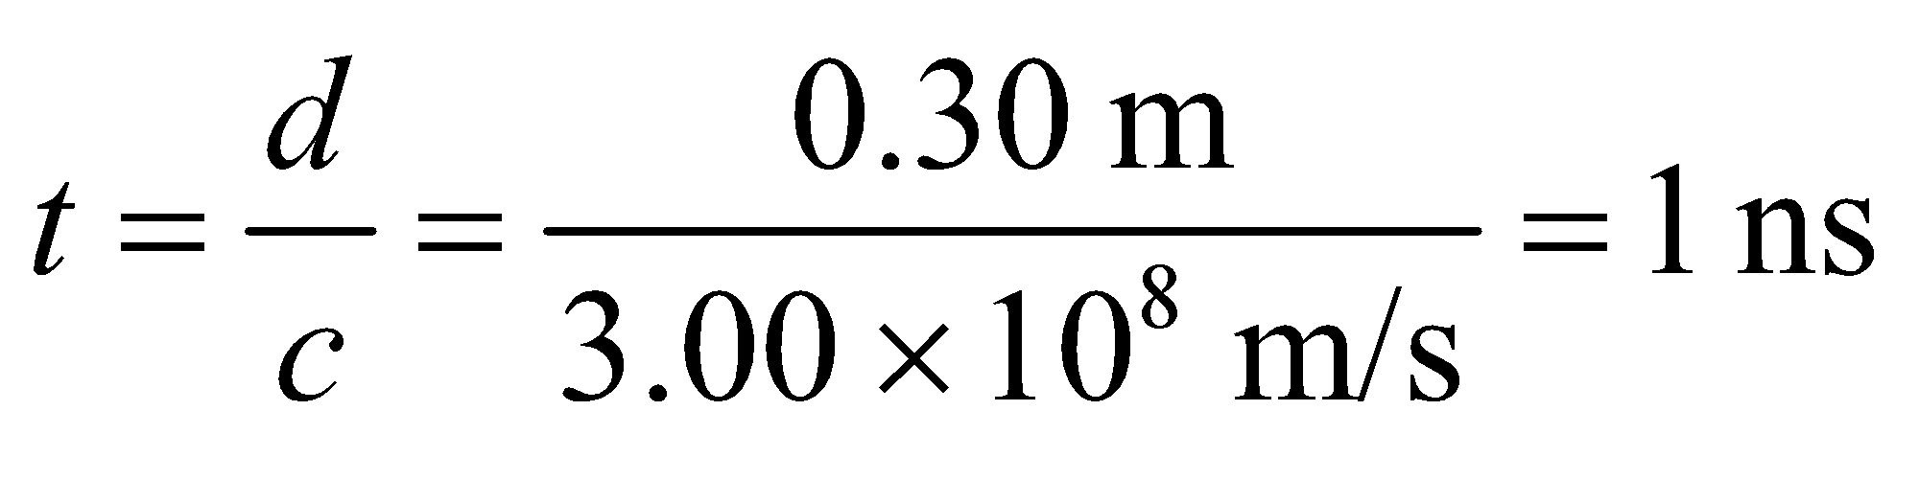

**Assess** This time delay may be measured by modern electronics. Faster times, however, are better measured using optical methods.

**21. Interpret** This problem involves finding the round-trip time delay for radio signals traveling between the Earth and the Moon.

**Develop** The time it takes to get a reply is twice the distance (out and back) divided by the speed of light, which is 3.00 × 108 m/s in vacuum.

**Evaluate** From Appendix E, we find the distance between the Earth and the Moon to be 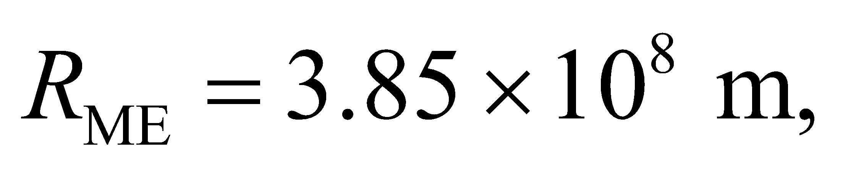 so the time required is

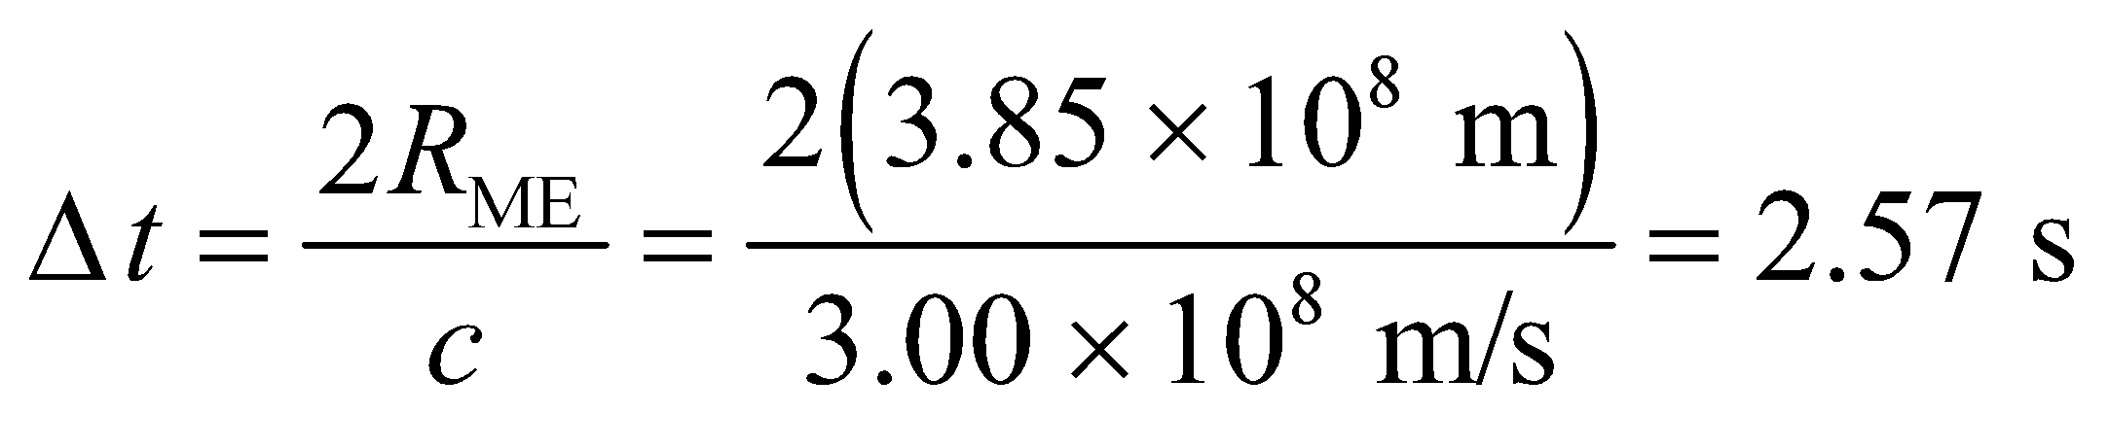

**Assess** The signal has to travel a very long distance, so a time delay of 2.57 seconds is not surprising. The time delay via geostationary satellite communication is typically between 240 ms and 280 ms (see Problem 29.18).

**22. Interpret** This problem involves converting frequency of light to wavelength.

**Develop**Equation 29.16c gives the relation between frequency and wavelength: 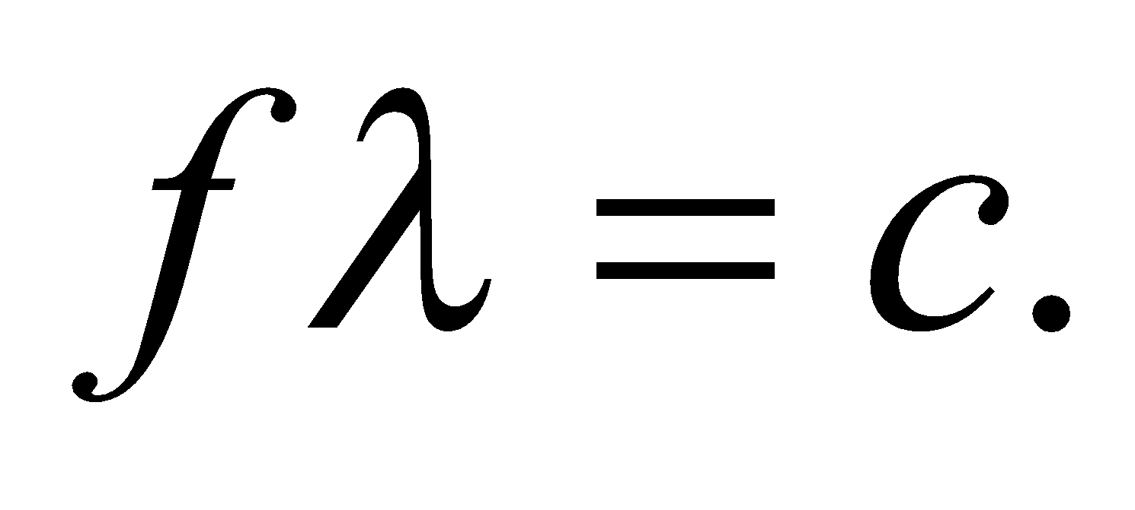

**Evaluate**(a) For an FM radio wave,

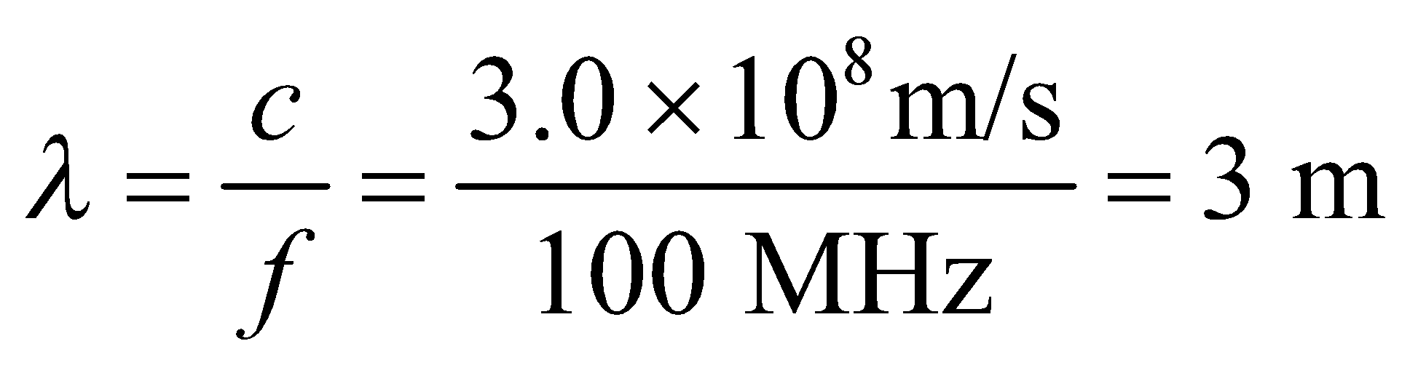

(b) For a WiFi signal,

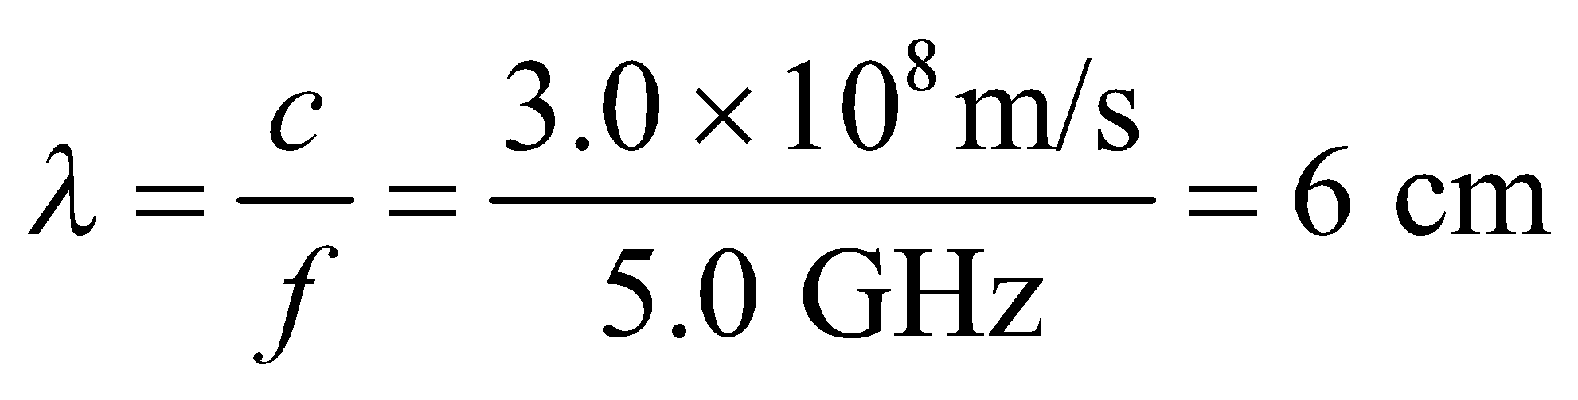

(c) For a visible light wave,

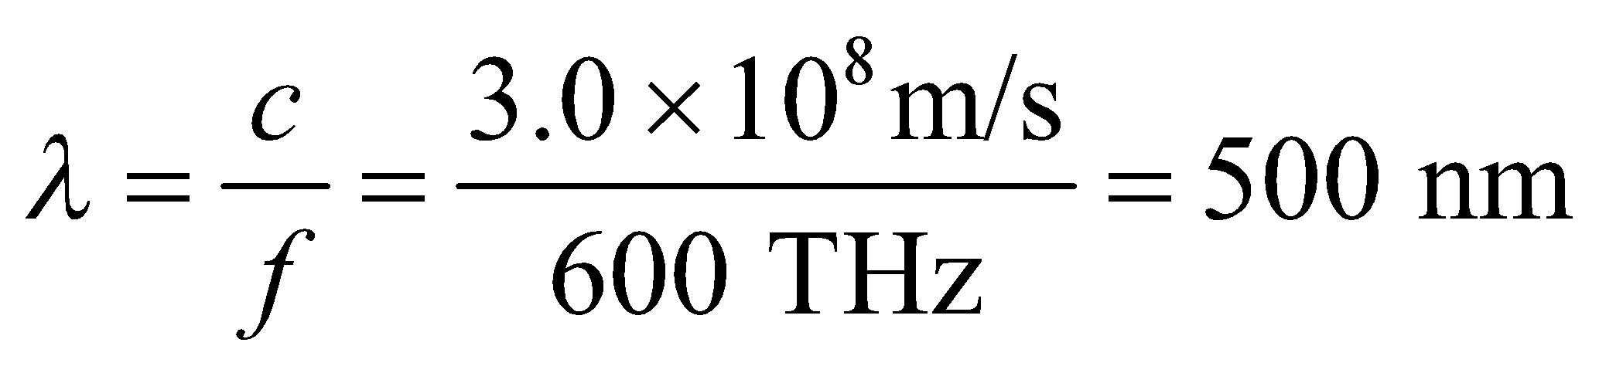

(d) For an X ray,

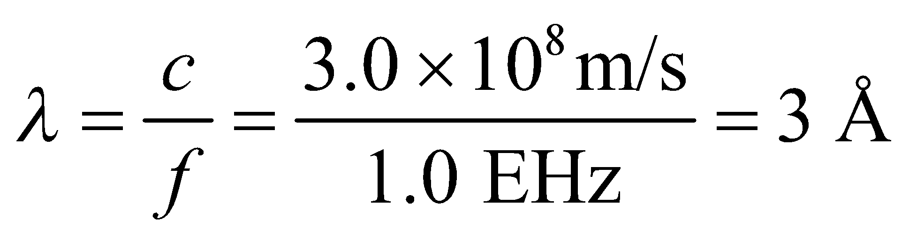

**Assess** From 3 m to 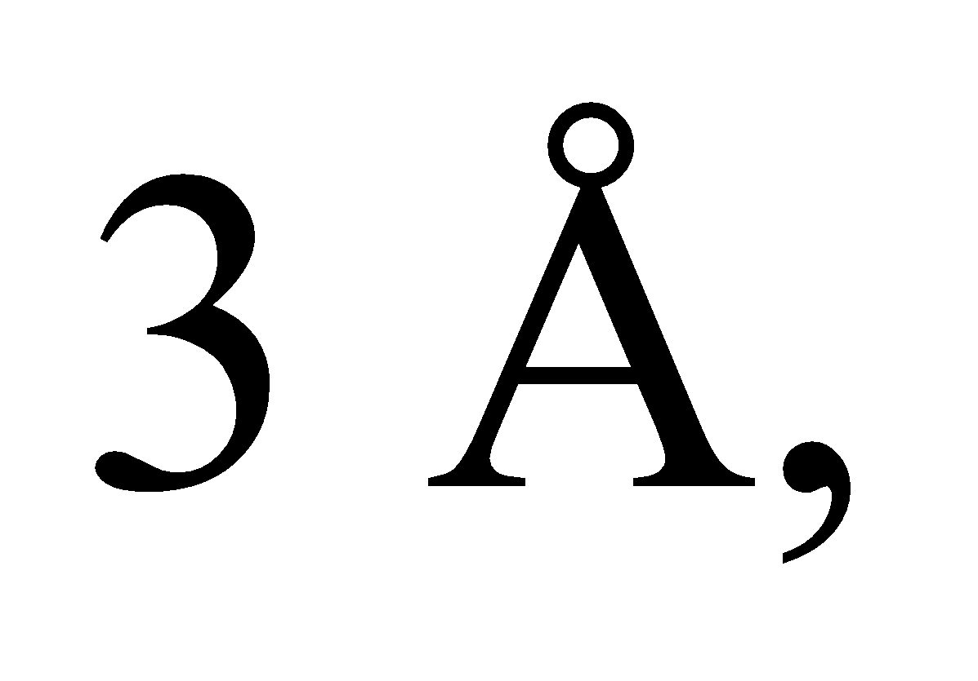the electromagnetic spectrum that we are most familiar with extends more than 10 orders of magnitude.

**23. Interpret** In this problem we are asked to find the wavelength of electromagnetic radiation that propagates through air, given its frequency.

**Develop** The wavelength of the electromagnetic wave can be calculated using Equation 29.16c:  Because air is not optically dense, it may be taken to be a vacuum, so the speed of light is c = 3.00 × 108 m/s.

**Evaluate** The wavelength in a vacuum (or air) is

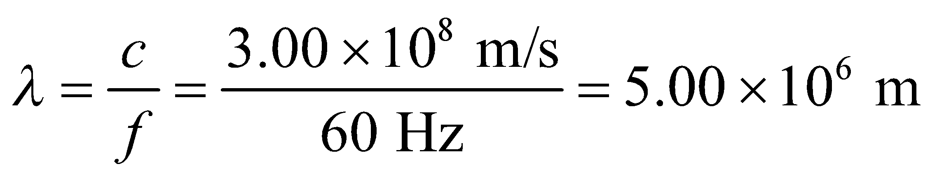

**Assess** The wavelength is almost as large as the radius of the Earth!

**24.** **Interpret** The distance between wave crests is the wavelength of the wave, which we are to find for an electromagnetic wave in vacuum given its frequency.

**Develop** Apply Equation 29.16c, *λ* = *c*/*f*, with *c* = 3.00 × 108 m/s and *f* = 2.4 × 109 s−1.

**Evaluate** The distance between wave crests is



**Assess** The result is reported to two significant figures.

**25. Interpret** This problem involves finding the direction of polarization of an electromagnetic wave, which is the direction in which the electric field oscillates.

**Develop** The direction of propagation of the electromagnetic wave is the same as the direction of the cross product  In our case, we have 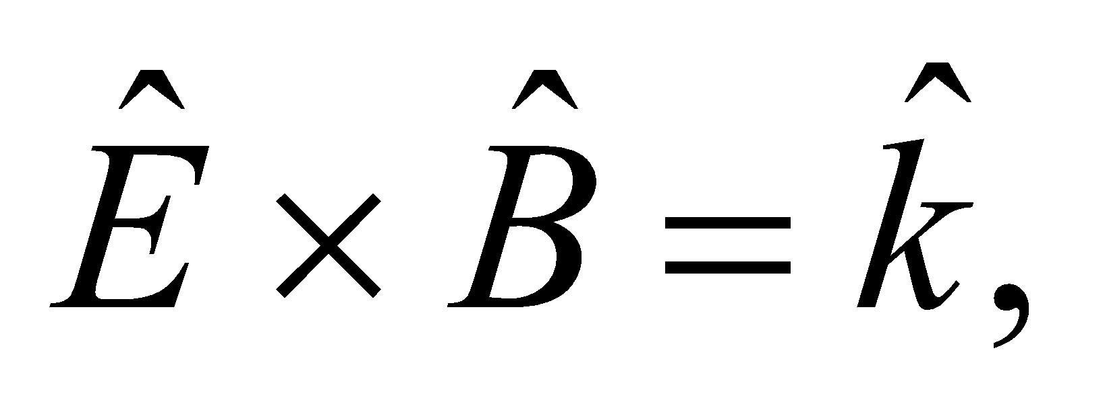 where  is the unit vector in the + *z* direction.

**Evaluate** Since the magnetic field points in the +*y* direction, 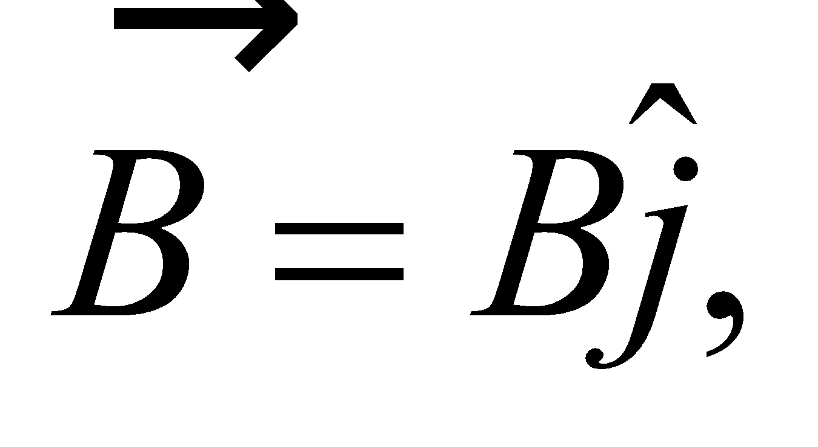 we must have 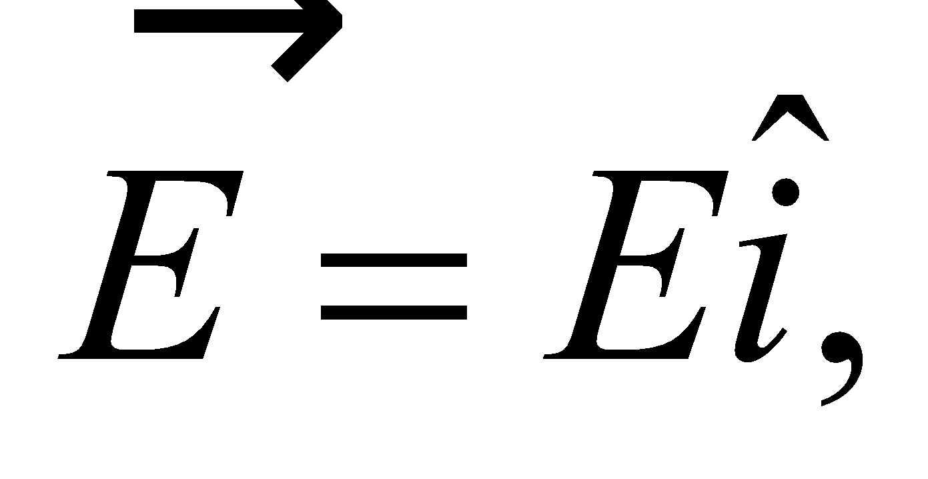 so that 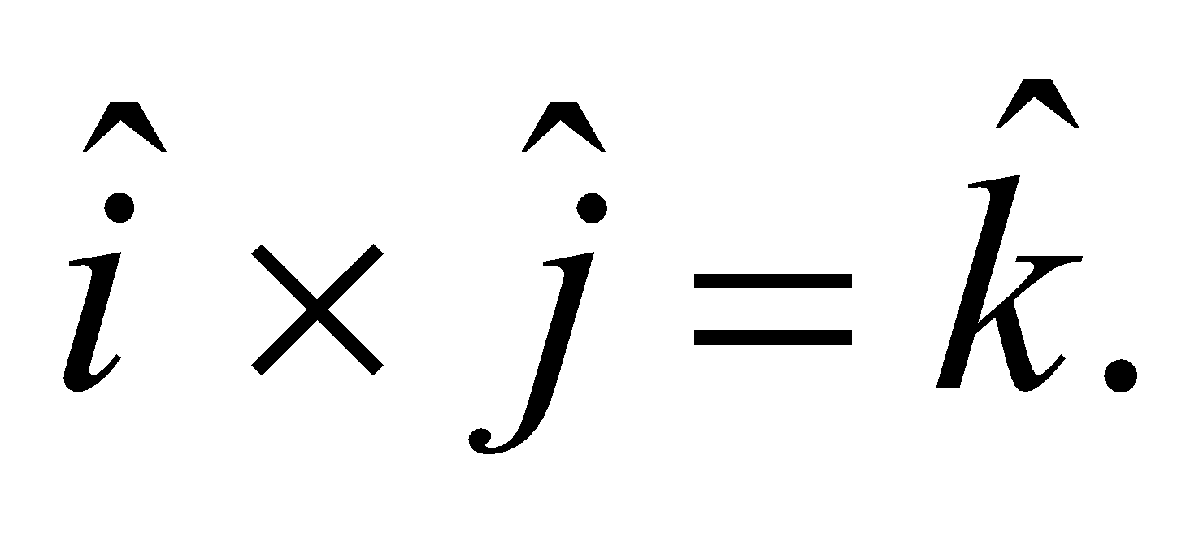 The wave is linearly polarized.

**Assess** For electromagnetic waves in vacuum, the directions of the electric and magnetic fields, and of wave propagation, form a right-handed coordinate system. One may write 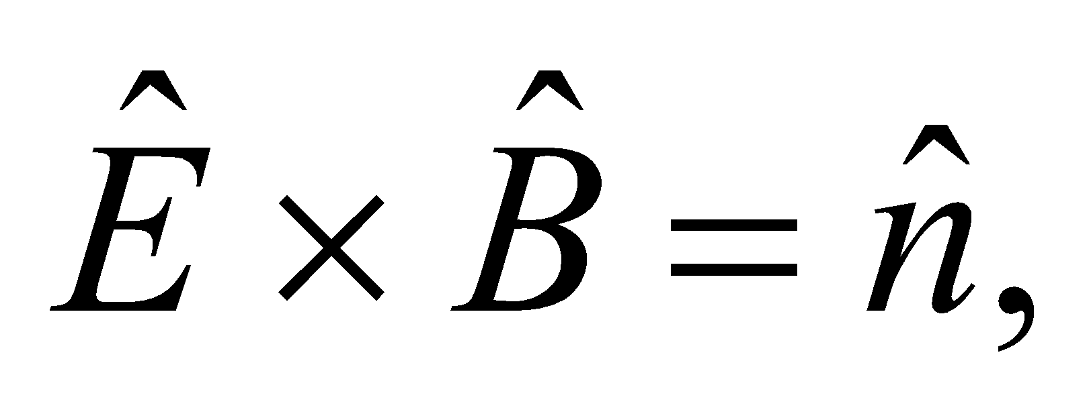 where 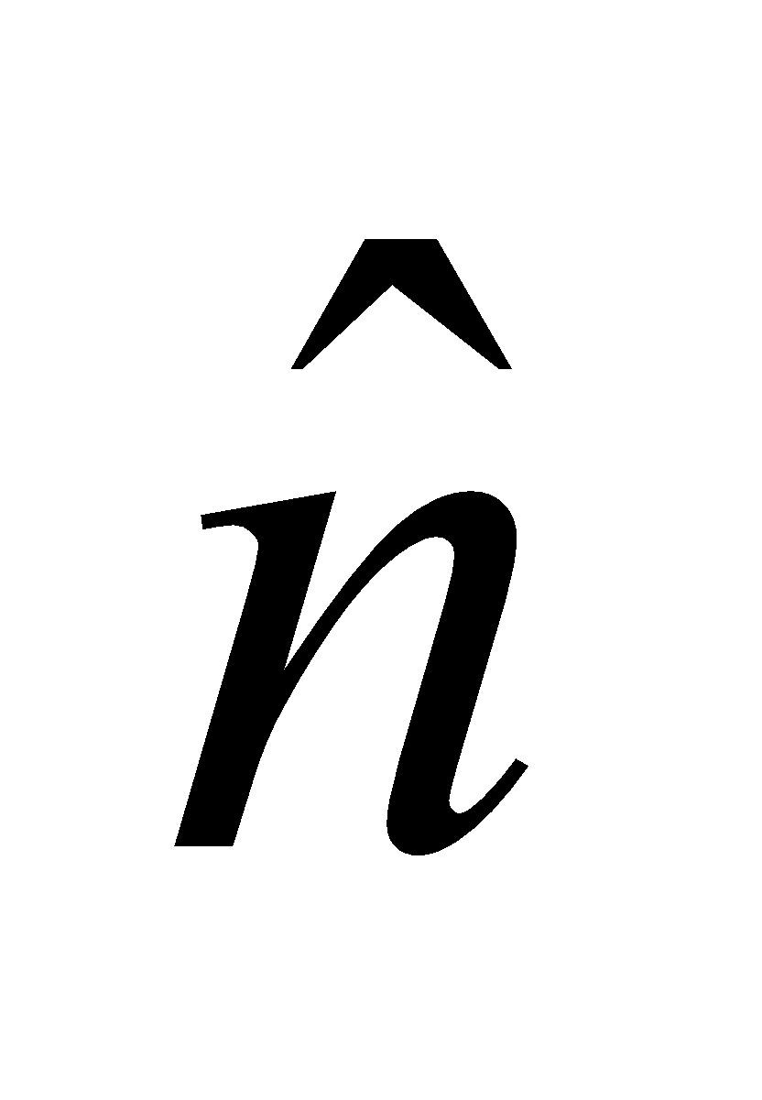 is the unit vector in the direction of propagation.

**26.** **Interpret** We are to find the angle between the polarization of the electromagnetic wave (i.e., the direction of its electric field) and the polarization direction of the polarizing material.

**Develop** Apply the Law of Malus, Equation 29.18.

**Evaluate** From the law of Malus, 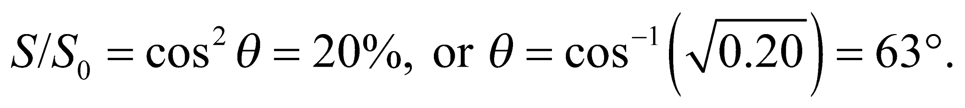

**Assess** By rotating the polarizer with respect to the incident electromagnetic field, the transmission can be adjusted from almost 100% to almost 0%.

**27. Interpret** This problem is about the intensity of a light beam that transits a polarizer. We are given the angle between the polarization of the light (i.e., its electric field) and the polarization direction of the material.

**Develop** The intensity of the light after emerging from a polarizer is given by the Law of Malus (Equation 29.18), 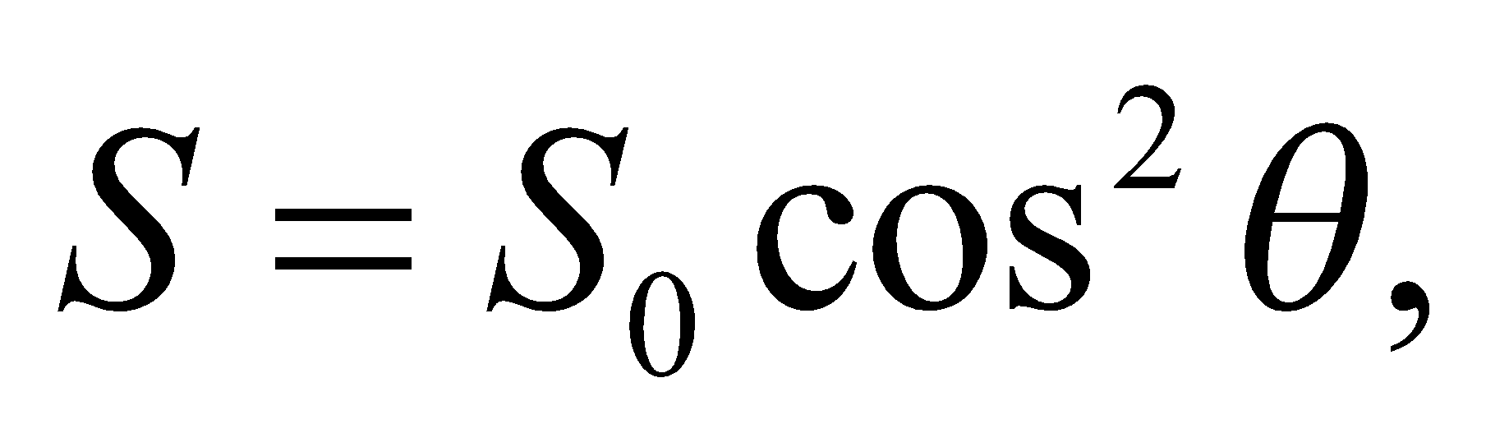 where *θ* is the angle between the field and the polarization direction of the material.

**Evaluate** The Law of Malus gives 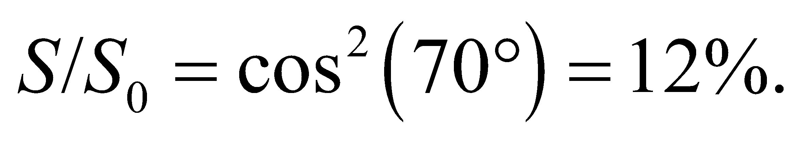

**Assess** The intensity depends on 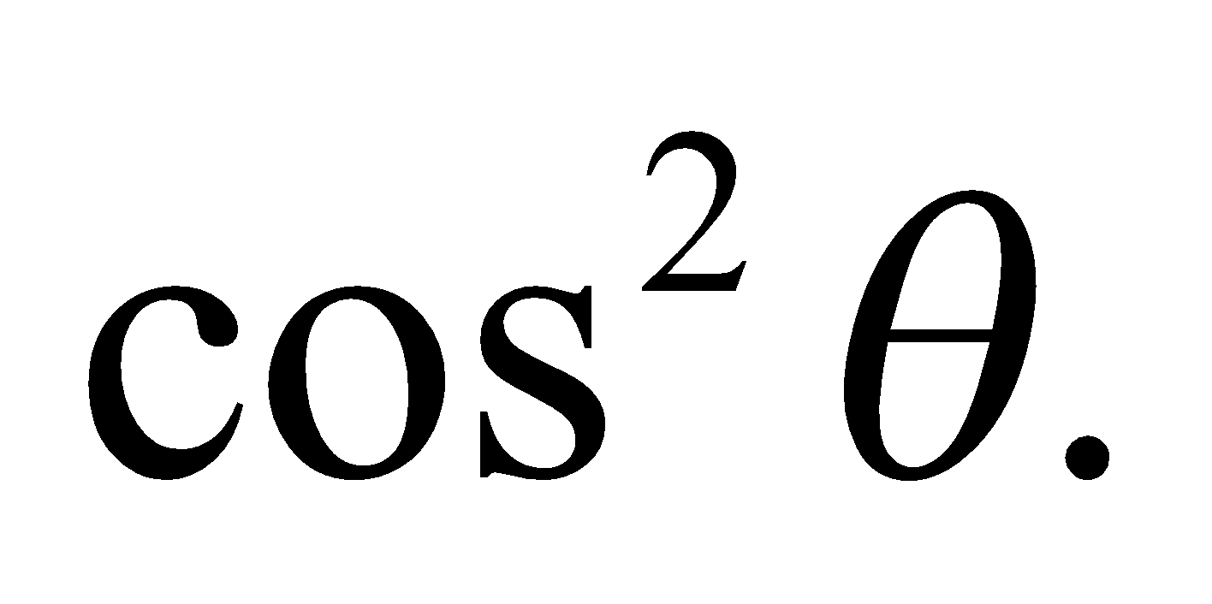 The limit *θ* = 0 corresponds to the situation where the direction of polarization of the incident light is the same as the preferred direction specified by the polarizer, and 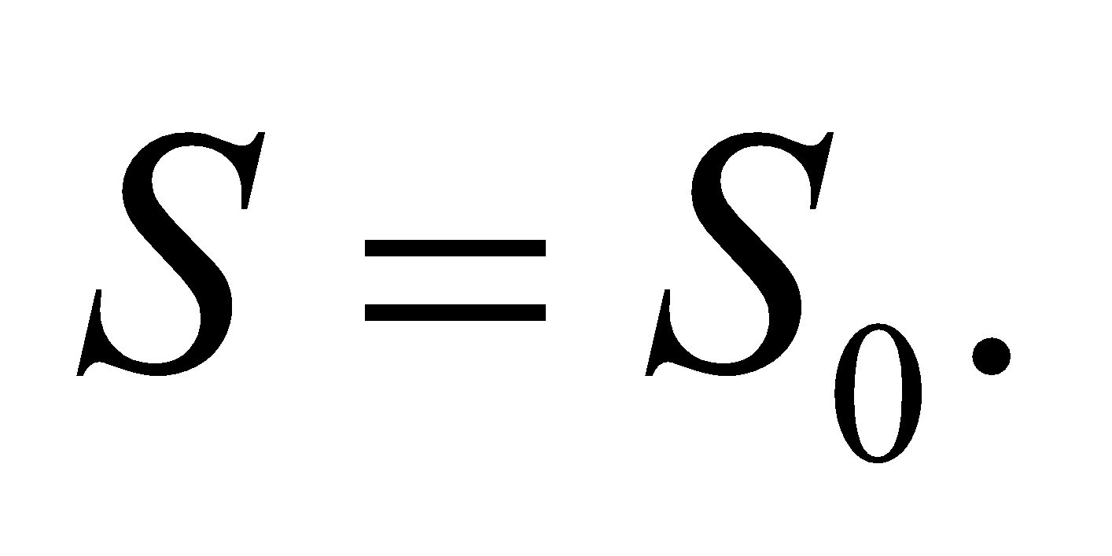 On the other hand, when *θ* = 90°, essentially no light passes through the polarizer.

**Section 29.8 Energy and Momentum in Electromagnetic Waves**

**28. Interpret** We are to find the intensity of an electromagnetic wave given the strength of its maximum electric field.

**Develop** Apply Equation 29.20b, 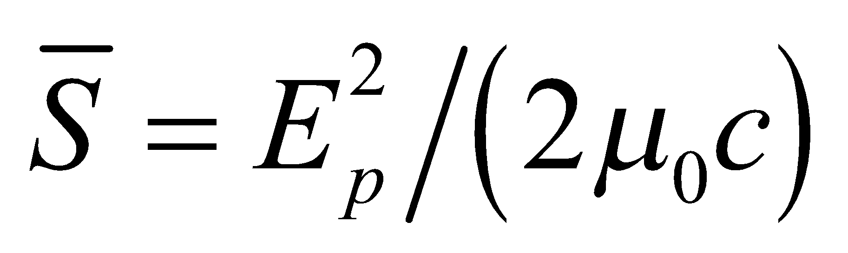.

**Evaluate** The intensity is

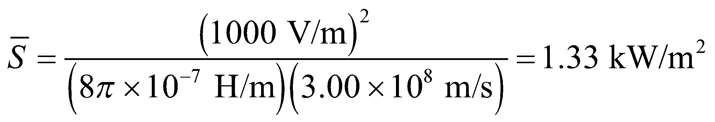

**Assess** This is comparable to the average solar intensity at the surface of the Earth, which is about 1370 W/m2.

**29. Interpret** This problem explores the average intensity of a laser beam required for dielectric breakdown in air.

**Develop** The average intensity of an electromagnetic wave is given by Equation 29.20:

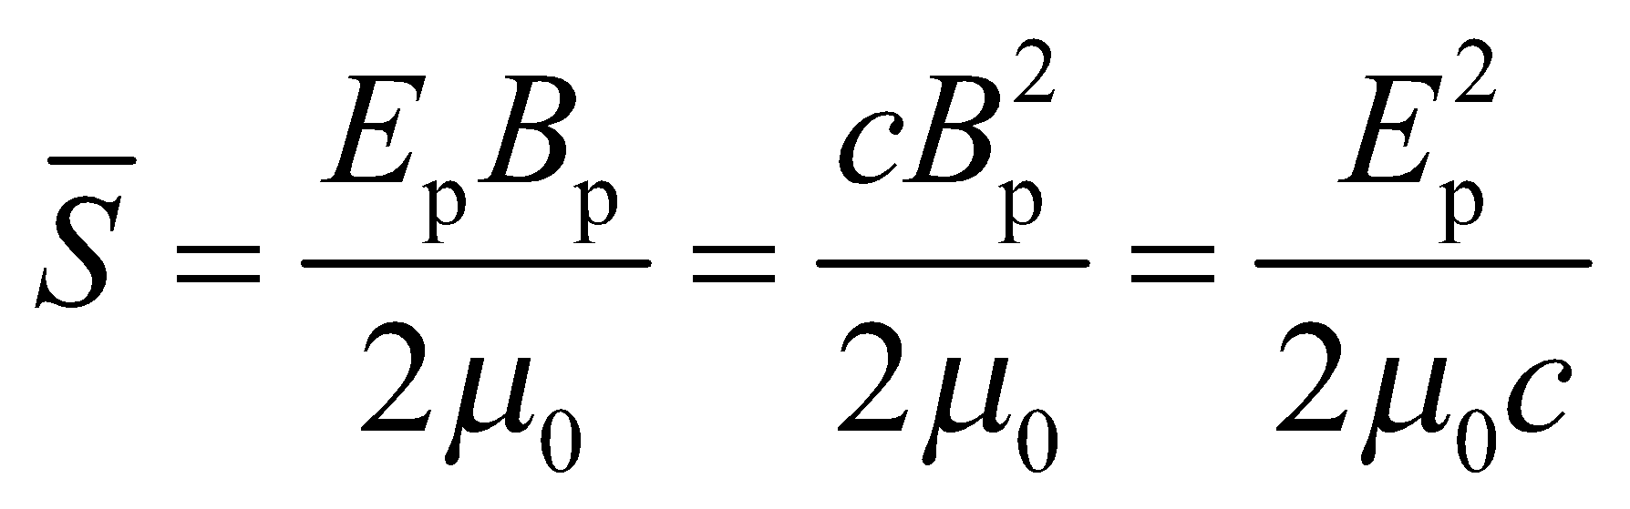

**Evaluate** With 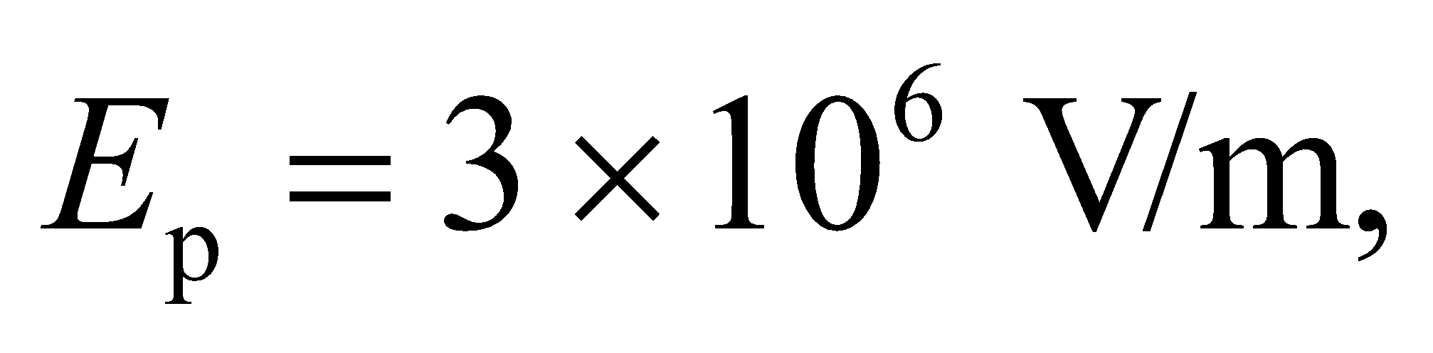 the average intensity is

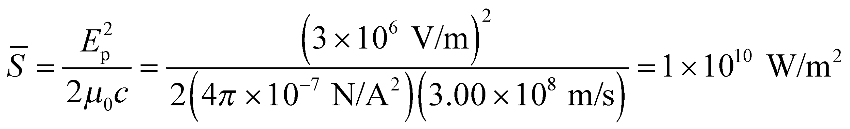

**Assess** We need a very powerful laser to produce the breakdown field strength. The laser intensity can be compared to the average solar intensity which is about 1370 W/m2.

**30. Interpret** We’re asked to calculate the electric field inside a microwave oven of a given power.

**Develop**If we assume the microwaves travel through the oven as plane waves, then the average intensity is related to the power by 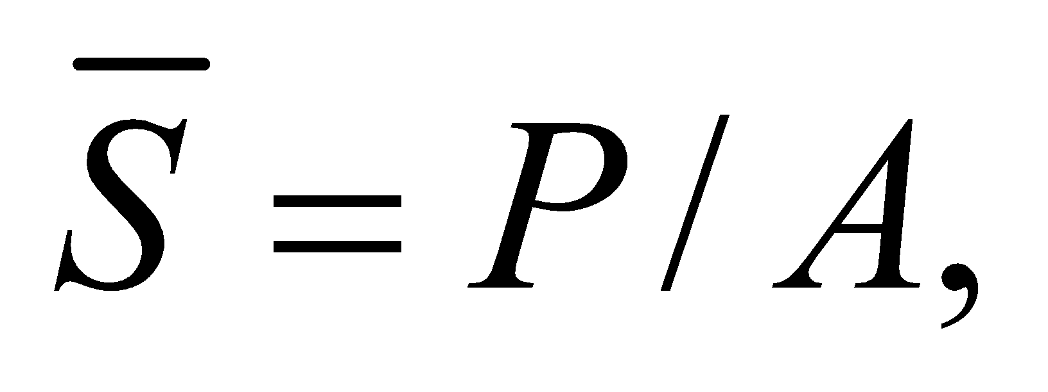 where *A* is the cross-sectional area of the oven. The average intensity is proportional to the square of the peak electric field in the light (Equation 29.20b): 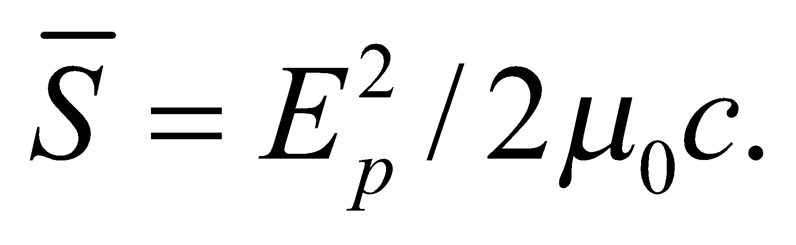

**Evaluate**Equating the two intensity equations from above, we can solve for the peak electric field:

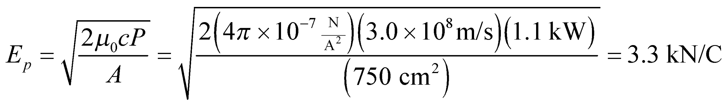

**Assess** The answer can also be written as 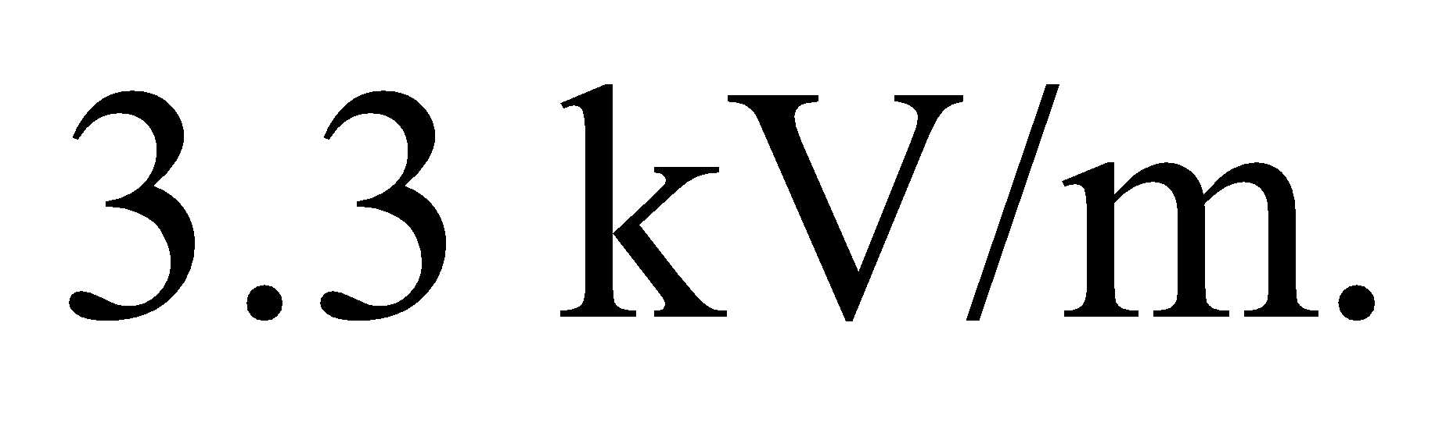This is almost 4 times the peak electric field of sunlight hitting the Earth’s surface (recall Example 29.3).

**31. Interpret** You want to know if your new radio can pick up a signal from a remote location.

**Develop**Given the minimum electric field that the radio can pick up, the minimum intensity is 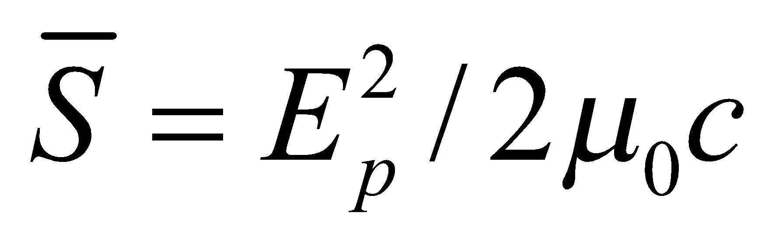 (Equation 29.20b).

**Evaluate**The radio’s intensity threshold is

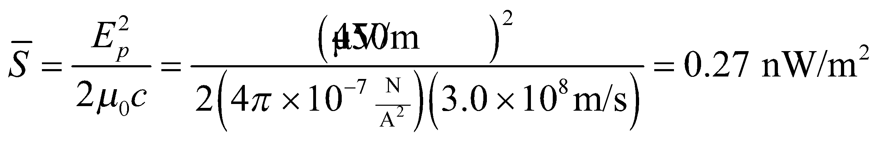

This means you will be able to hear your favorite station at your remote cabin.

**Assess** The minimum detectable signal for a radio or other receiver is usually set by the background noise. A radio station’s signal has to be significantly more powerful than stray electromagnetic waves that contribute to the "static" we hear between stations.

**32. Interpret** This problem involves finding the average intensity and the peak electric and magnetic field for the given laser pointer.

**Develop** The average intensity is the power per unit area, so we need only divide the given power by the given area. To find the electric and magnetic fields, apply Equations 29.20b and 29.17, respectively.

**Evaluate** (**a)** The average intensity is

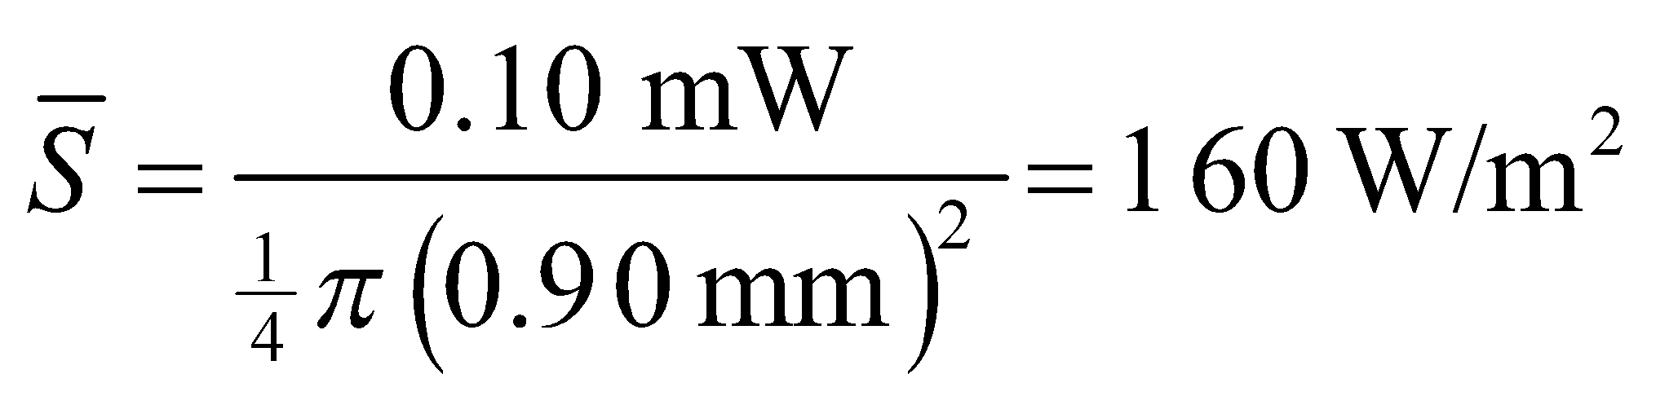

**(b)** Equation 29.20b gives  and

**(c)** Equation 29.17 gives 

**Assess** This average intensity is much less than that of the Sun’s radiation at the surface of the Earth.

**33. Interpret** You want to double the range of your radio station’s antenna.

**Develop**Listeners at a distance of 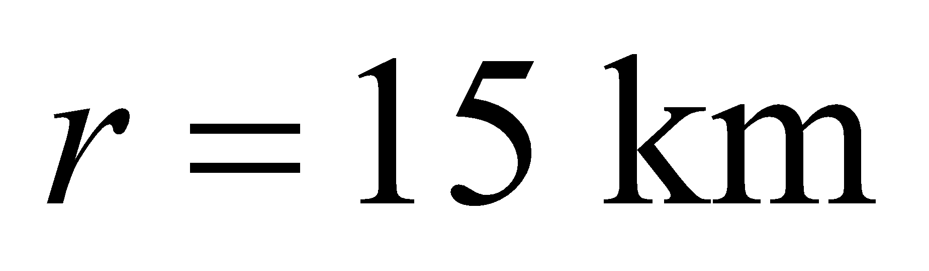 from the antenna can pick up your radio station because the intensity, *S*, inside this perimeter is above a typical radio receiver’s threshold. You want to increase the power so that the intensity at 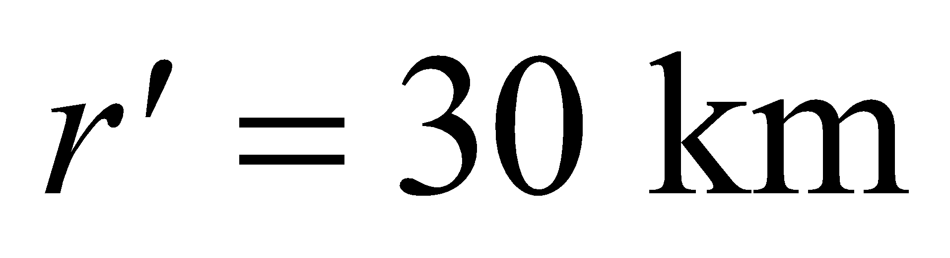is above threshold. The relation between intensity and power is given in Equation 29.21: 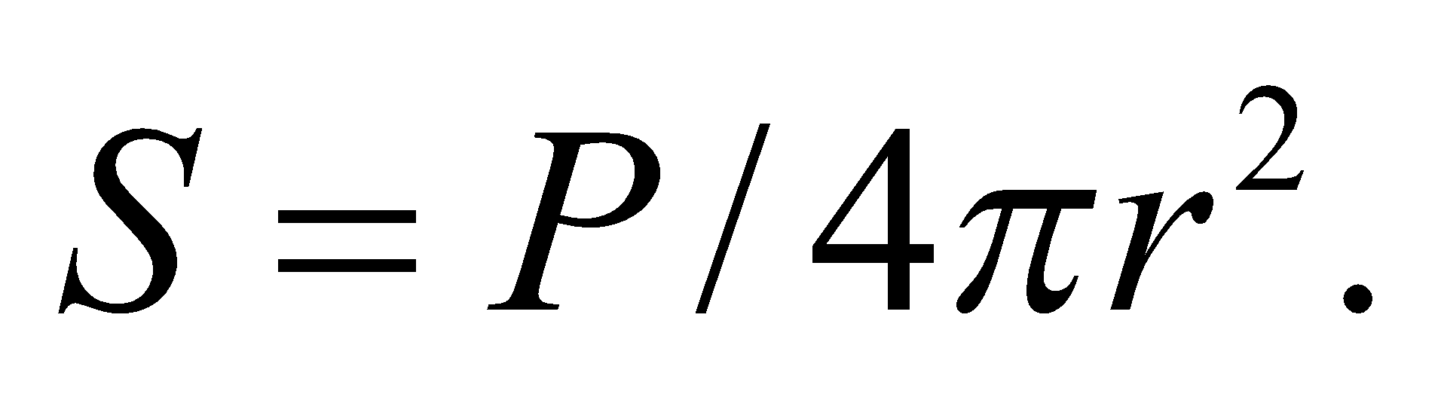

**Evaluate**The required power for doubling the range is

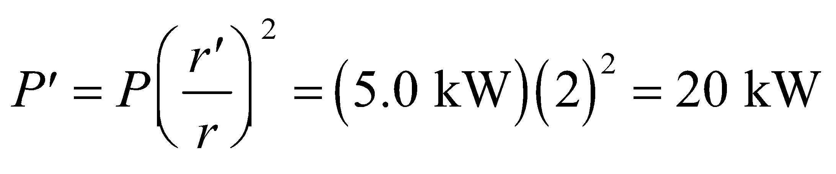

**Assess** We have assumed that the signal from the antenna radiates uniformly out in all directions, but that is not always the case. Some antennas focus their intensity in particular directions. However, no matter what the radiation pattern from the antenna, the power will have to be quadrupled to double the range in a given direction.

**Problems**

**34. Interpret** This problem involves applying Gauss’s law to find the magnetic field induced by a changing electric field in a circular parallel-plate capacitor. The symmetry involved is cylindrical symmetry, so the magnetic field will be constant at a given distance from the axis of the circular capacitor plates and in the plane of the plates.

**Develop**  Cylindrical symmetry and Gauss’s law for magnetism require that the 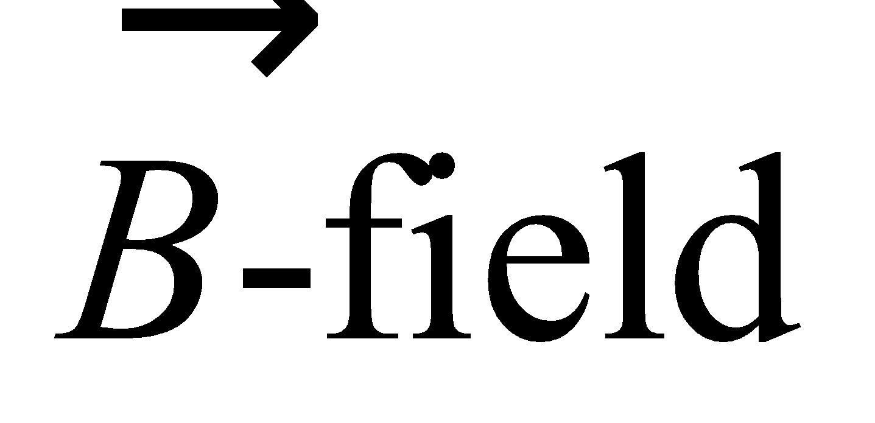 lines be circles around the symmetry axis. For a radius *r* less than the radius *R* of the plates, the displacement current is

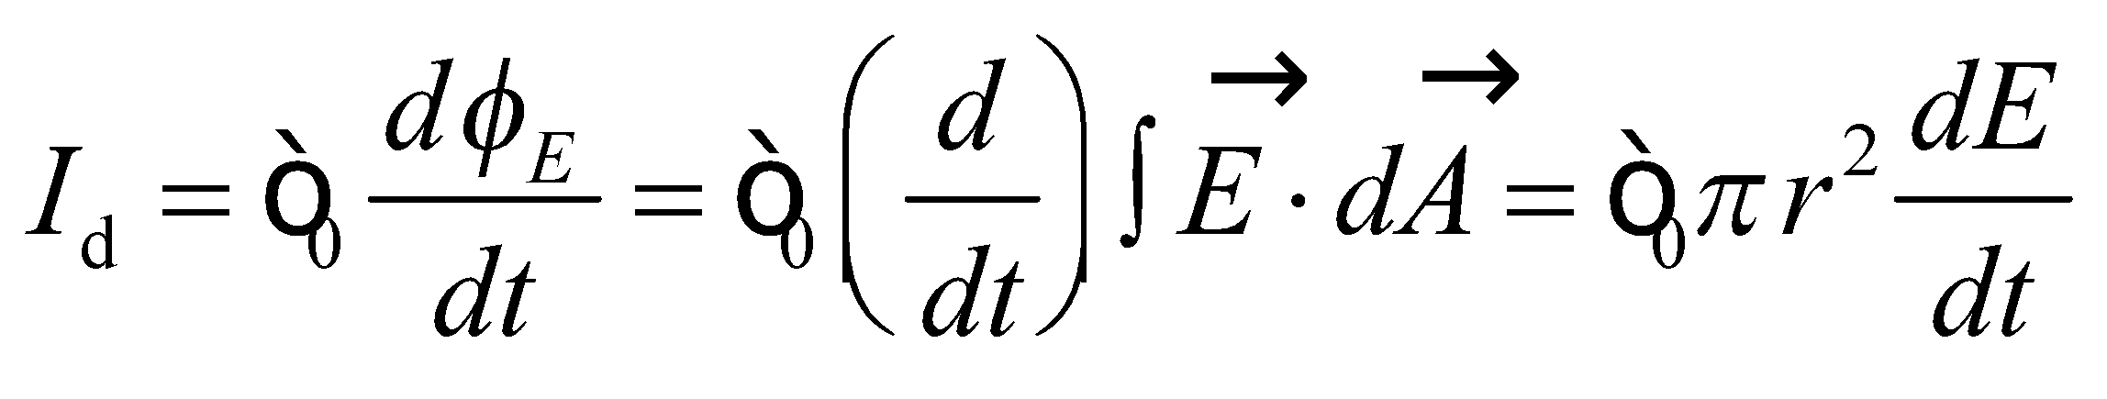

where the integral is over a disk of radius *r* centered between the plates. Maxwell’s form of Ampère’s law gives

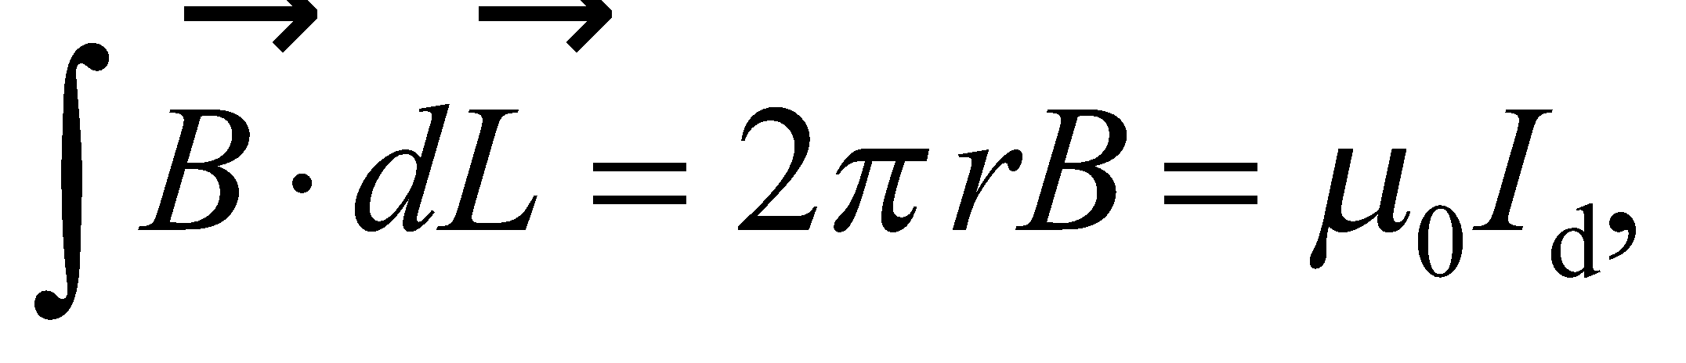

where the line integral is around the circumference of the disk. Thus,

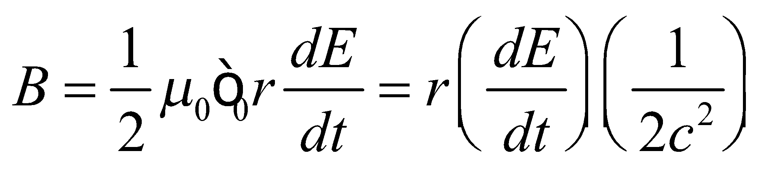

where *c* is the speed of light (Equation 29.16a).

**Evaluate** **(a)** On the symmetry axis, *r* = 0, so *B* = 0.

**(b)** For 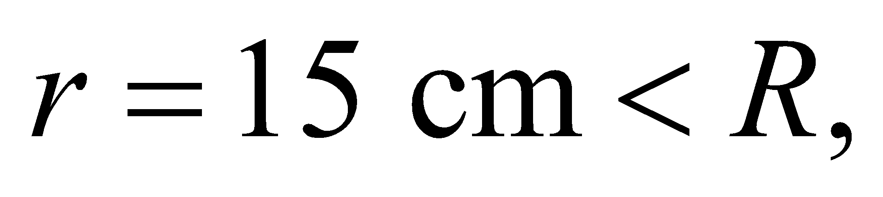

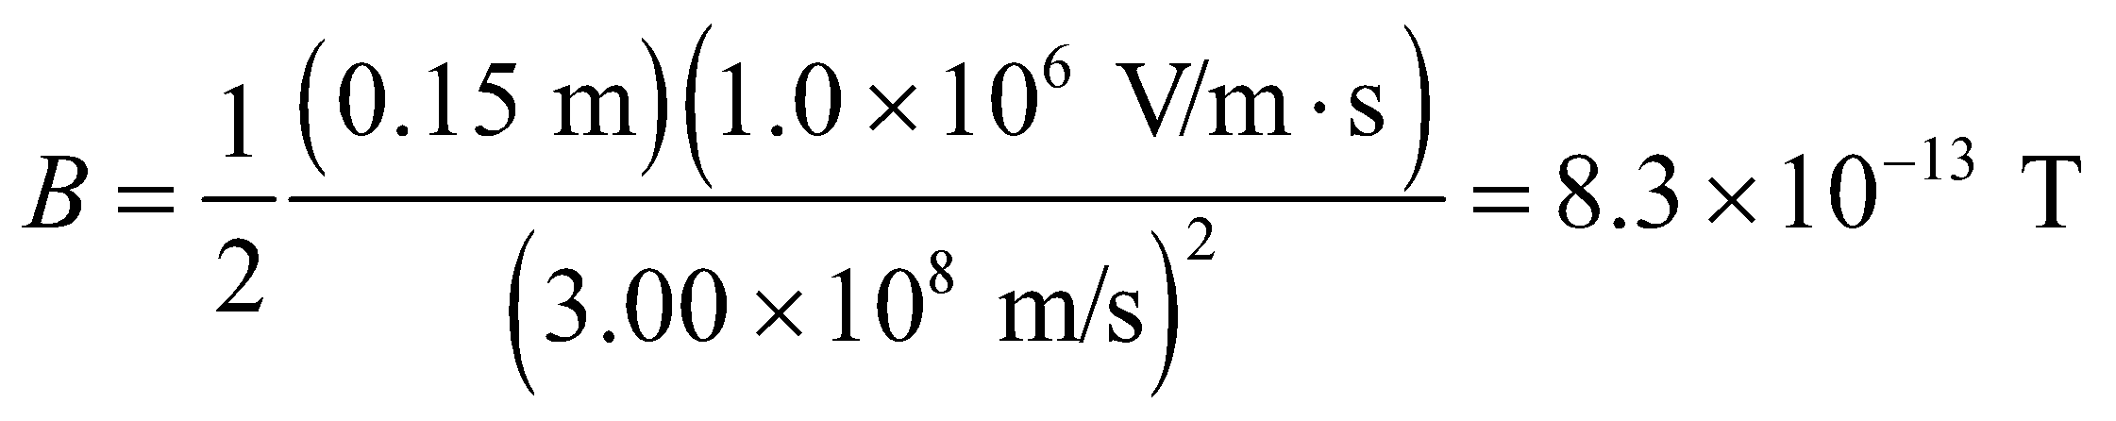

**(c)** For 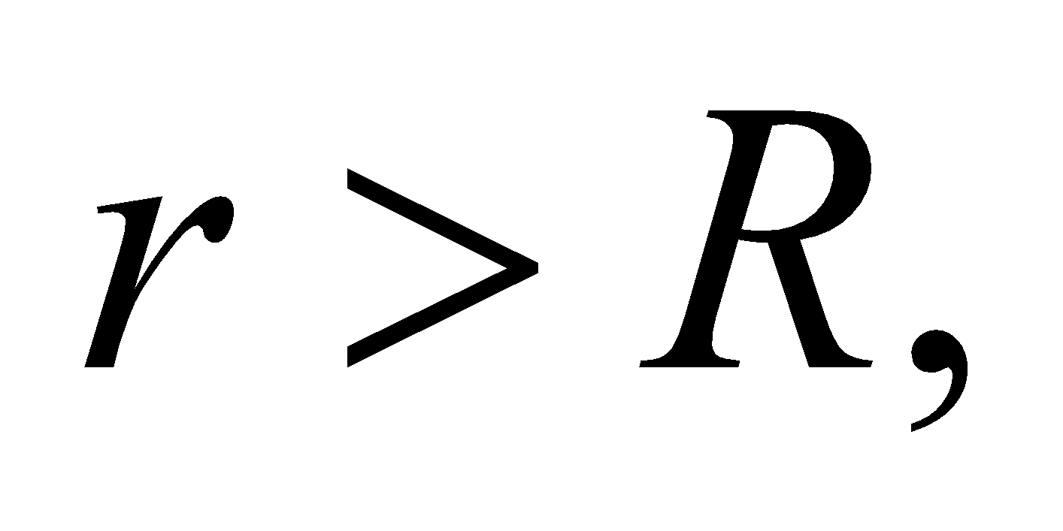 the displacement current is

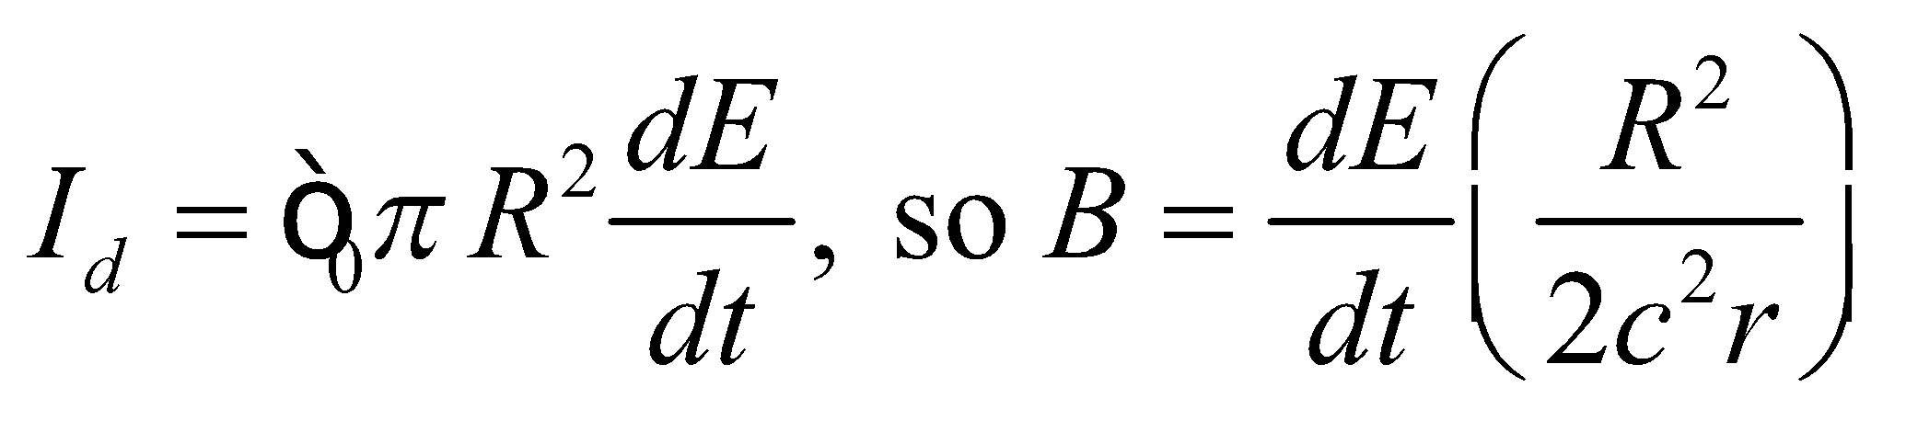

At *r* = 150 cm,

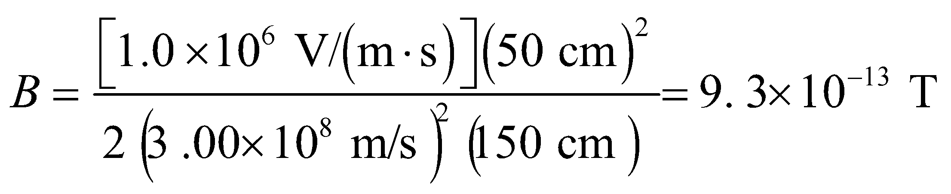

**Assess** The magnetic field strength increases from *r* = 0 to *r* = *R*, then decreases beyond *r* = *R*.

**35. Interpret** This problem is about the rate of change of electric field, which induces a magnetic field. Given the magnetic field strength at 50 cm from the center, we are to find the rate of change of the electric field and whether it is increasing or decreasing.

**Develop** The electric and magnetic fields are related by Equation 29.1. If we evaluate the integrals around the circular field line of radius *r* shown in Figure 29.15, and the plane area it bounds, we obtain:

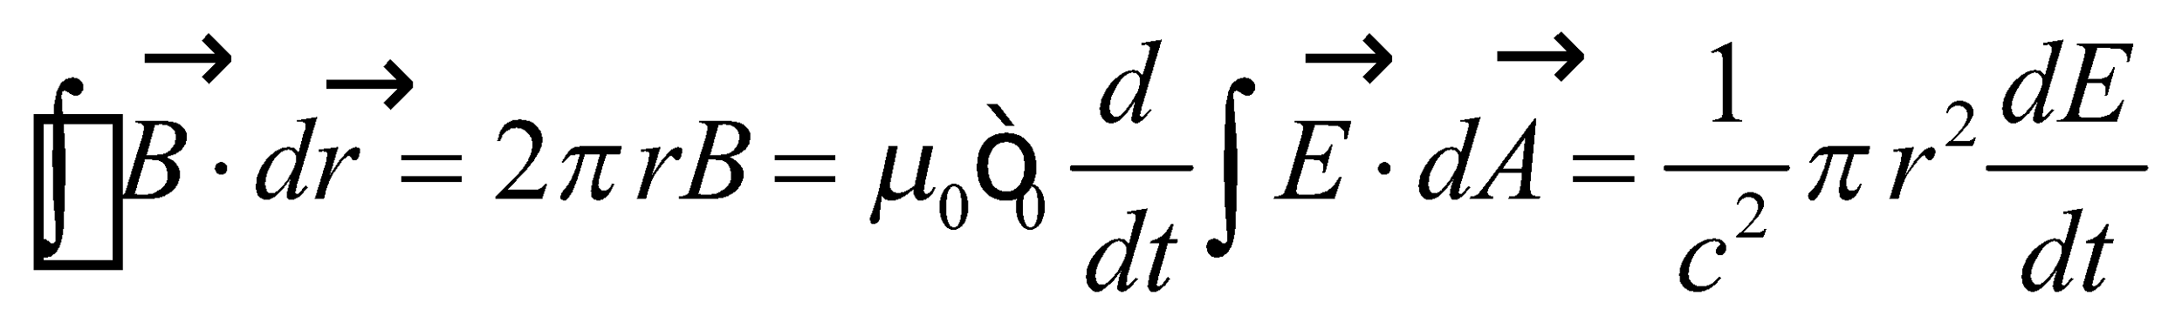

where we have used 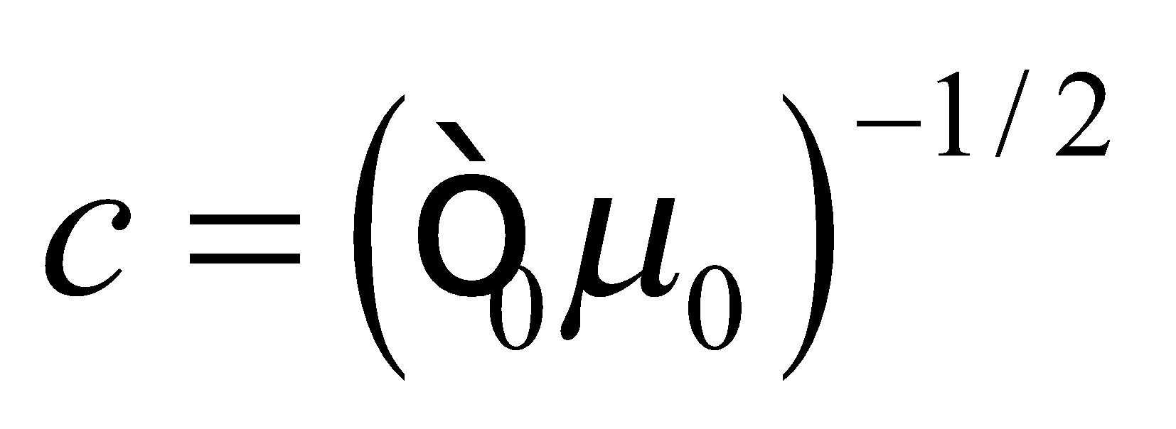

**Evaluate** **(a)** Thus, the rate of change of electric field is

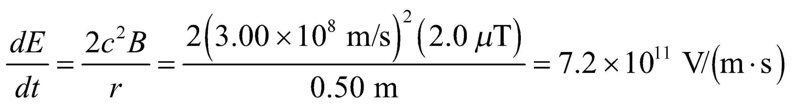

**(b)** A circulation of  clockwise around the circle gives a positive displacement current into the page, so  is increasing in this direction.

**Assess** Any change in electric flux results in a displacement current that produces a magnetic field. The displacement current encircled by the loop of radius *r* = 0.5 m is

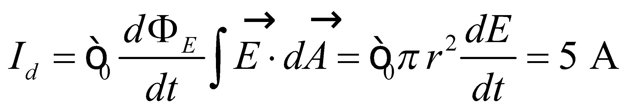

This is precisely the current a long wire must carry in order to produce the same magnetic field strength at a distance *r* = 0.5 m from its center.

**36. Interpret** You want to see if a new cell phone you are designing has enough room to incorporate all of its antenna.

**Develop**The proposed antenna will need a length of 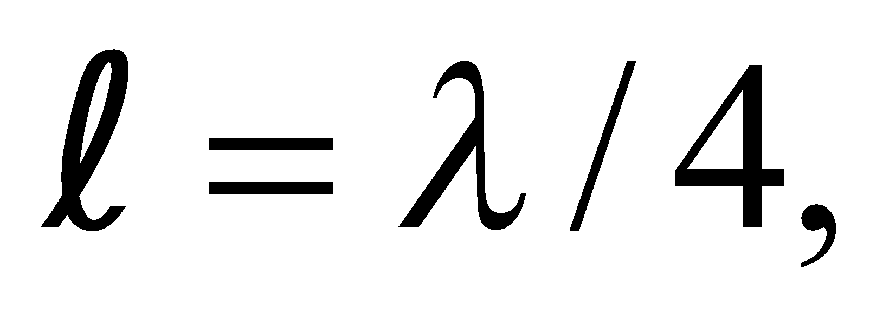where the wavelength corresponds to the signal frequency, 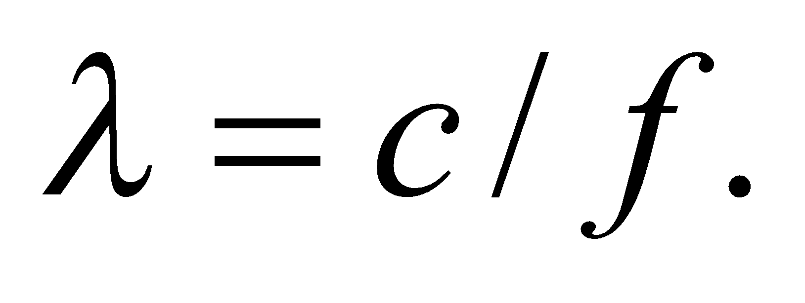

**Evaluate**The antenna’s length is

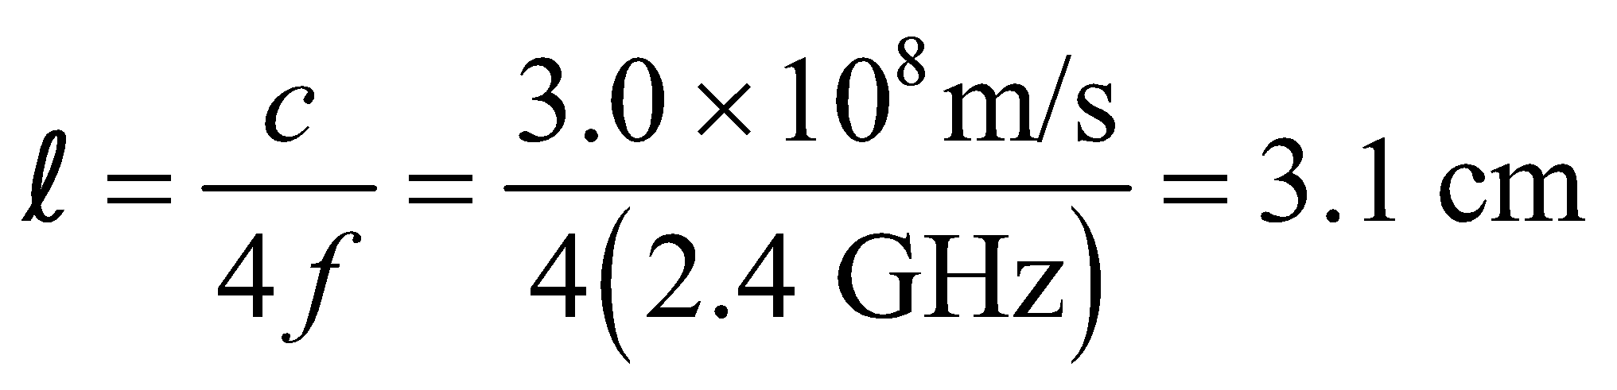

This means there’s plenty of room in the 9-cm cell phone for the quarter-wavelength antenna.

**Assess** There’s even enough room for an antenna that is half a wavelength long. Choosing quarter- or half-wavelength antennas makes tuning easier, since the resonant frequency of the antenna will be some integer fraction of the cell phone frequency.

**37. Interpret** The problem simply asks what frequencies correspond to the UVB wavelength range.

**Develop**The frequency is inversely proportional to the wavelength: 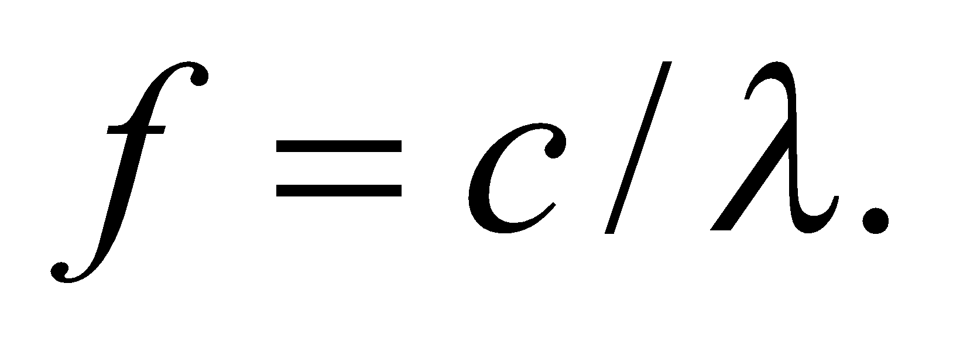

**Evaluate**The limits of the UVB band in frequency are

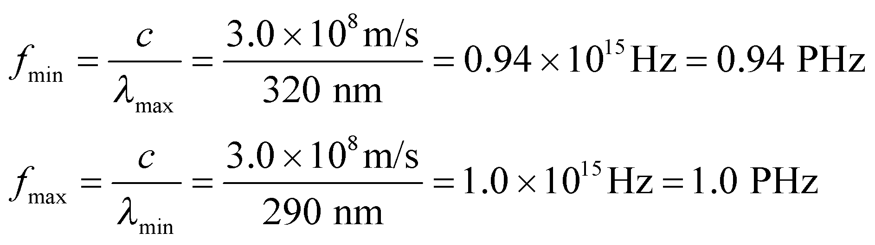

**Assess** Since most people are more familiar with nanometers than with petahertz, the wavelength limits for UV radiation are more often given than the frequency limits.

**38.** **Interpret** We are to find the magnetic field strength of an electromagnetic wave that produces dielectric breakdown in air.

**Develop** Treating electromagnetic waves in air approximately like those in vacuum, we can apply Equation 29.17, 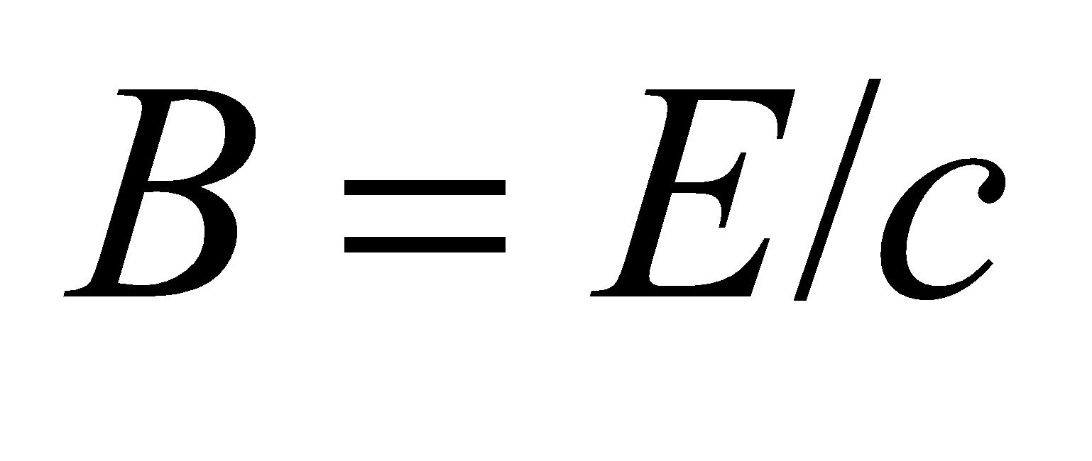 to find the magnetic field strength associated with an electric field strength of 3 MV/m.

**Evaluate** The magnetic field strength is approximately

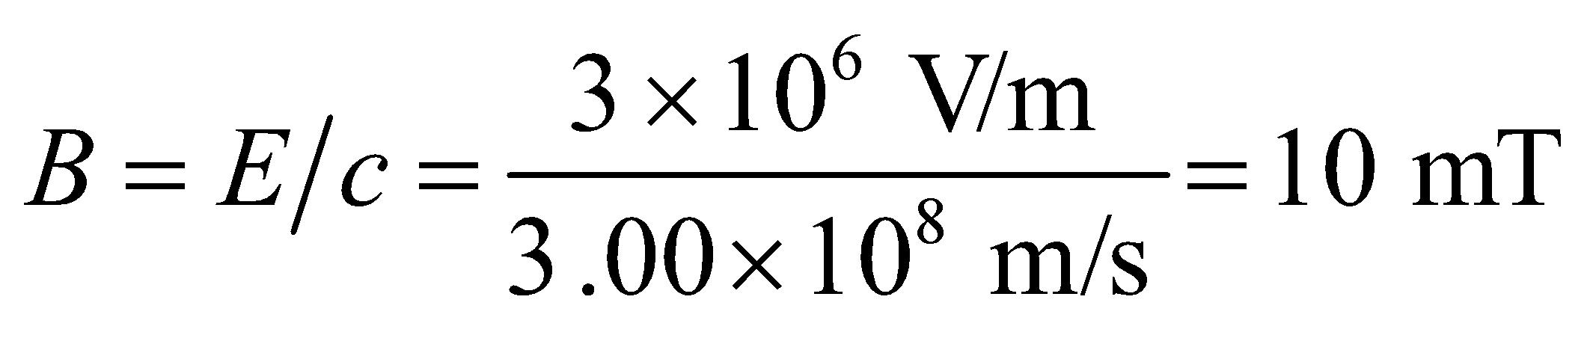

**Assess** This is some three orders of magnitude larger than the strength of the magnetic field at the surface of the Earth, which ranges from 30 to 60 μT.

**39. Interpret** Given the electric field strength, we are asked to find the corresponding magnetic field strength for an electromagnetic wave propagating in air, which we can treat as a vacuum.

**Develop** For an EM wave in free space, Equation 29.17 gives 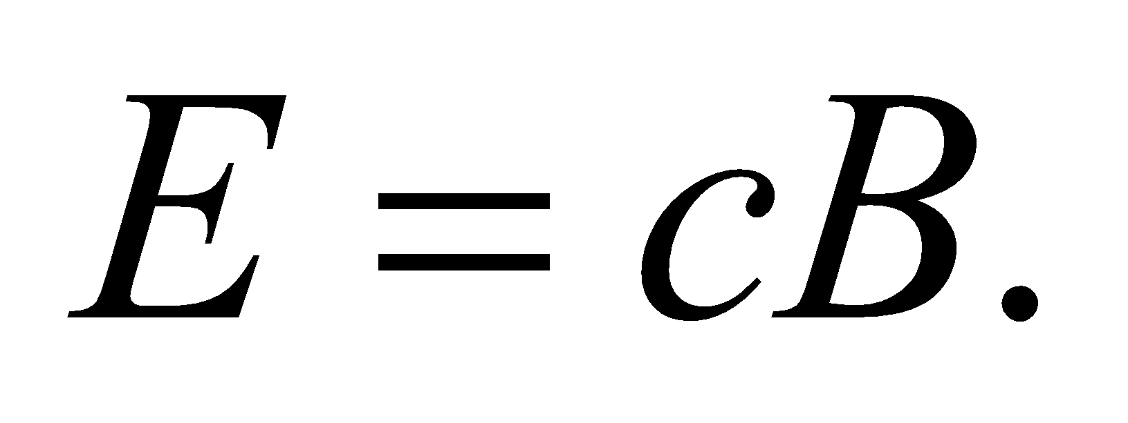

**Evaluate** Given that 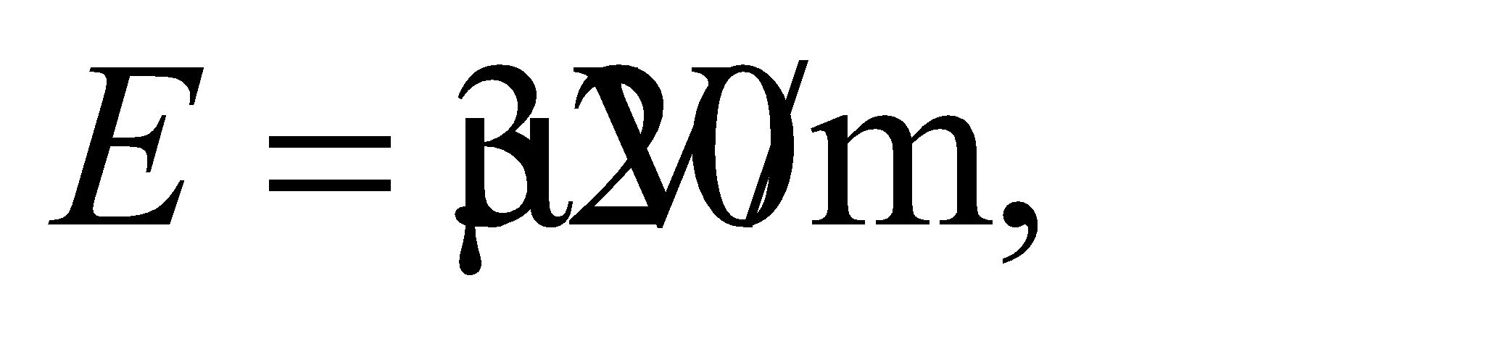 the corresponding magnetic field strength is

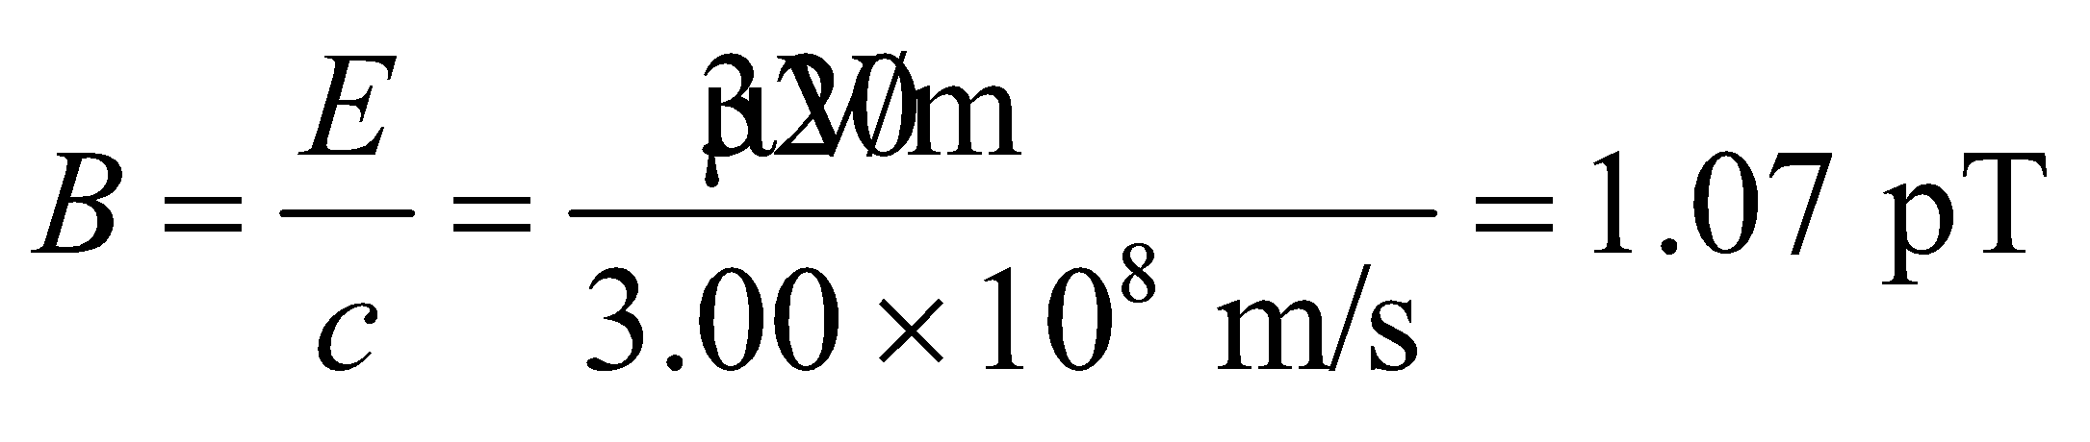

**Assess** This is a very small magnetic field. Note that in an EM wave, both the field strengths *E* and *B* are not independent; once one quantity is determined, the other can be found via the relation 

**40.** **Interpret** We are to find the angle between a polarizer’s axis and the polarization direction of an electromagnetic wave given that the polarizer blocks 75% of the wave.

**Develop** Apply the Law of Malus (Equation 29.18).

**Evaluate** Equation 29.18 gives 

**Assess** The angle must be between 0 and *π*/2.

**41. Interpret** This problem involves finding the fraction of light transmitted through a polarizer as the direction of the incident polarization changes.

**Develop** The fraction of light transmitted can be found by using the Law of Malus (Equation 29.18),  where *θ* is the angle between the polarization direction (i.e. the direction of the electric field) in the electromagnetic wave and the polarization direction of the polarizer. Note that, with zero voltage applied, the laser beam polarization is perpendicular to the polarizer, so zero light is transmitted. During the brown out, the electro-optic modulator manages to rotate the polarization 72°, which is 18° short of the 90° rotation needed to pass 100% of the laser light through the polarizer. In the Law of Malus, the angle *θ* measures the angular departure from parallel alignment (i.e., when there is 100% transmission), so we must use *θ* = 18° in our calculation.

**Evaluate** From Equation 29.18, we find that 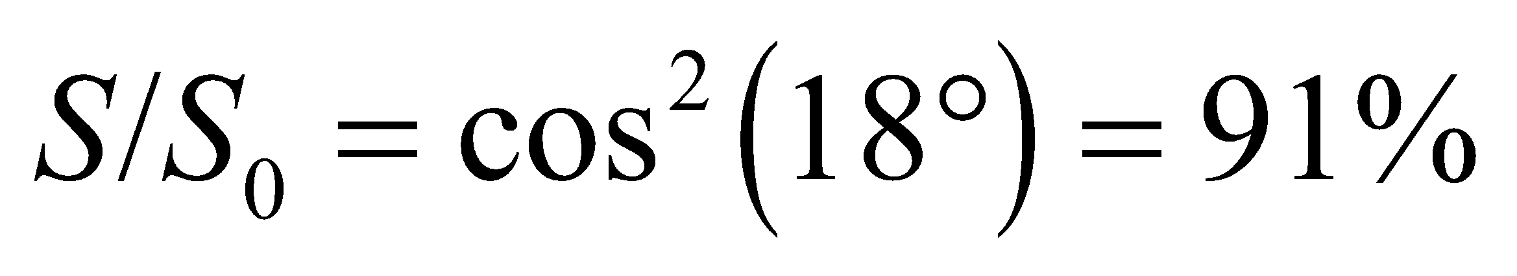 is transmitted.

**Assess** The intensity of the laser beam depends on  The limit *θ* = 0 corresponds to the situation where the direction of polarization of the laser beam is the same as the preferred direction specified by the polarizer, and 

**42.** **Interpret** We are to find the intensity of an initially unpolarized light beam after it passes through two linear polarizers oriented at the given angle.

**Develop** Only 50% (one half the intensity) of the unpolarized light is transmitted through the first polarizer, and the second cuts this down by 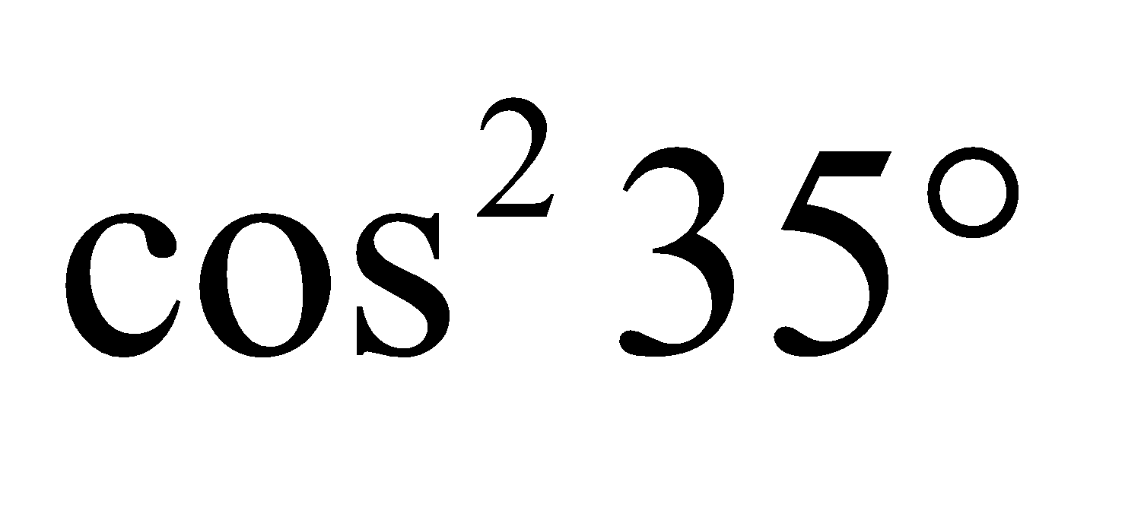 (Law of Malus, Equation 29.18).

**Evaluate** Therefore 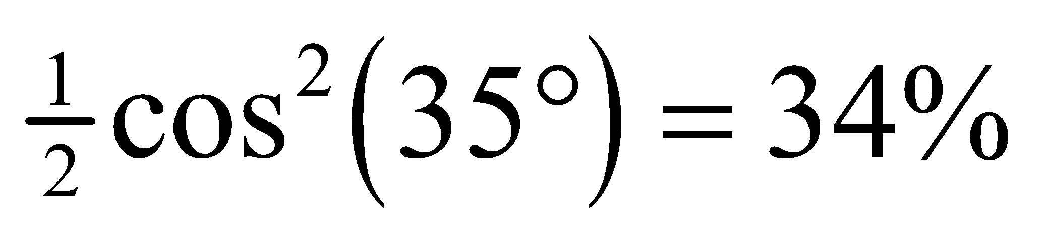 of the unpolarized intensity gets through both polarizers.

**Assess** Most of the intensity is lost transiting the first polarizer.

**43. Interpret** We are to find the intensity of a light beam after passing through two polarizers that are oriented at different angles to the polarization direction of the light. Note that the second polarizer is oriented perpendicular to the initial polarization, so we may expect that no light is trasmitted.

**Develop** The intensity of the light after emerging from the first polarizer is given by the Law of Malus (Equation 29.18), 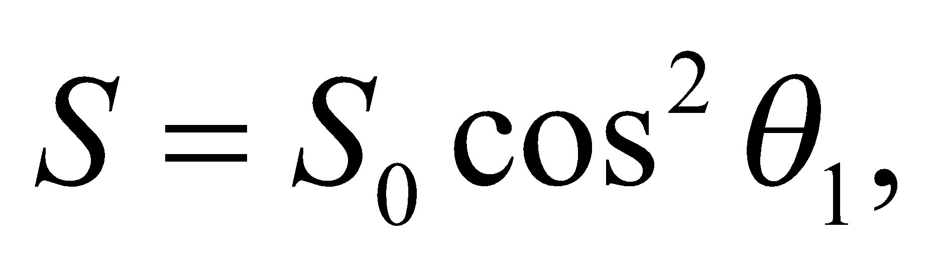 where *θ*1 is the angle between the electric field and the first polarizer’s axis. After passing through the first polarizer, the electric field is rotated to the angle *θ*1 and so makes an angle *θ*2 – *θ*1 with the axis of the second polarizer. Thus, the intensity of the light transmitted through both polarizers is

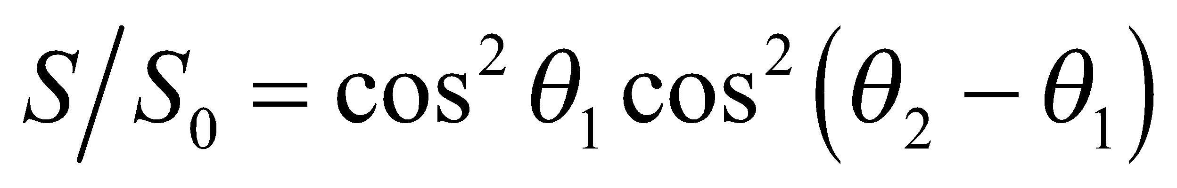

**Evaluate** Two successive applications of Equation 29.18 yield

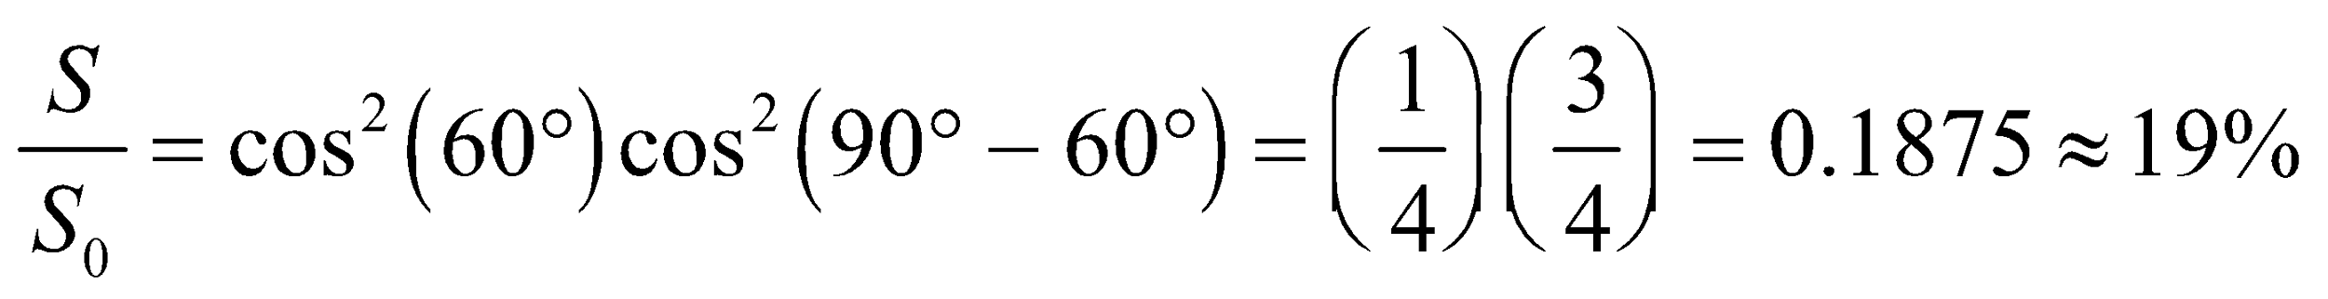

**Assess** To see that the result makes sense, let’s solve the problem in two steps. The intensity of the beam after passing the first polarizer with 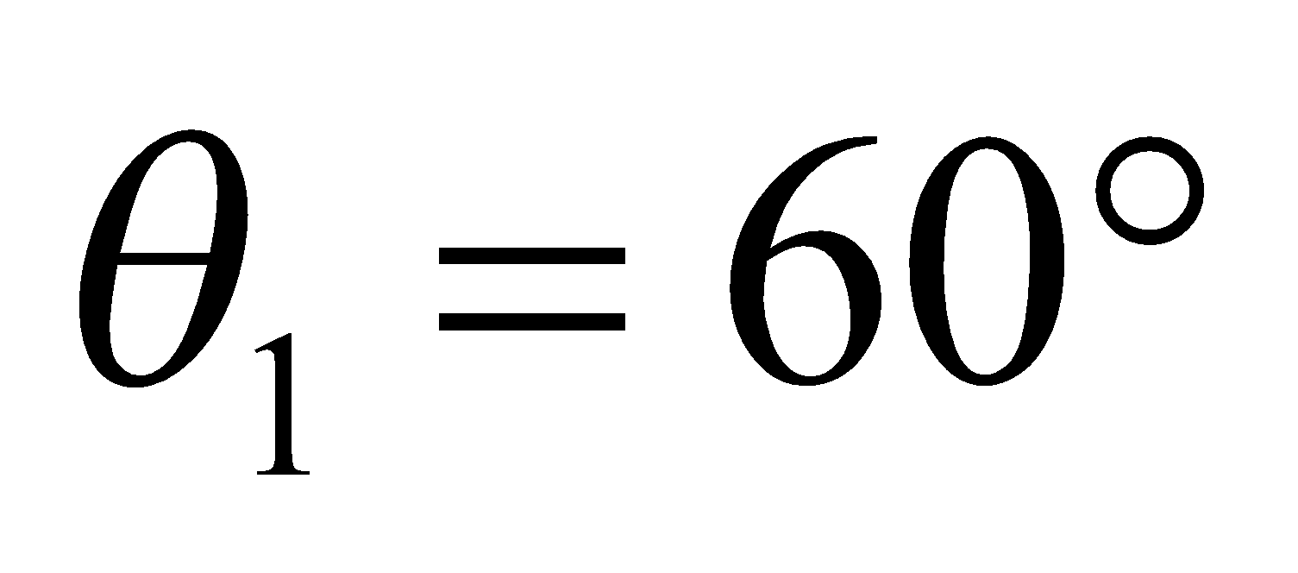 is 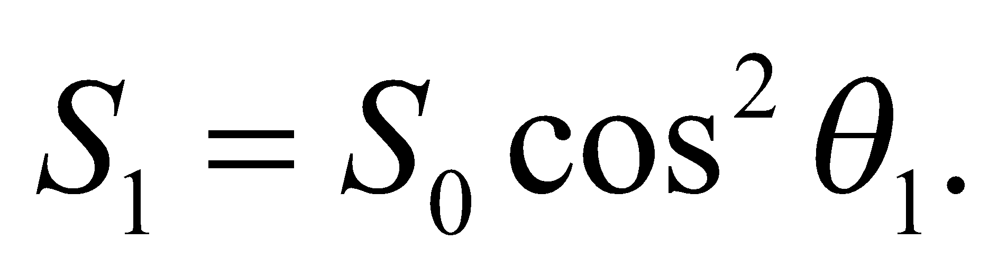 Since the angle between the first and the second polarizers is 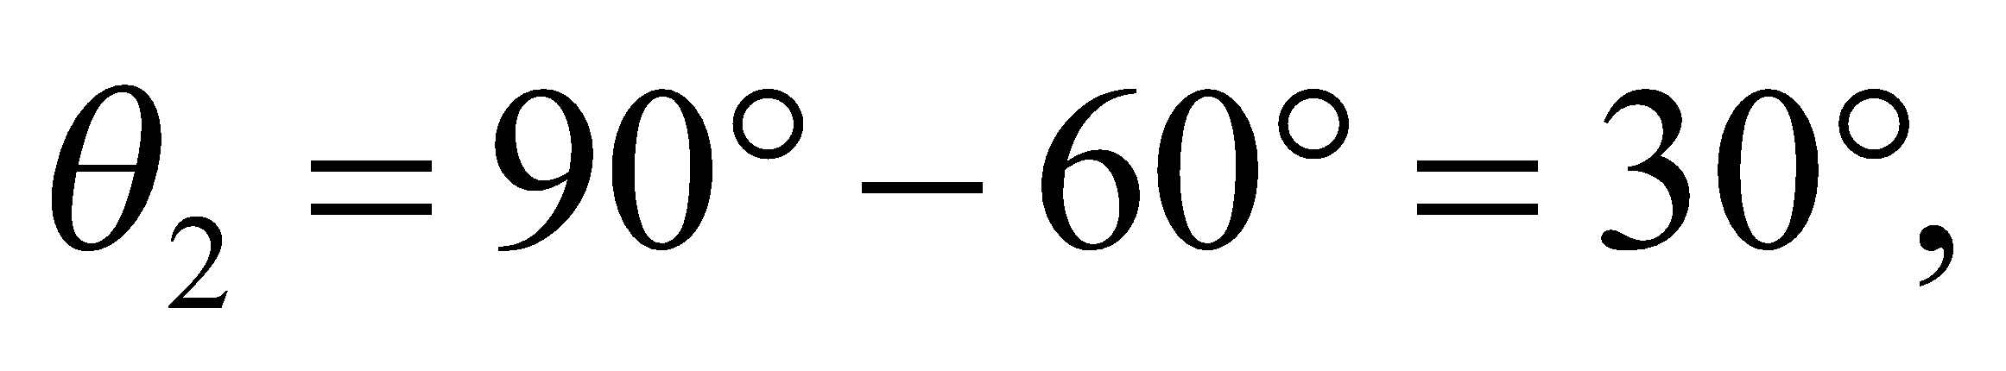 so upon emerging from the second polarizer, the intensity becomes

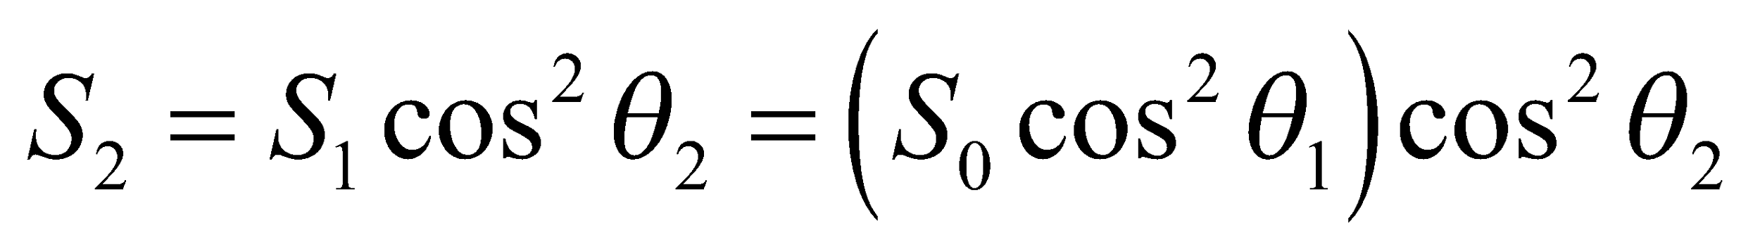

which is the same as above.

**44.** **Interpret** We are to use Gauss’s law and Faraday’s law to show that it is not possible for the electric field to have a time-varying component in the direction of the magnetic field.

**Develop** Consider a wave propagating in the *x*-direction through a vacuum (no charges or currents present), as illustrated in the figure below. Gauss’s laws for electricity and magnetism require the field lines to continue forever in the *y-z* plane (no *Ex* or *Bx*) because the integral on the right-hand side of Gauss’s laws (Equations 29.6 and 29.7) can be taken over *any* closed surface. We may choose the *z*-direction parallel to the magnetic field, 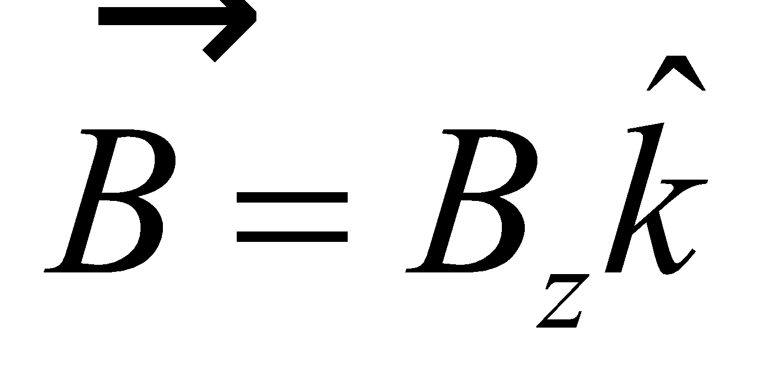. Suppose 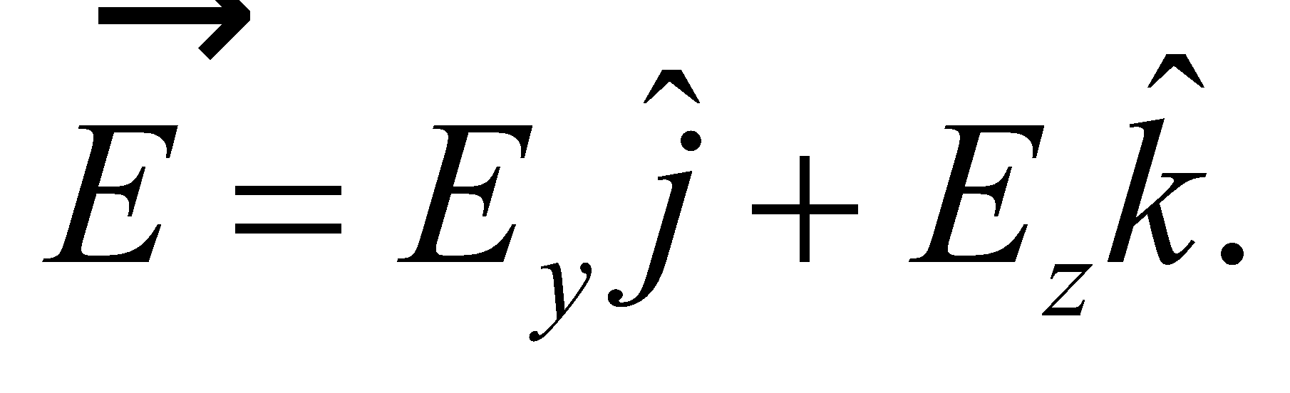 The discussion of Faraday’s law leading to Equation 29.12 shows that 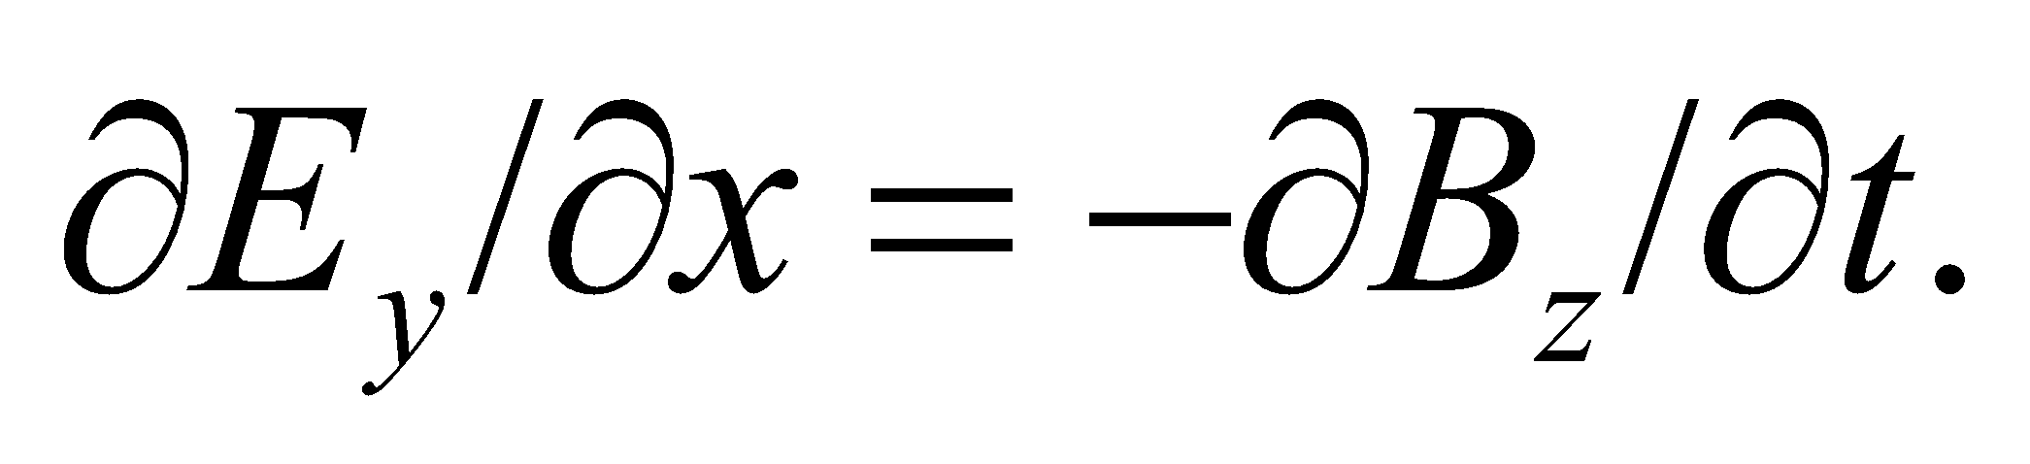



**Evaluate** Consider a corresponding loop in the *x*-*z* plane, as shown above. Then 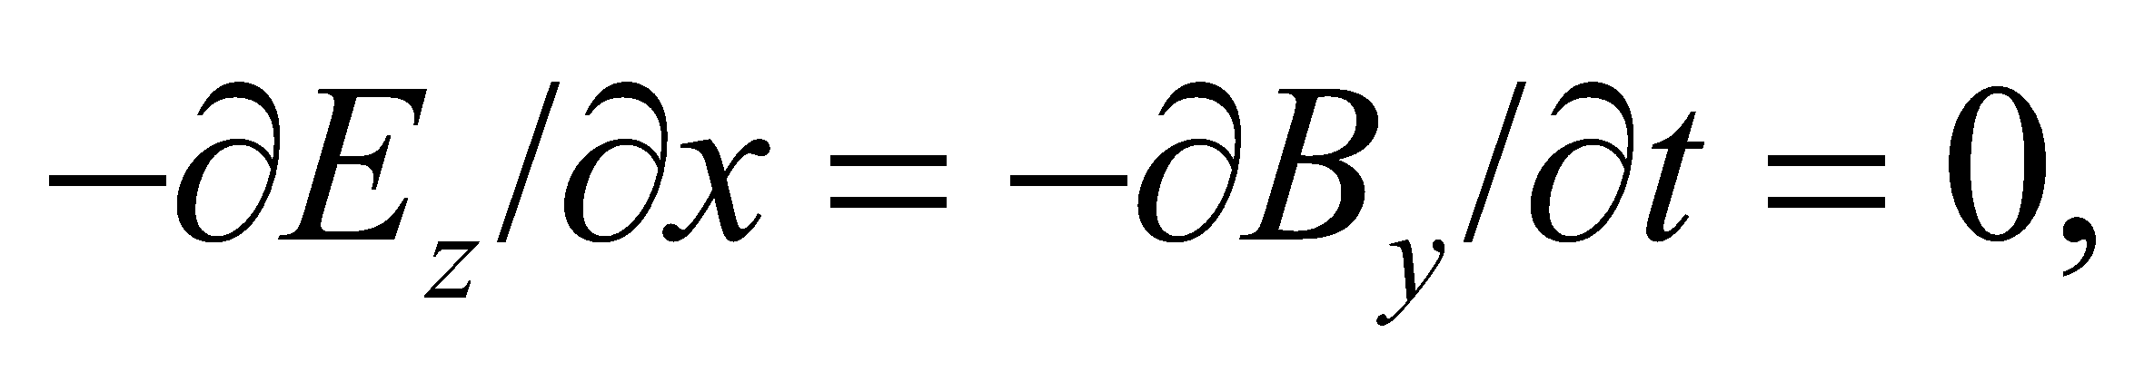 since there is no 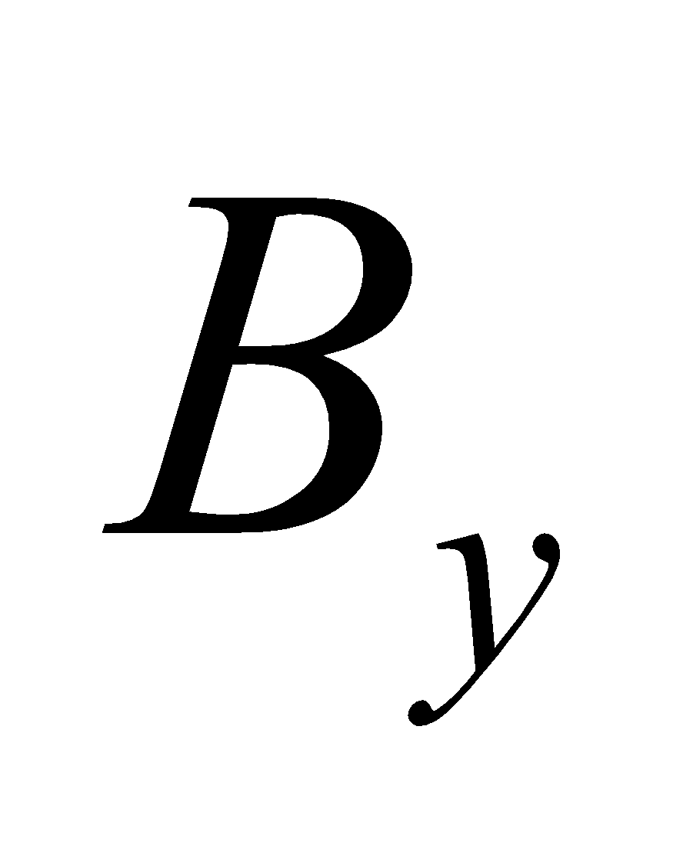 by assumption. Thus 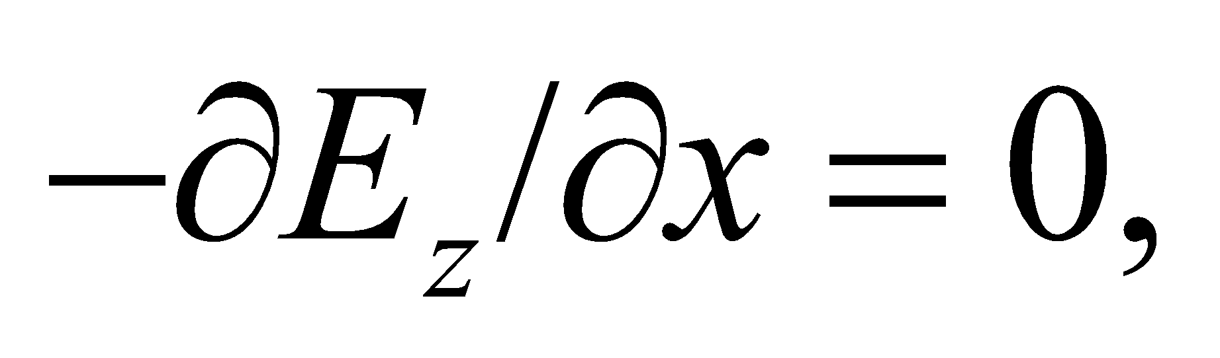 and *Ez* must be a constant, so it cannot be part of the wave.

**Assess** Similar consideration of Ampère’s law over the loop in the *x-y* plane gives 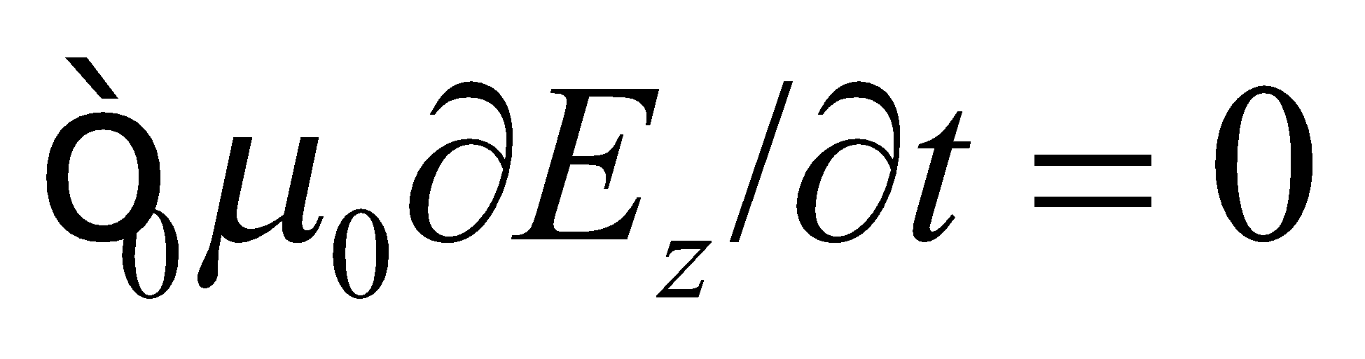 directly, with the same conclusion regarding 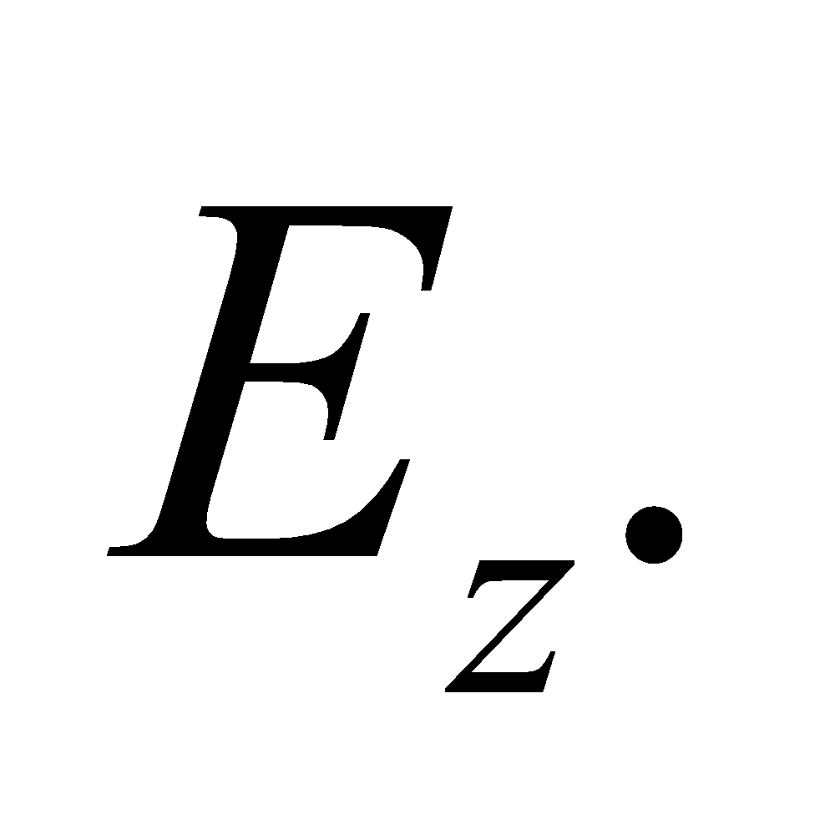

**45. Interpret** We want to determine how much of a microwave oven’s radiation can leak out its door and still be below regulation standards.

**Develop**If we assume power is leaking uniformly out the door, then the maximum power allowed is just the intensity limit multiplied by the area: 

**Evaluate**The fraction of power that is allowed to leak out the oven door is

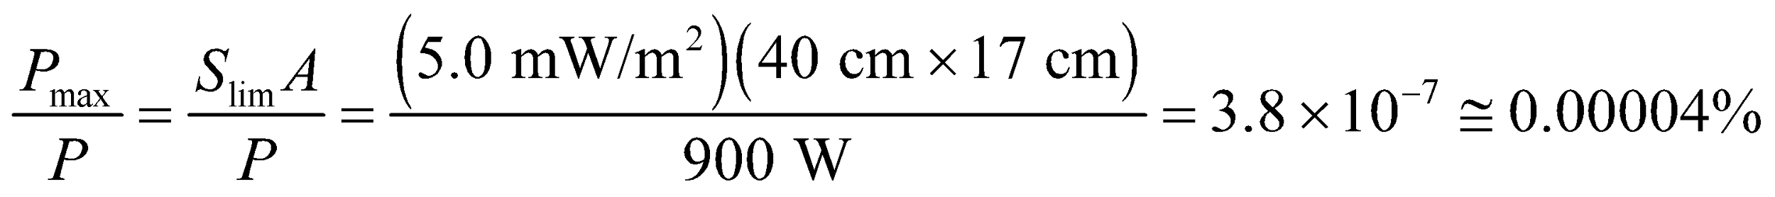

**Assess** This is less than one part in a million. It might be surprising, therefore, that a metal screen with holes in it could provide this good of protection. The holes in the metal are much smaller than the microwave wavelength 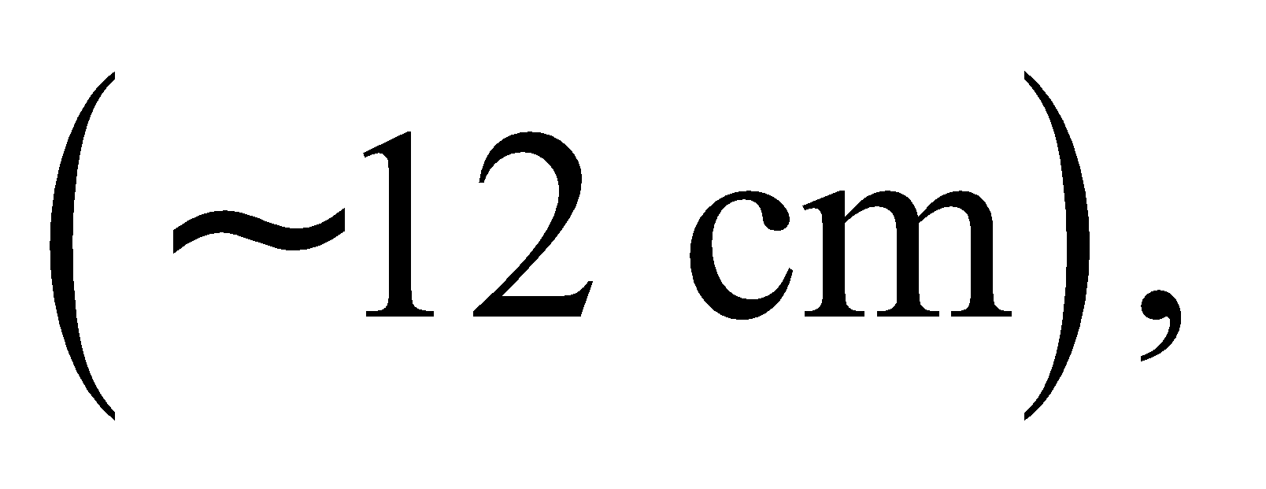 which means very little of the radiation can pass through.

**46.** **Interpret** From the astronomical data in Appendix E and the given intensity of the Sun’s radiation at the surface of the Earth, we are to estimate the Sun’s total power output.

**Develop** If the Sun emits isotropically, its power output is 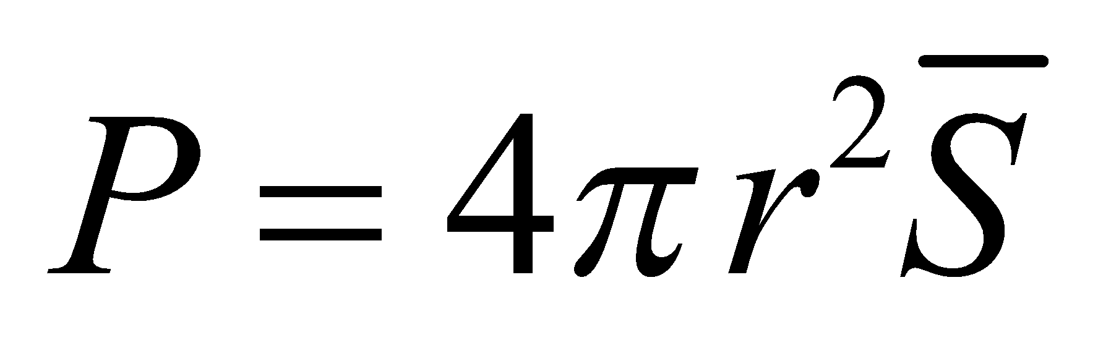 (from Equation 29.21). A sphere with a radius of one Earth orbit has a surface of 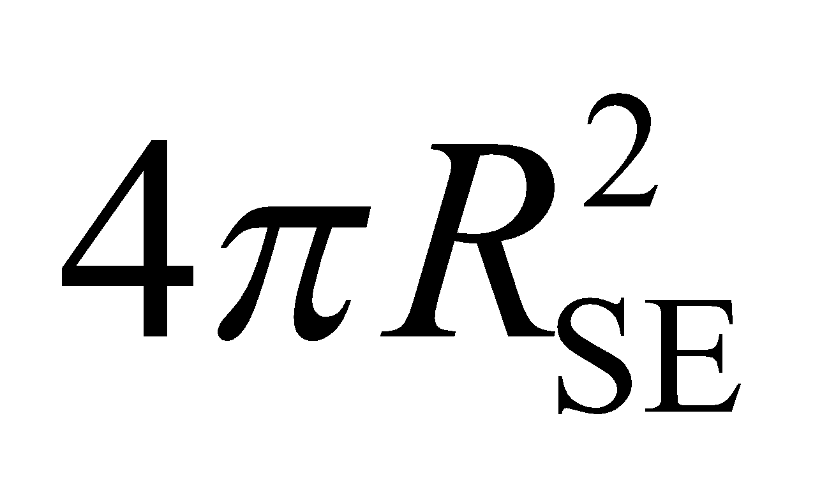, so the total power is the power *P*E in one square meter multiplied by the total surface area of this sphere.

**Evaluate** The power output of the Sun is approximately



**Assess** This is a significant power output. Note that the condition that the Sun radiates isotropically becomes better for greater distances from the Sun (or from any source, for that matter).

**47. Interpret** The problem asks for a comparison of power output between a star and a quasar. The two objects have the same brightness but are at different distances from the Earth.

**Develop** The average intensity of radiation received determines the apparent brightness, so 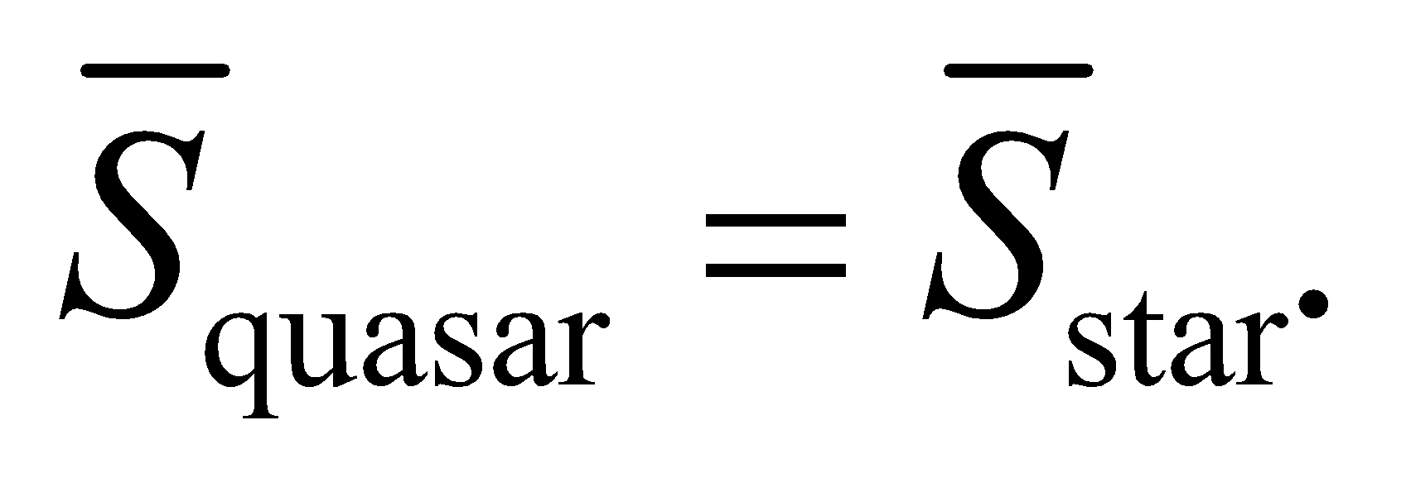 Apply Equation 29.21 to find the relative power from each source.

**Evaluate** From Equation 29.21, 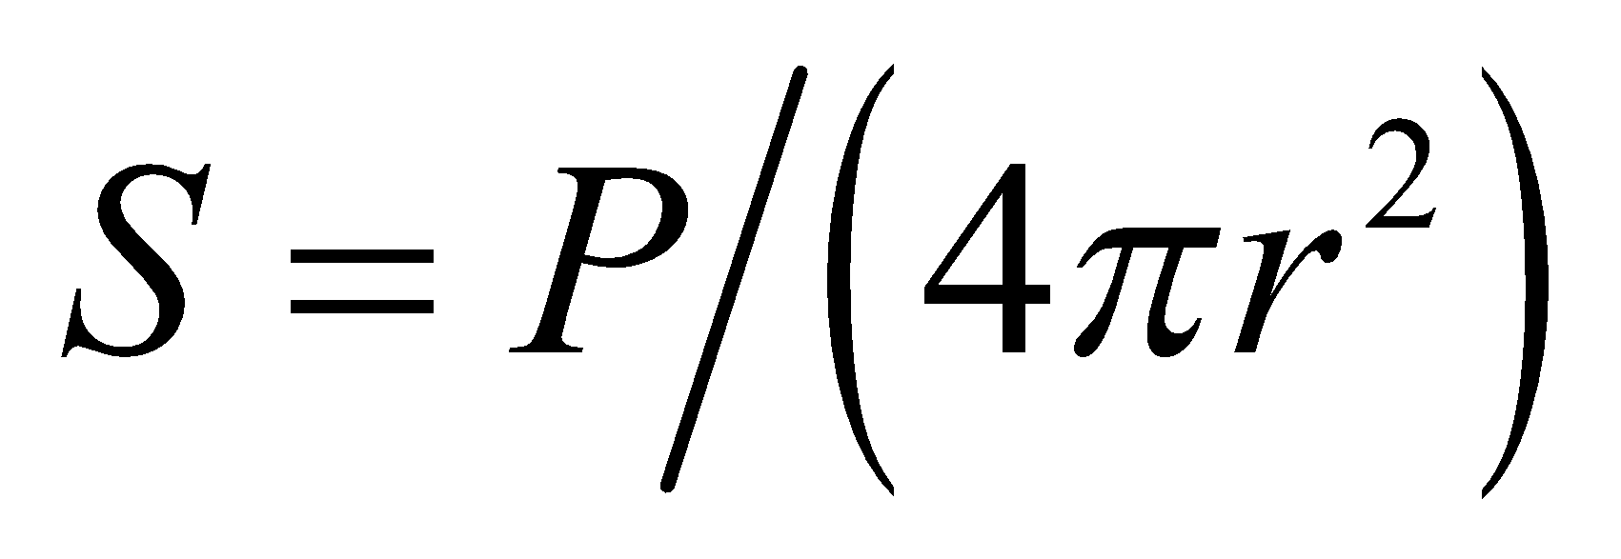 we see that the above condition implies that

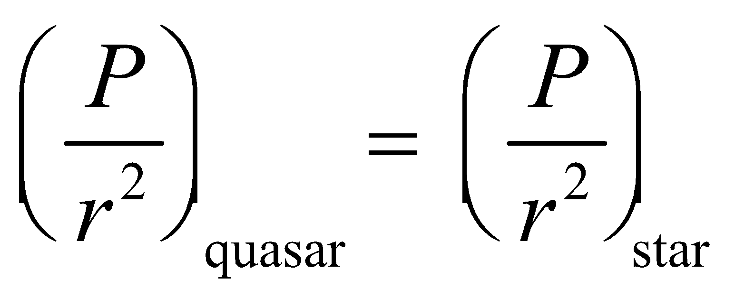

if both behave like isotropic sources (which should be a good approximation; see Problem 29.46). Thus,

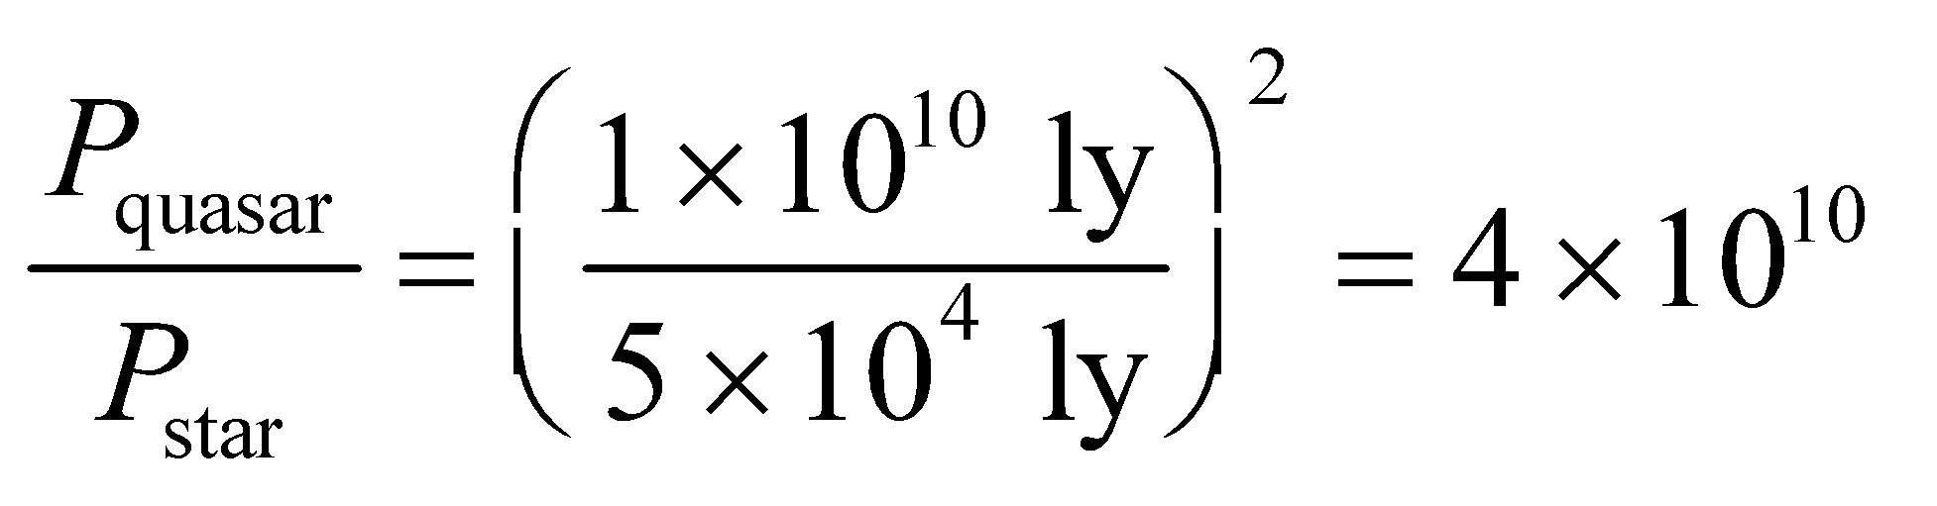

**Assess** The luminosity of a quasar is comparable to a galaxy of stars!

**48. Interpret** We’re asked to characterize the electromagnetic properties of a typical laser pointer.

**Develop**Assuming the laser’s power is distributed uniformly over the beam cross-section, then the intensity is just the power divided by the area: 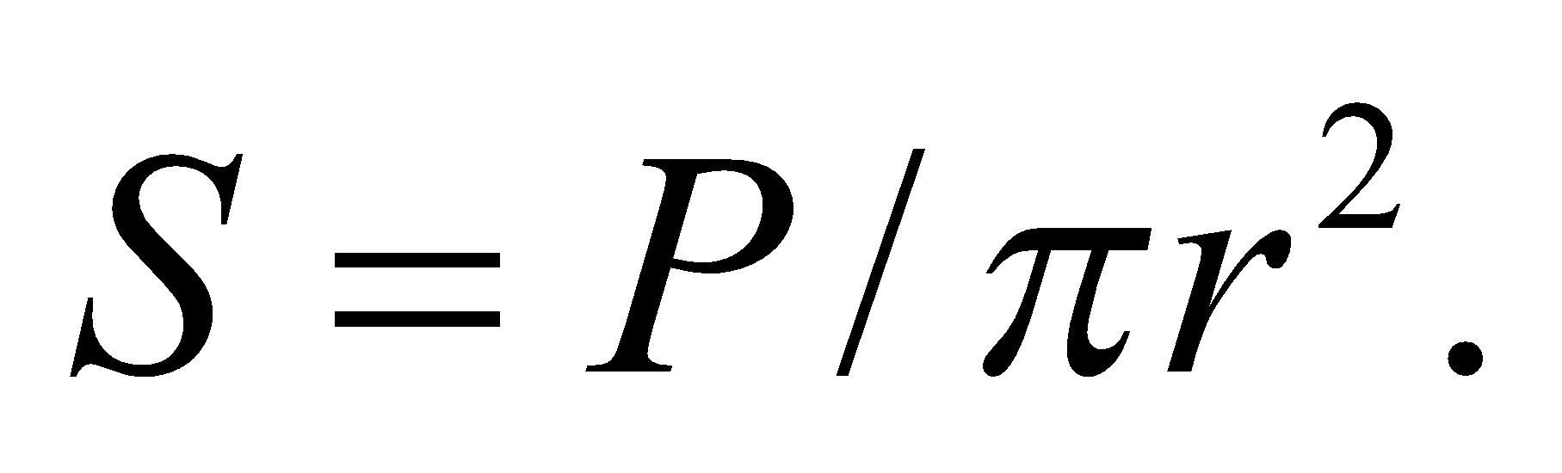 If the beam points directly into a person’s eye, the total energy delivered before the eye blinks will be 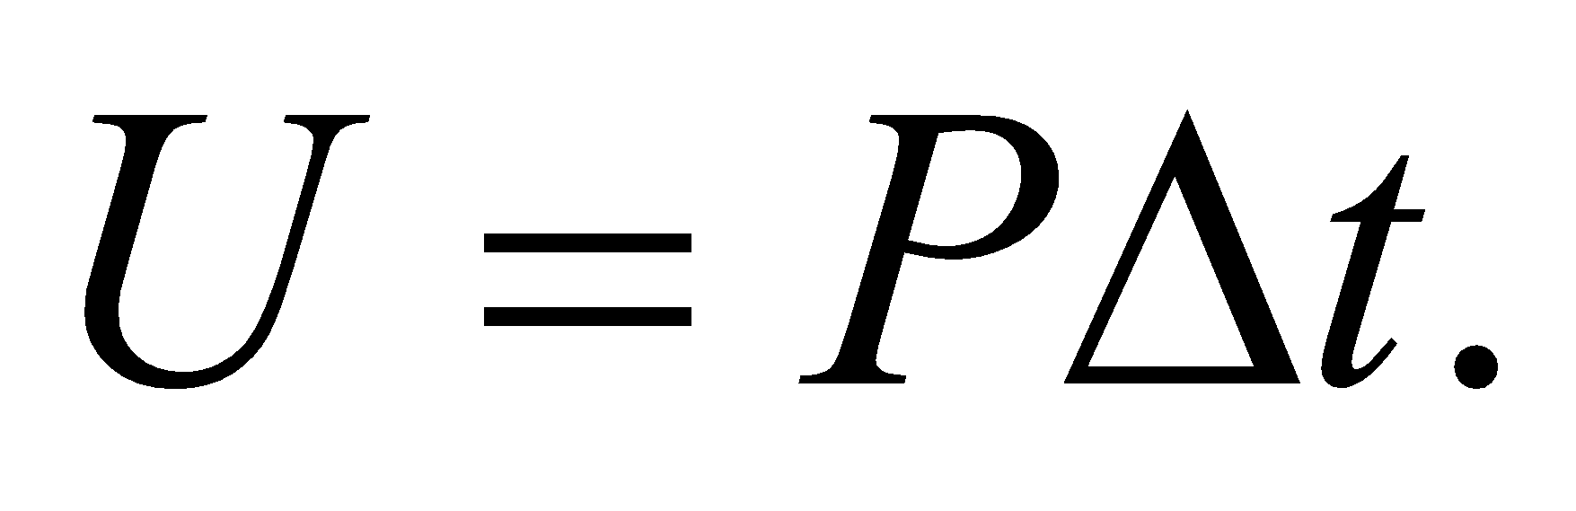 Finally, the peak electric field can be found with Equation 29.20b: 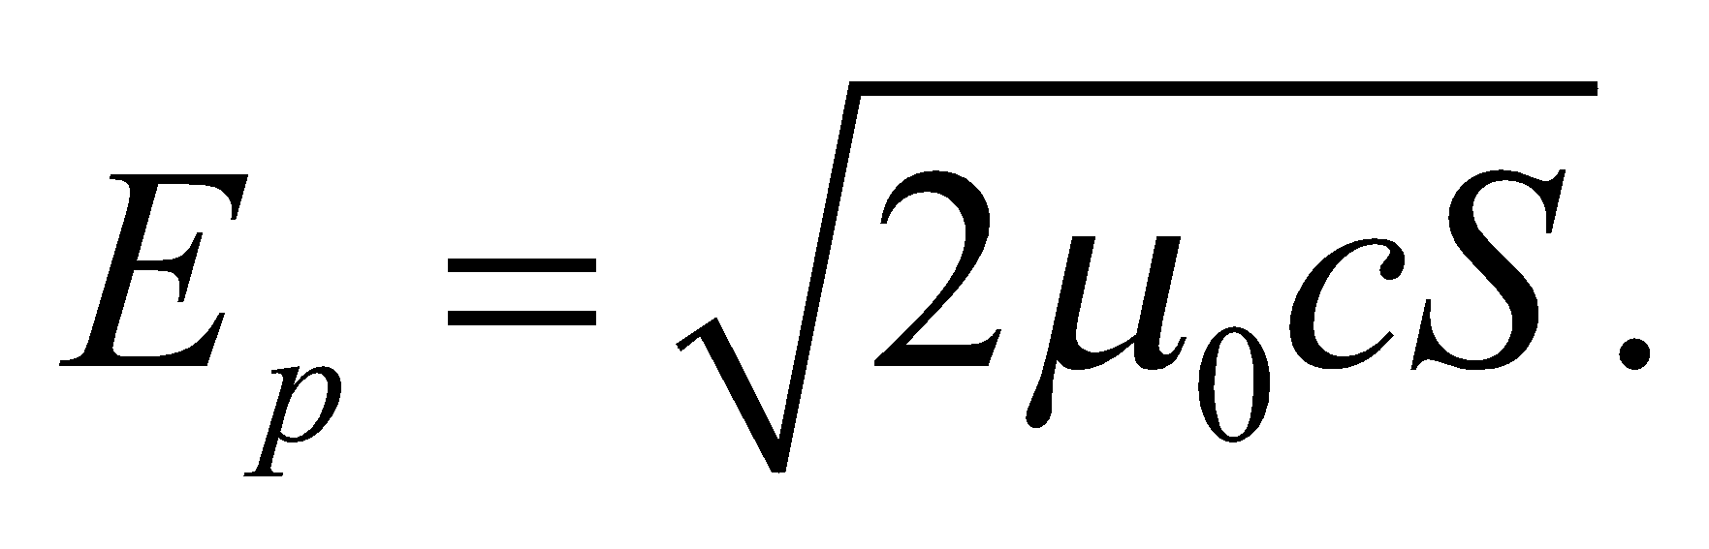

**Evaluate**(a) The laser beam intensity is

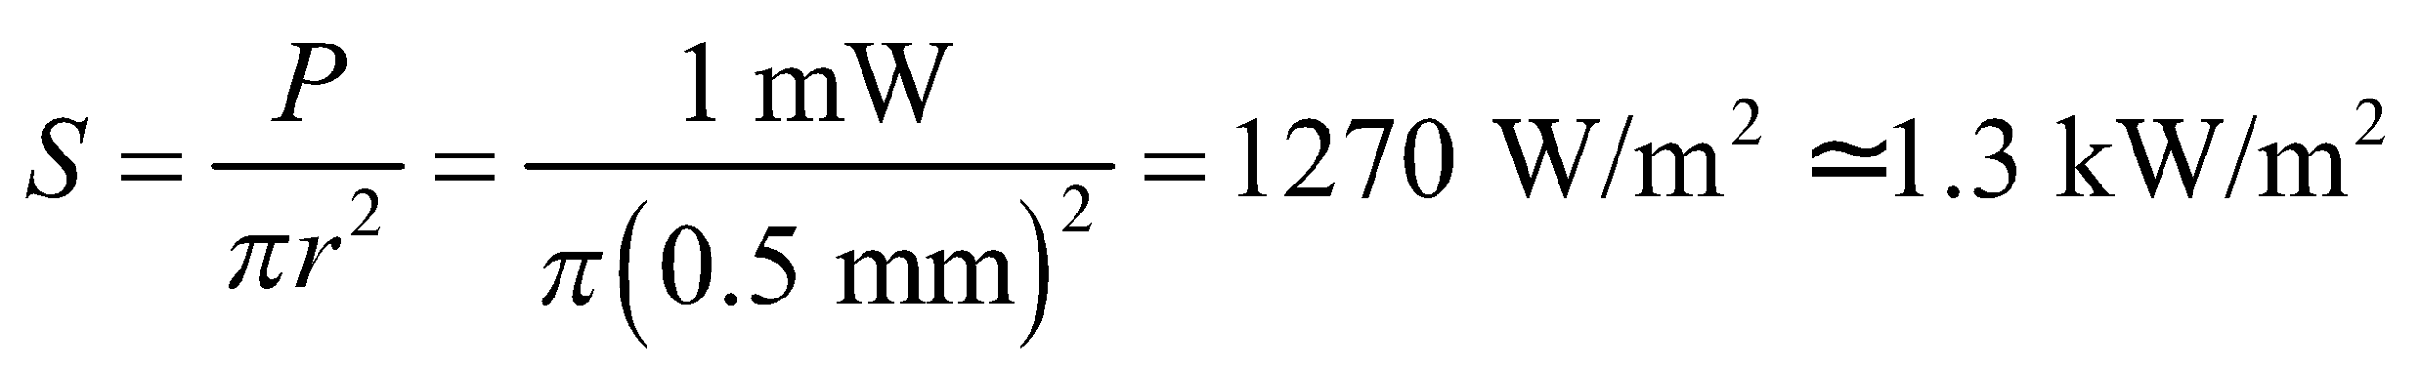

(b) The energy delivered before blinking is

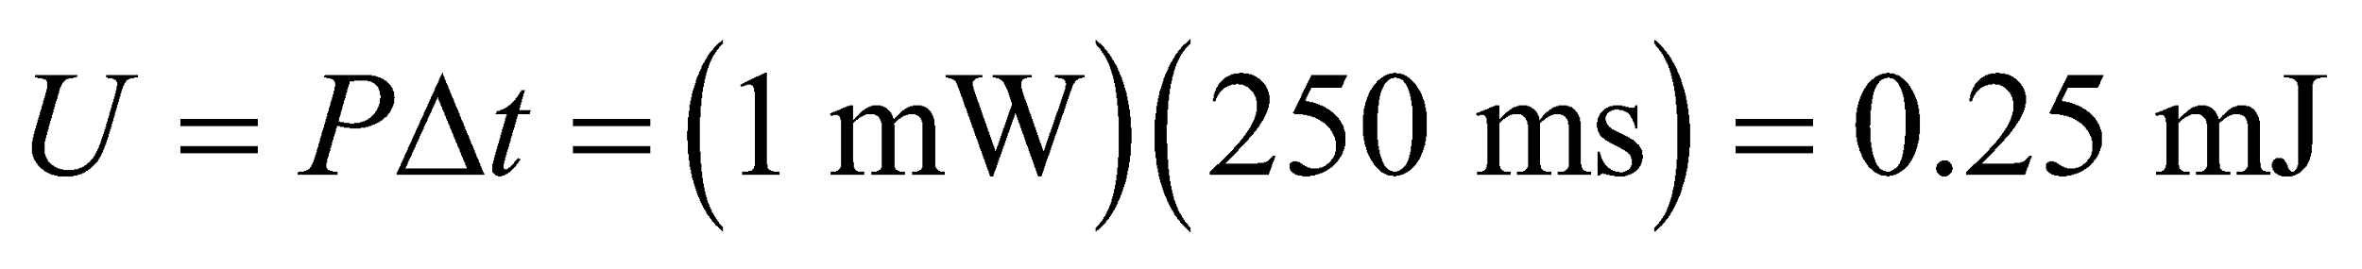

(c) The peak electric field in the laser is



**Assess** Notice that the laser pointer’s intensity is comparable to the intensity of noontime sunlight on a clear day (see Example 29.3). Both light sources can damage your eyes if you forced yourself to look at them long enough.

**49.** **Interpret** We are to find the transmitted power and the peak electric field in the given electromagnetic wave.

**Develop** Equations 29.21 and 29.20b can be combined to express the average power output of an isotropic transmitter in terms of the peak electric field at a distance r:

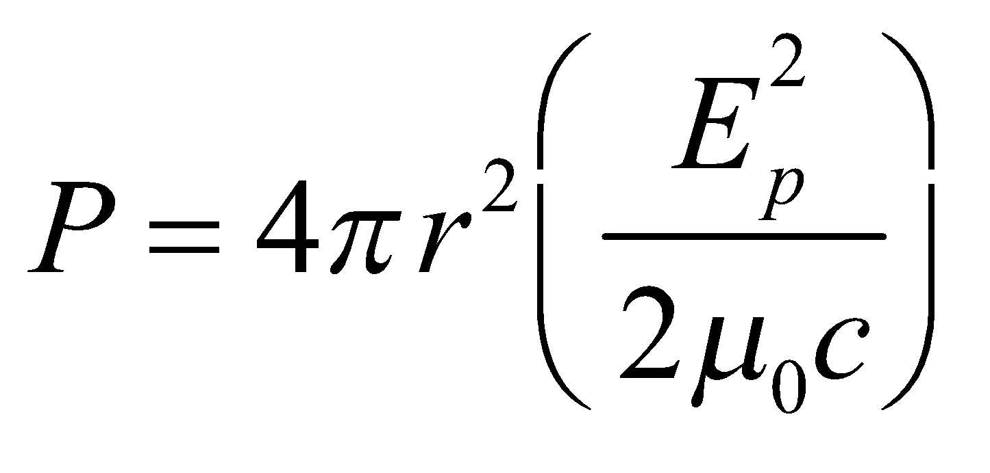

**Evaluate** (**a**) The transmitted power is

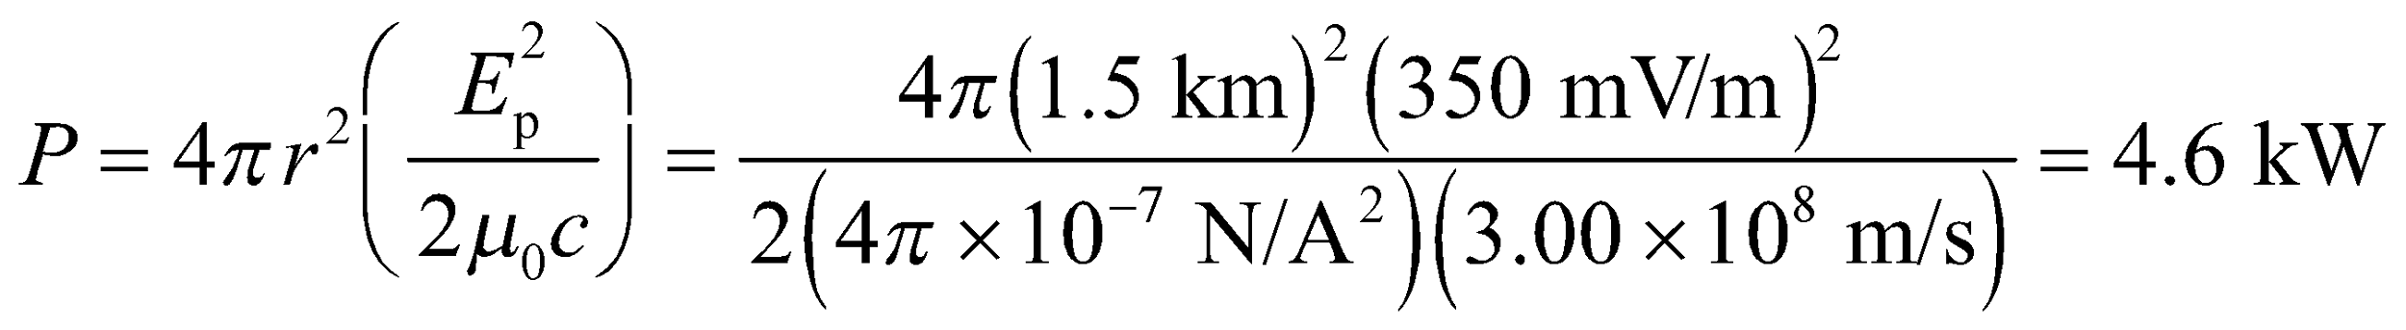

**(b)** Since 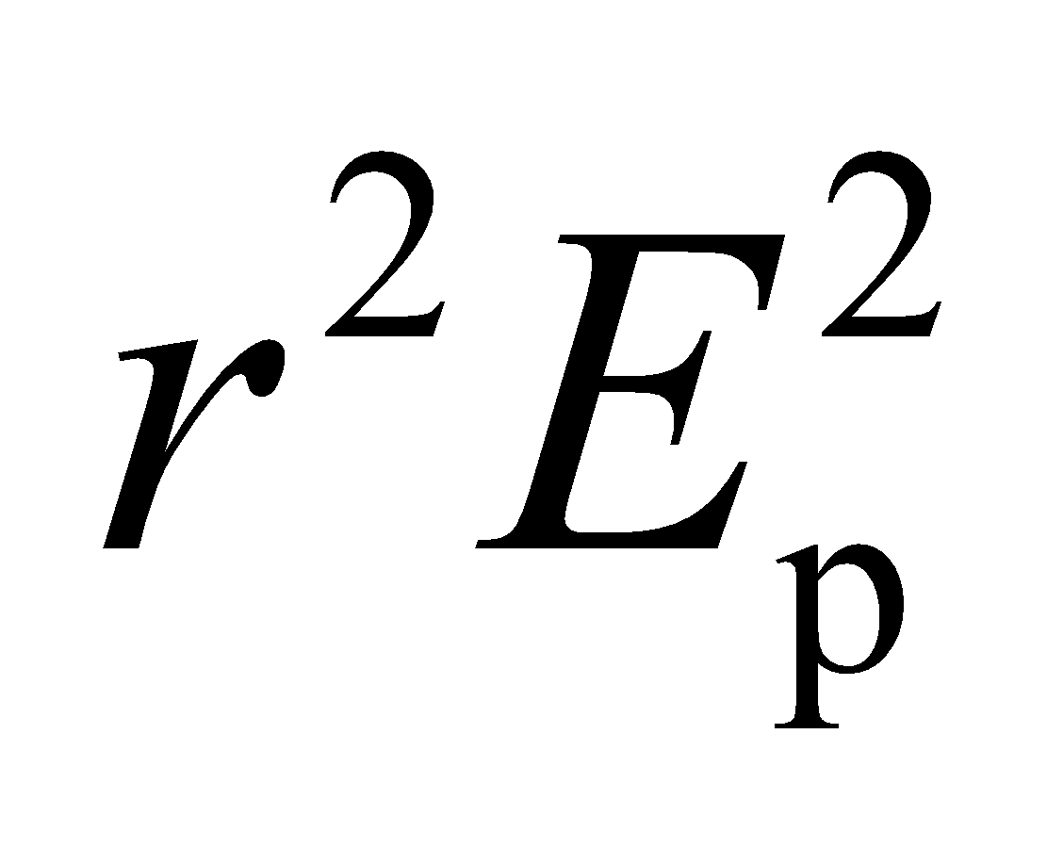 is a constant,

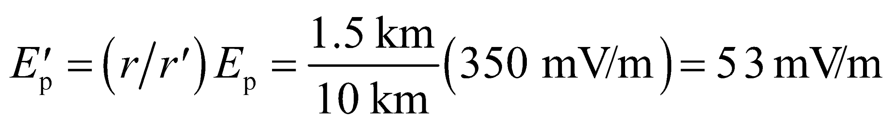

at a distance of

**Assess** This signal is still strong enough to be captured by modern radios. Checking the units for part (a), we find

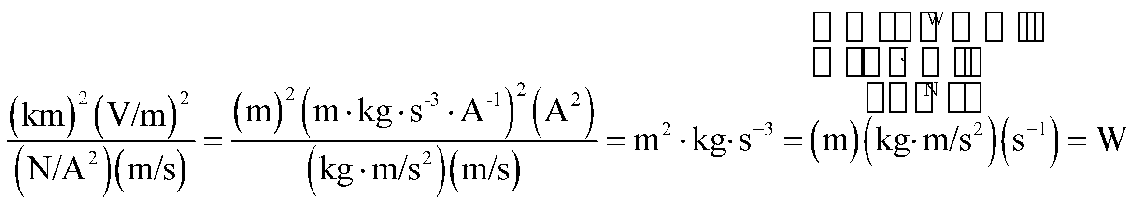

**50. Interpret** This problem involves finding the peak electric and magnetic field strengths of electromagnetic radiation, given the average power of the light source and the distance to the light source.

**Develop** For an isotropic source of electromagnetic waves (in a medium with vacuum permittivity and permeability), Equations 20.20 and 20.21 give

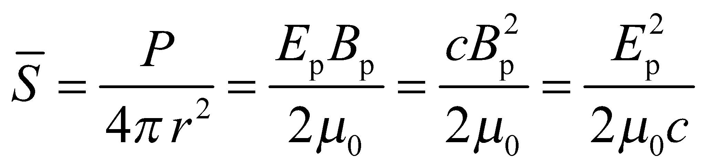

**Evaluate** The peak electric field strength is

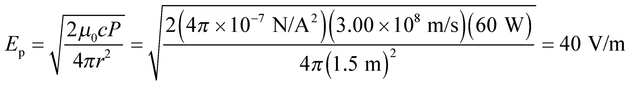

Using Equation 29.17, we find the peak magnetic field strength to be 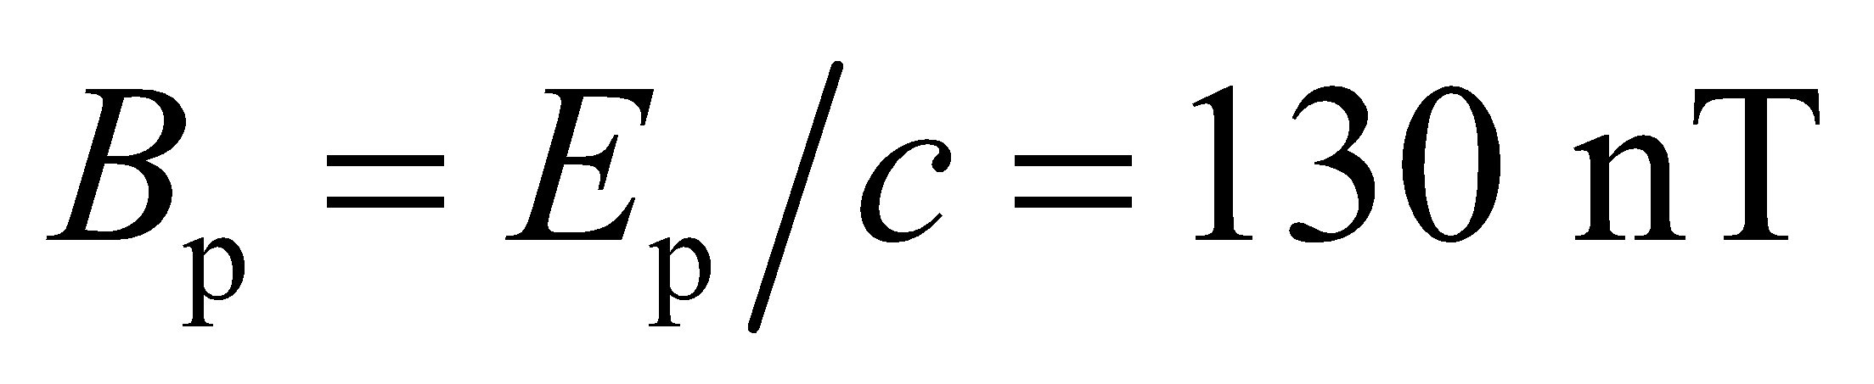, to two significant figures.

**Assess** The field strengths due to the light bulb are rather small.

**51.** **Interpret** This problem explores the influence of the symmetry of a line source of light in the distribution of intensity that it radiates. Specifically, we are to compare the variation of intensity with distance near a line source and far from the line source.

**Develop** Near the lamp (i.e., at distances  the length *L* of the lamp), but far from its ends, light waves travel approximately radially outwards from the tube axis. The power crossing two co-axial cylindrical patches is the same, but the area of each patch is proportional to the radius (see figure below). Very far away, the lamp appears as a point source.



**Evaluate** **(a)** Near the lamp, the intensity varies as 1/*r* because

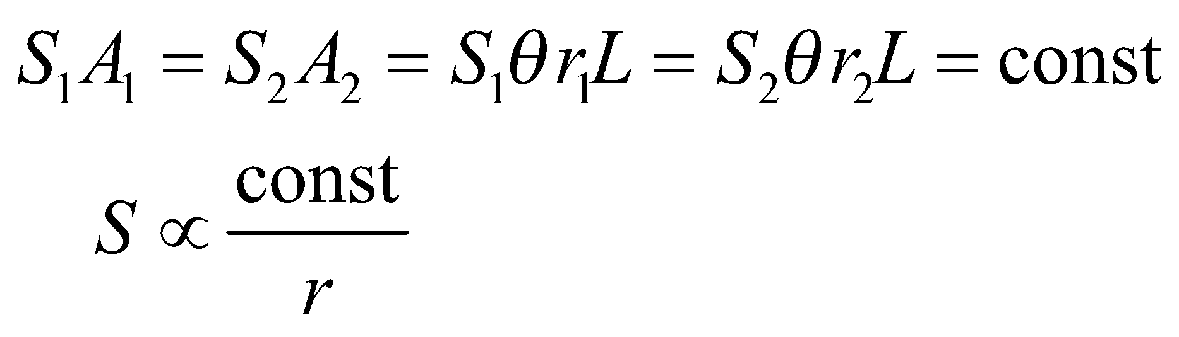

**(b)** Far from the lamp, Equation 29.21 holds, so the intensity varies like 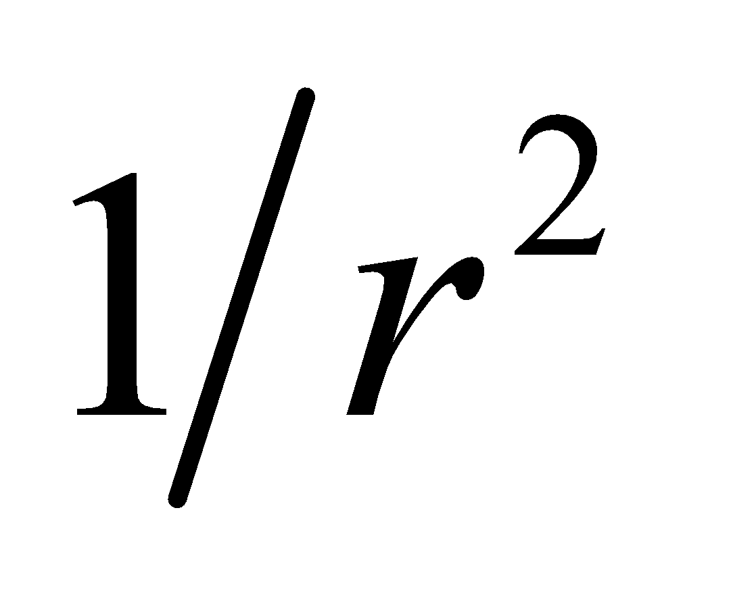

**Assess** Extending this reasoning, we would expect the intensity of a plane source of light to be independent of distance to the source for distances  the dimensions of the plane source, assuming we are not near the edges of the source.

**52. Interpret** This problem asks for the energy and momentum carried by the light from a camera flash.

**Develop** The energy *U* is the average power times the duration of the flash, and the momentum is simply given by 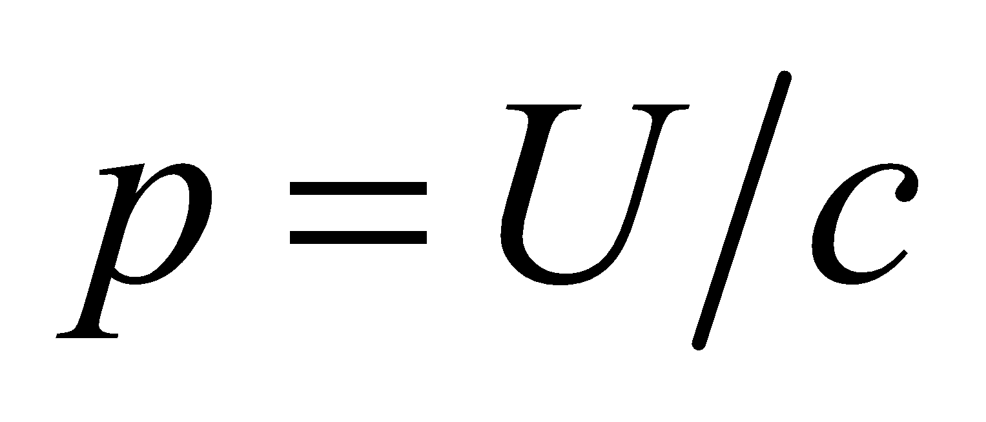 (see section on momentum and radiation pressure).

**Evaluate** **(a)** The total energy the flash carries is 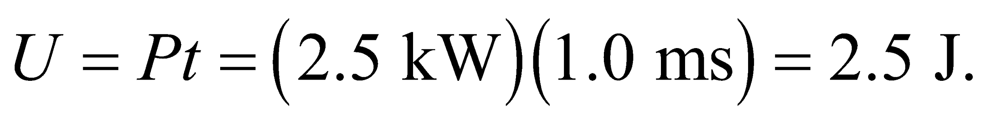

**(b)** The momentum is

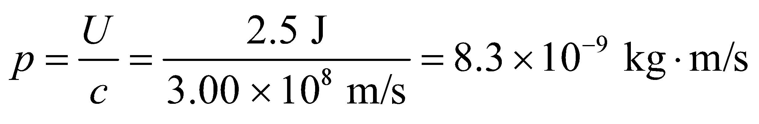

**Assess** A camera flash works by storing energy in a capacitor and then rapidly releasing the energy to cause a quick bright flash of light.

**53. Interpret** We are to find the average intensity and the peak electric field of the light from a laser, given its average power and its beam diameter.

**Develop** Intensity is defined as power per unit area. We know that the power of the beam is *P* = 7.0 W and the area is 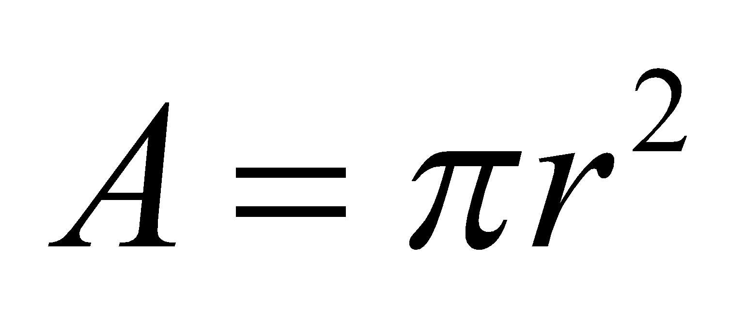 where 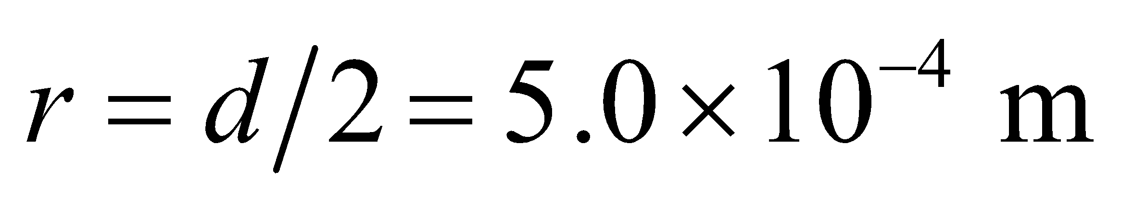, so we can find the intensity. Intensity is also given by the Poynting vector, 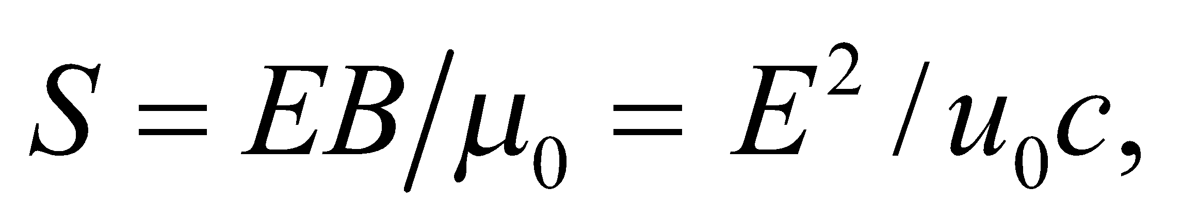 from which we can determine the peak electric field.

**Evaluate (a)** 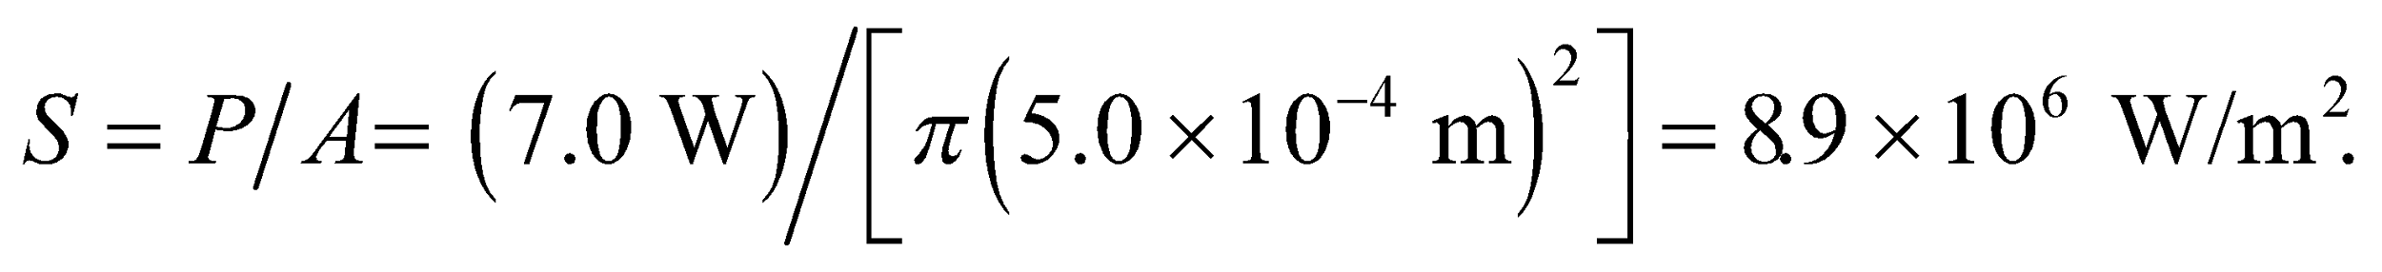

**(b) **

**Assess** This intensity is one factor in what makes a laser beam so dangerous. Seven watts is really not much power, but packed into such a small area it gives an enormous intensity.

**54. Interpret** Given the intensity of the laser beam, we are asked to find the corresponding radiation pressure it exerts on a light-absorbing surface.

**Develop** The radiation pressure generated by a totally absorbed electromagnetic wave of given average intensity can be calculated using Equation 29.22: 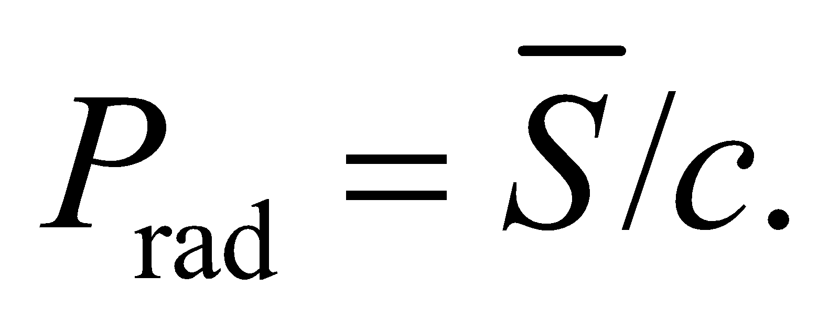

**Evaluate** Inserting the values given, the radiation pressure is

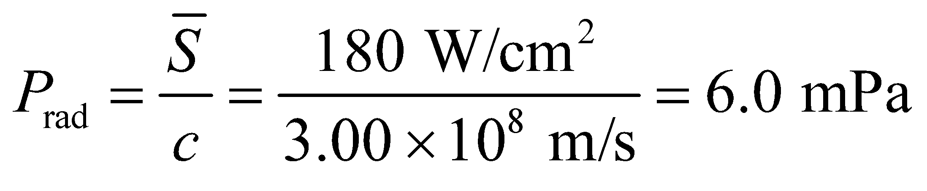

**Assess** The pressure is a lot smaller compared to the normal atmospheric pressure of 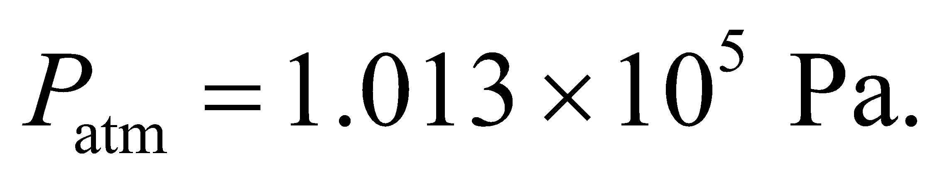

**55.** **Interpret** We will use Newton’s third law (Chapter 4) and the radiation momentum generated by the given flashlight to find the time it takes the astronaut to accelerate from rest to 10 m/s.

**Develop** By Newton’s third law, the reaction force of the light emitted on the flashlight equals the rate at which momentum is carried away by the beam, or 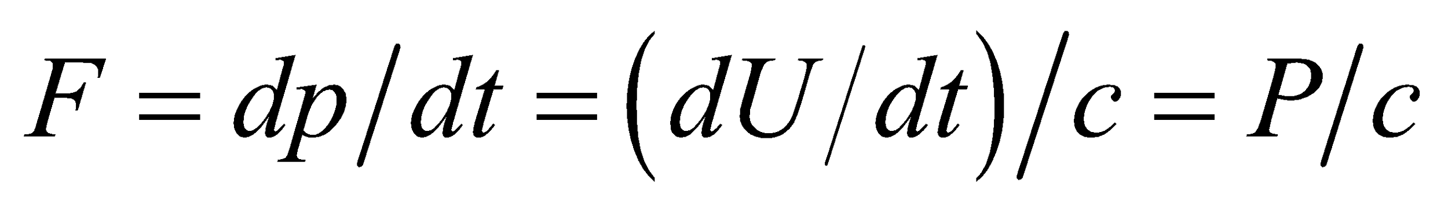. Such a force could accelerate a mass *m* from rest to a speed *v* in time 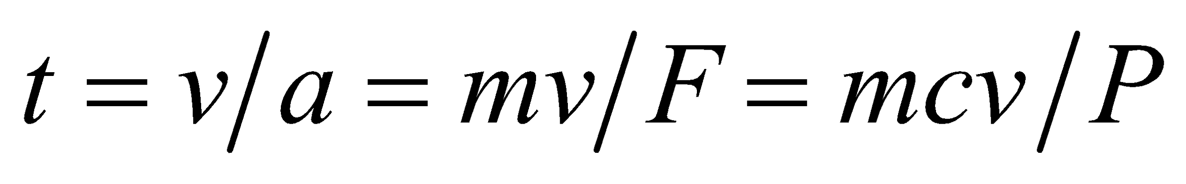.

**Evaluate** For the values given for the astronaut and flashlight,

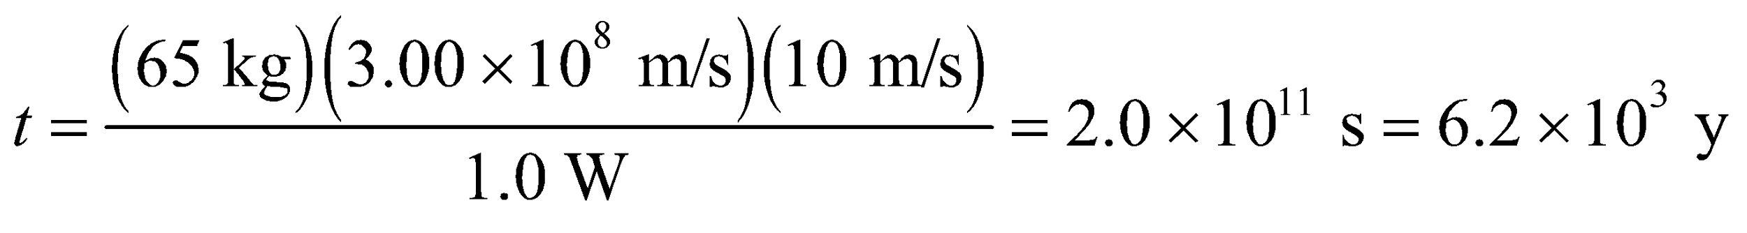

**Assess** This is impractically long, as one might expect.

**56. Interpret** This problem involves finding the power of a light source, given the thrust it yields.

**Develop** The thrust of a (photon) rocket is the rate that momentum is carried away by its electromagnetic exhaust beam:

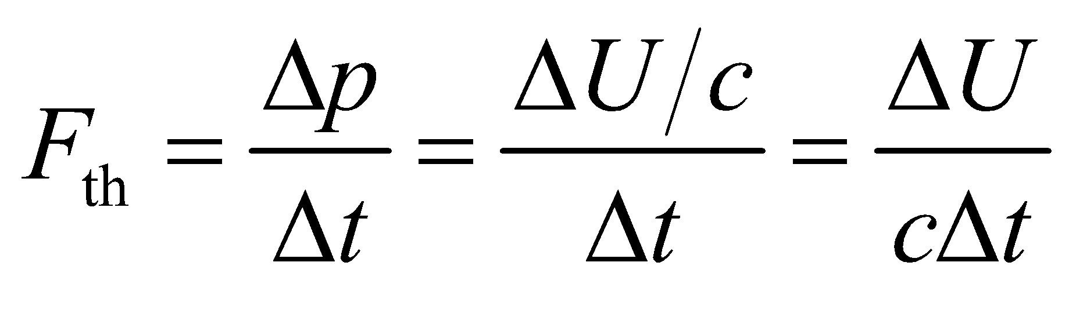

**Evaluate** To yield a thrust of 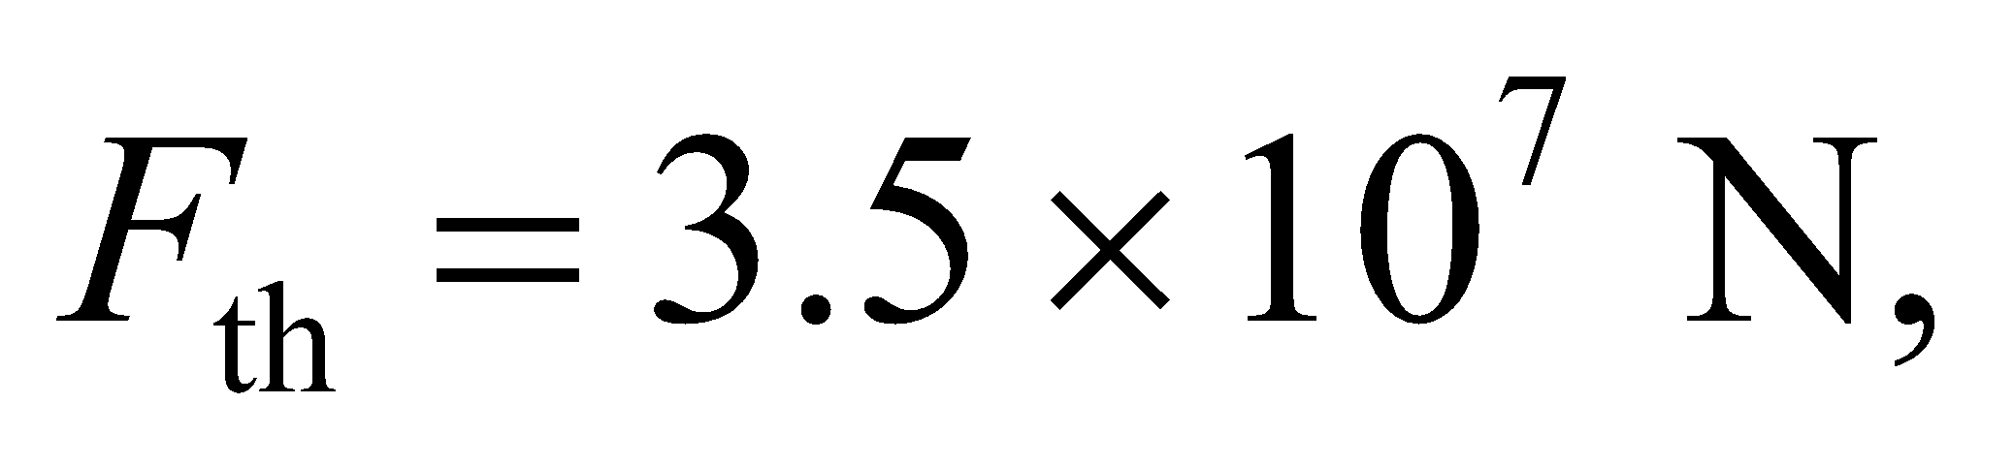 the beam power must be

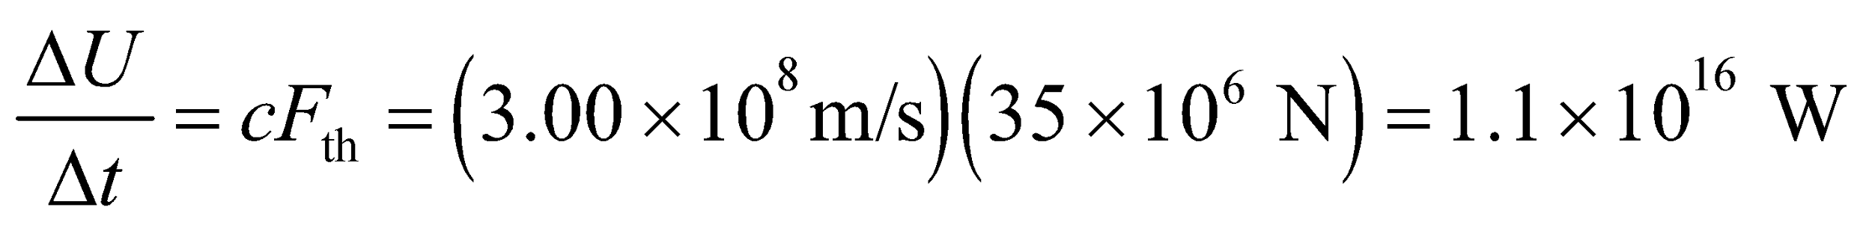

This is 104 times the world’s electric-power generating capacity.

**Assess** This is not a practical means of launching payloads off the Earth. The momentum per unit energy of a light beam 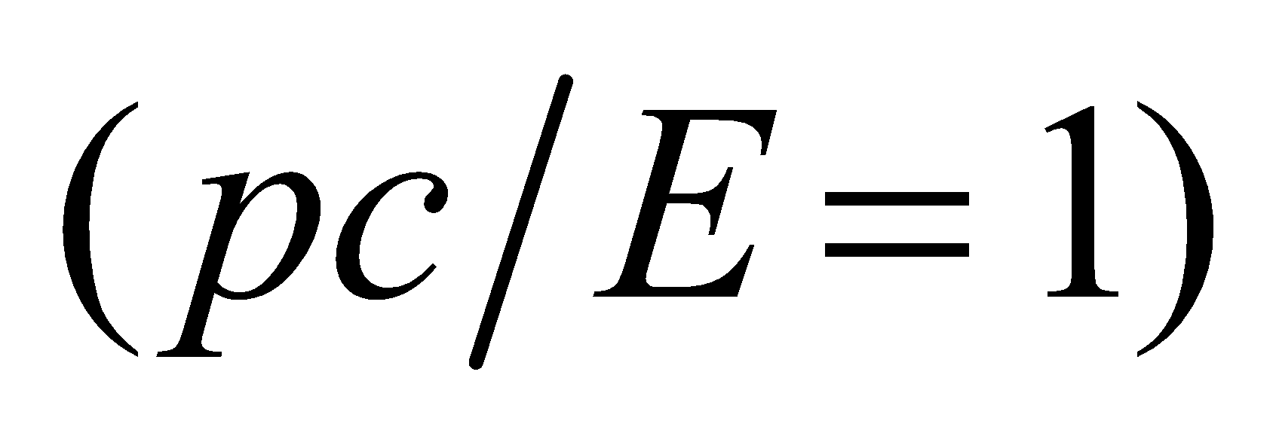 is greater than that of any particle beam 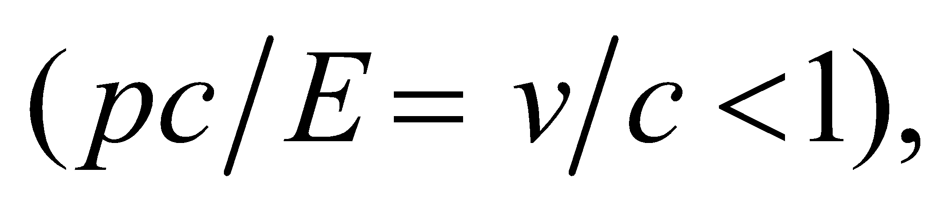 so a photon rocket could be more energy-efficient in long-distance, low-thrust space travel.

**57.** **Interpret** This problem involves finding the radiation pressure at the surface of a white dwarf, given its power and radius.

**Develop** From Problem 29.46, the Sun radiates 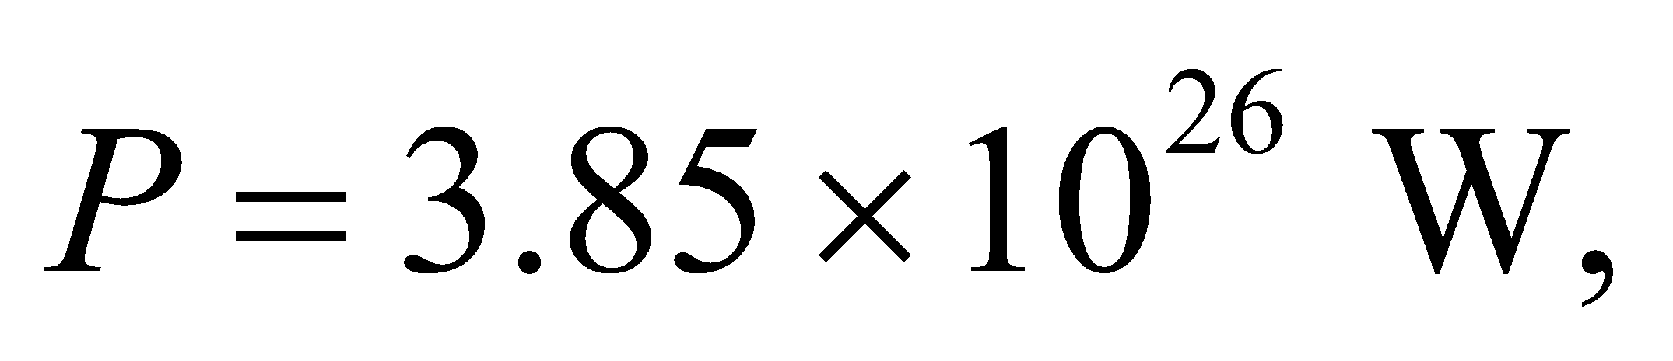 and the radius of the Earth is 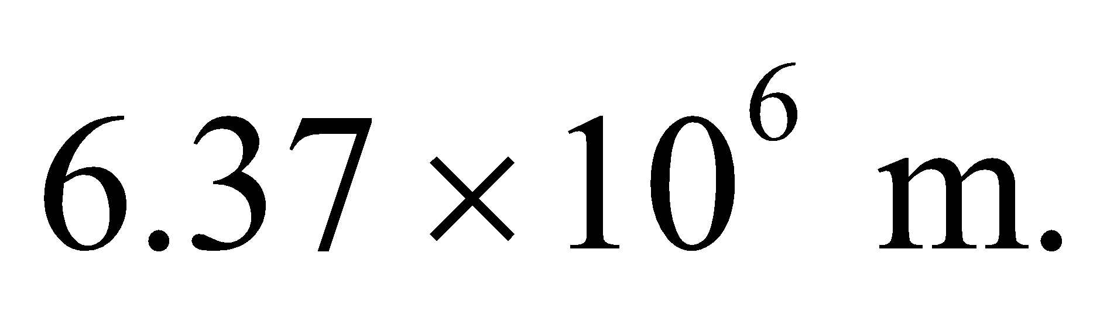 Equation 29.22 gives the radiation pressure on a perfect absorber as 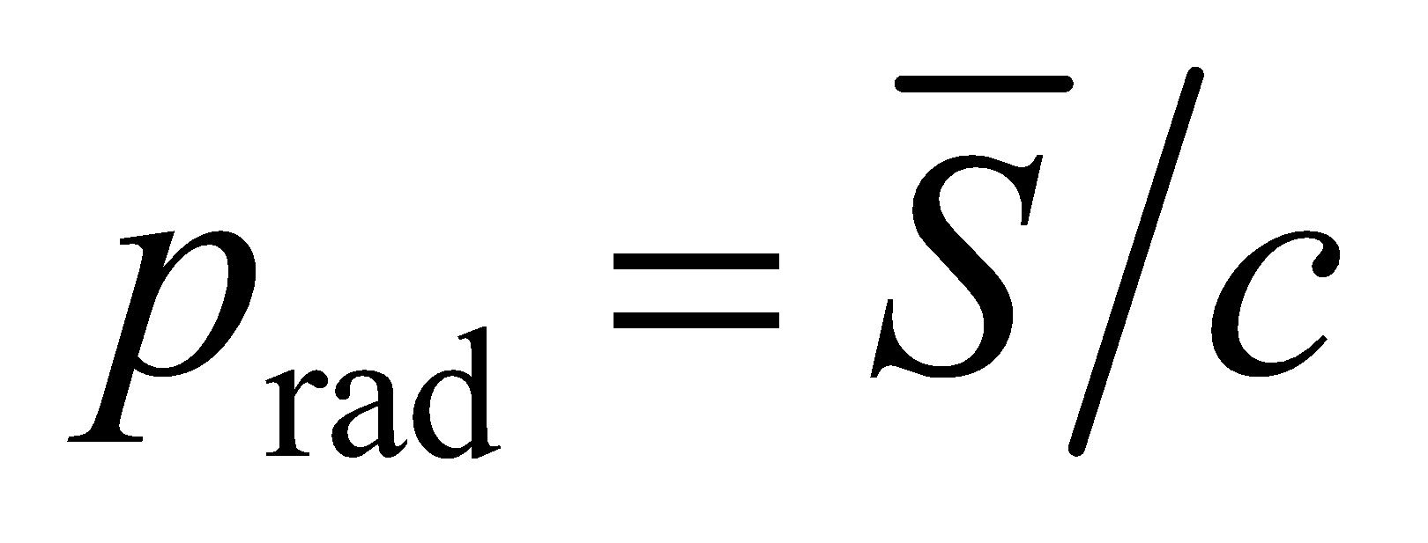 and the intensity may be found using Equation 29.21, 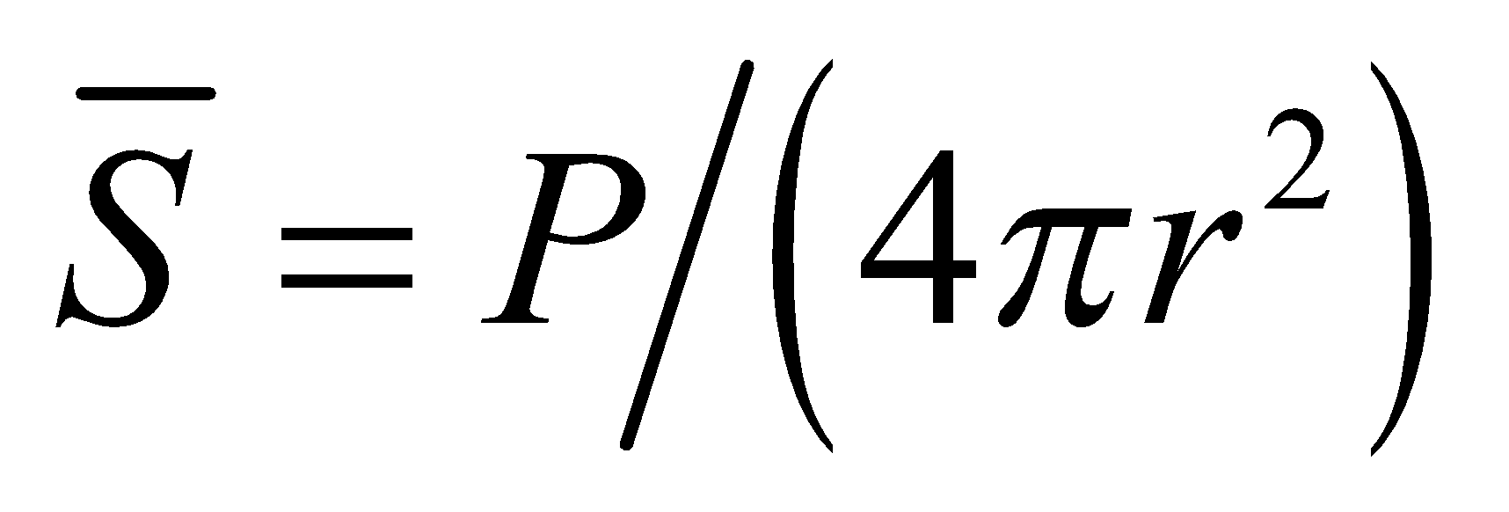.

**Evaluate** Combining the expressions above gives a radiation pressure of

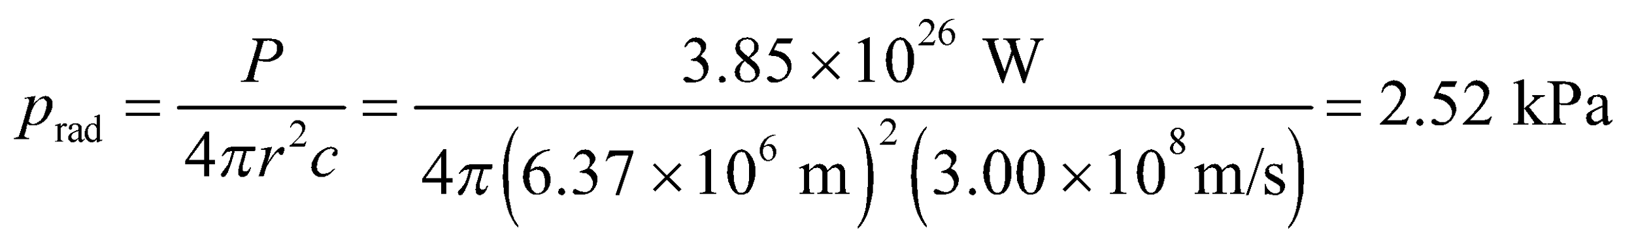

**Assess** This is some 100 times less than the atmospheric pressure at the surface of the Earth.

**58. Interpret** This problem is about radiation pressure on an absorbing object at the Sun’s surface.

**Develop** For an isotropic source, the radiation pressure on an opaque (perfectly absorbing) object is (Equation 29.22)

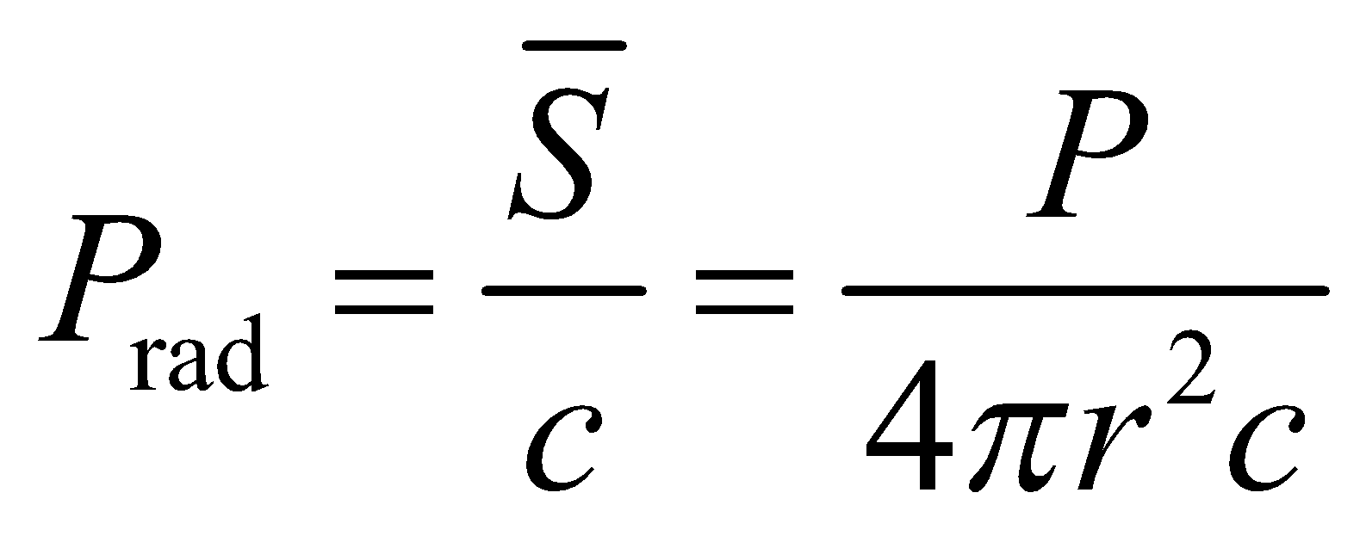

**Evaluate** The luminosity of the Sun (power radiated) is 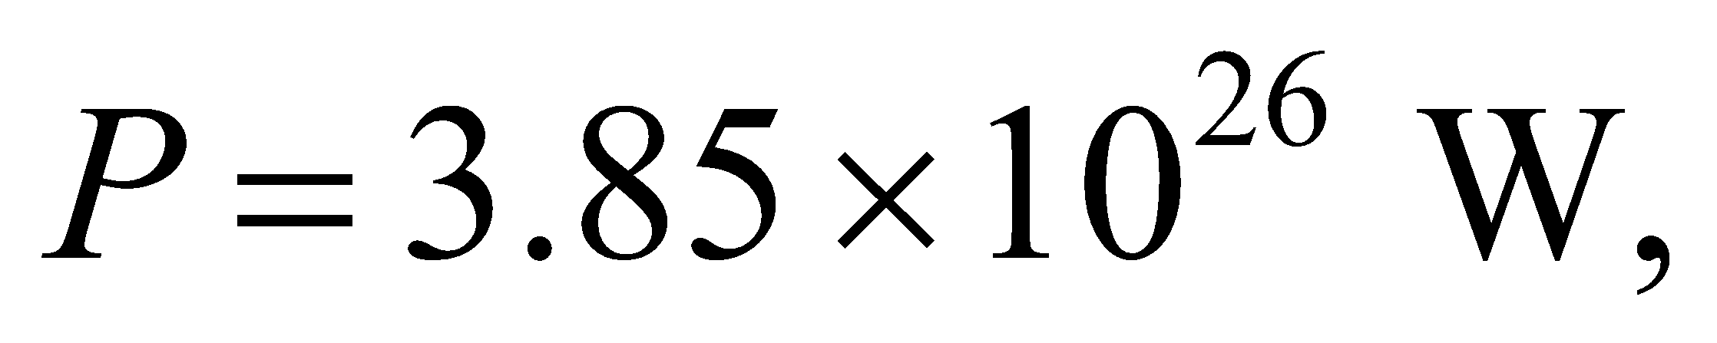 and the radius of the Sun is

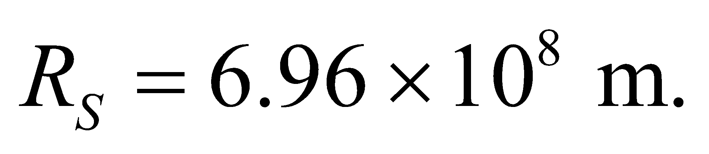 Thus, the radiation pressure is

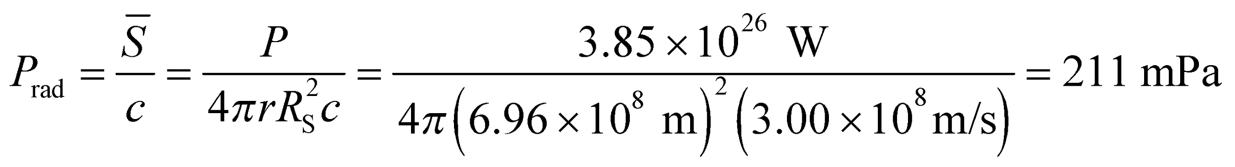

**Assess** This is much greater compared to  on the surface of the Earth.

**59.** **Interpret** This problem involves characterizing an electromagnetic wave given the relevant parameters.

**Develop** The average intensity of a pulse is the average power during a pulse divided by the beam area; 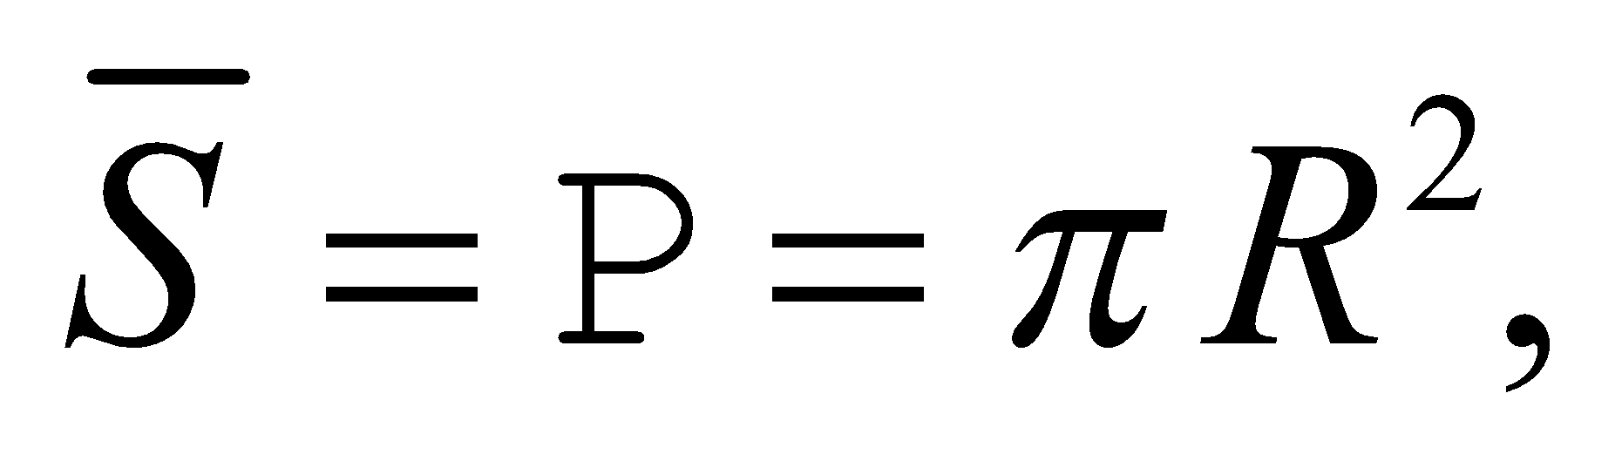 and (from Equation 29.20b) the peak electric field is 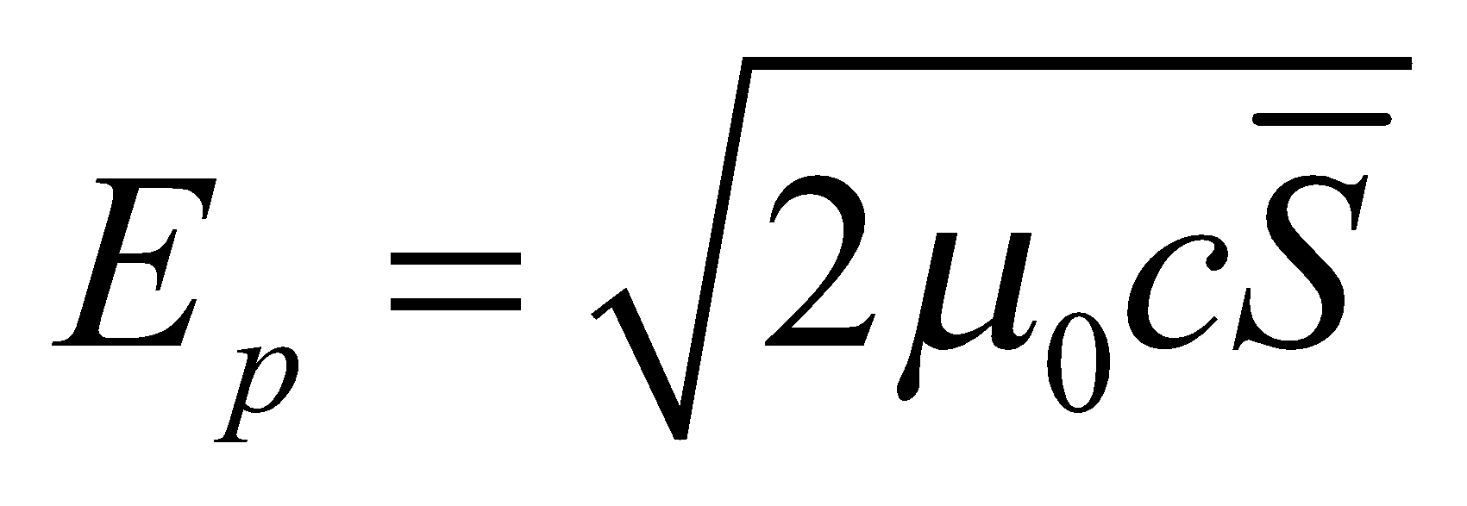. The wavelength may be found using Equation 29.16c, *c* = *fλ*.. To find the energy in a pulse, use 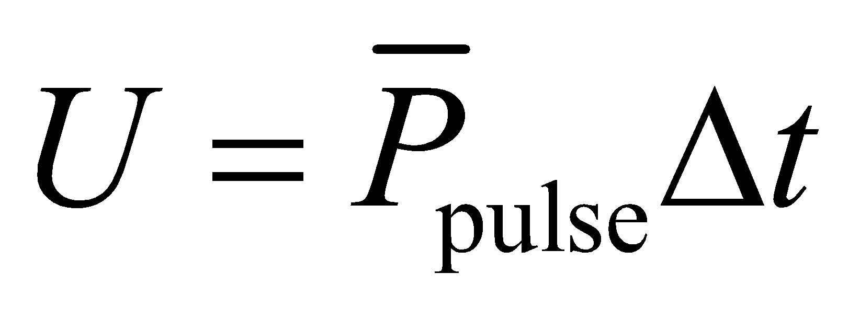, where *Δt* =*NT* = *N*/*f*, with *N* = 100 and *f* = 70 GHz. To find the average power output, calculate the power in a pulse, multiply by 1000 because there are 1000 pulses per second, and divide by 1 s to get the power (energy per unit time).

**Evaluate** **(a)** The peak electric field is



**(b)** The wavelength is 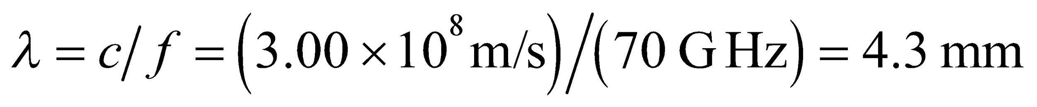.

**(c)** The total enegy in a pulse is 

**(d)** The momentum per pulse is given by *p* = *U*/*c* = 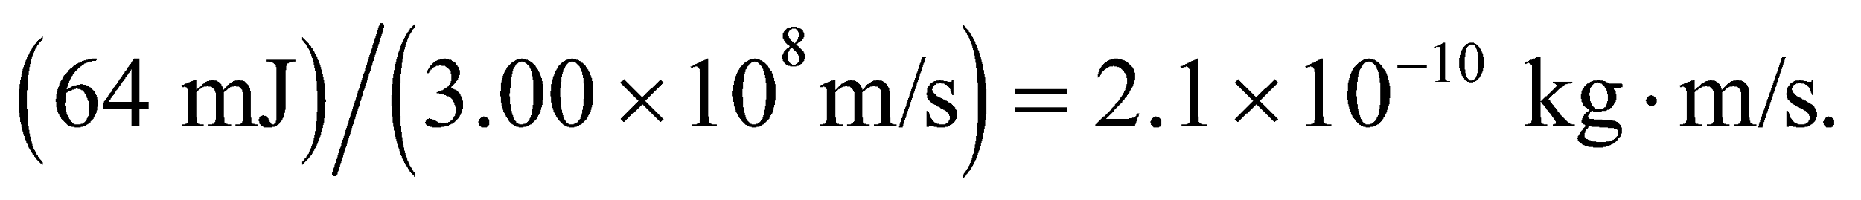

**(e)** Every pulse carries 64.3 mJ, and there are 1000 per second, so the average power is 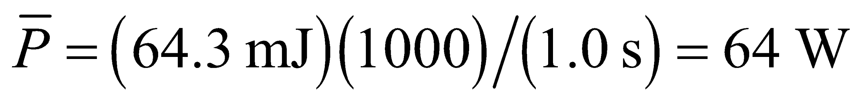.

**Assess** The average power in the beam is much less than the power per pulse because the duty cycle is

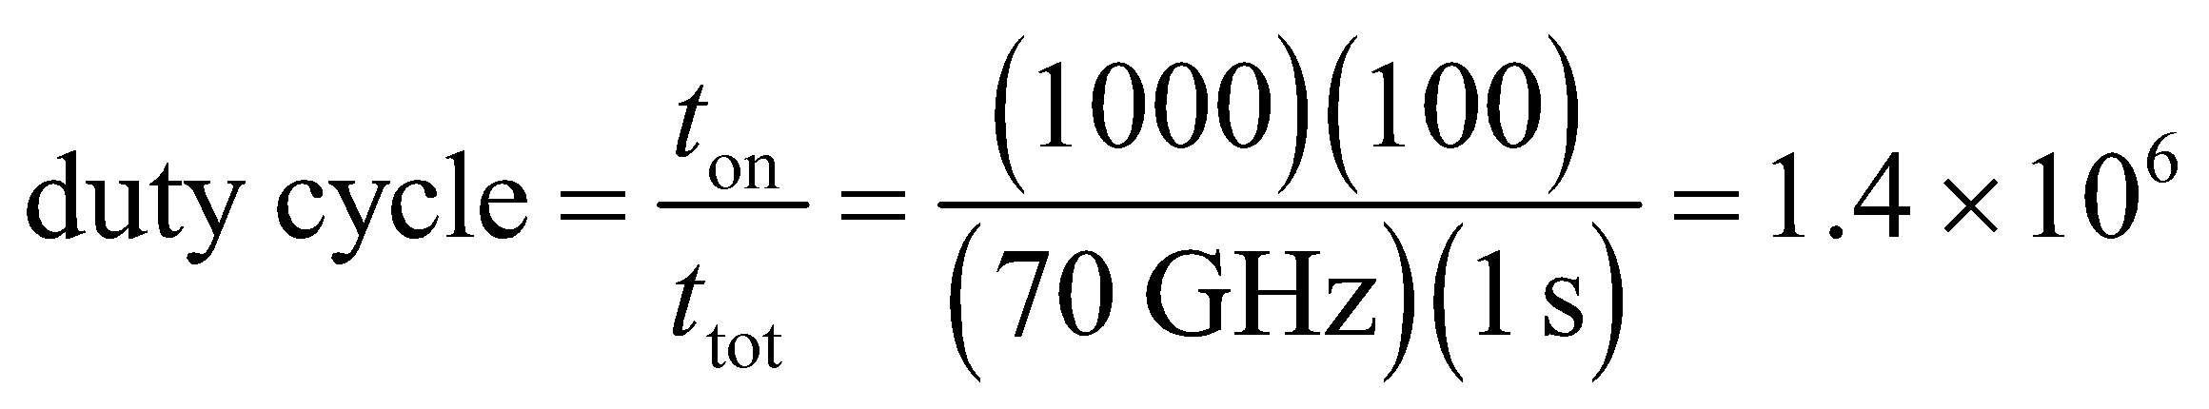

which explains the six-order-of-magnitude difference between 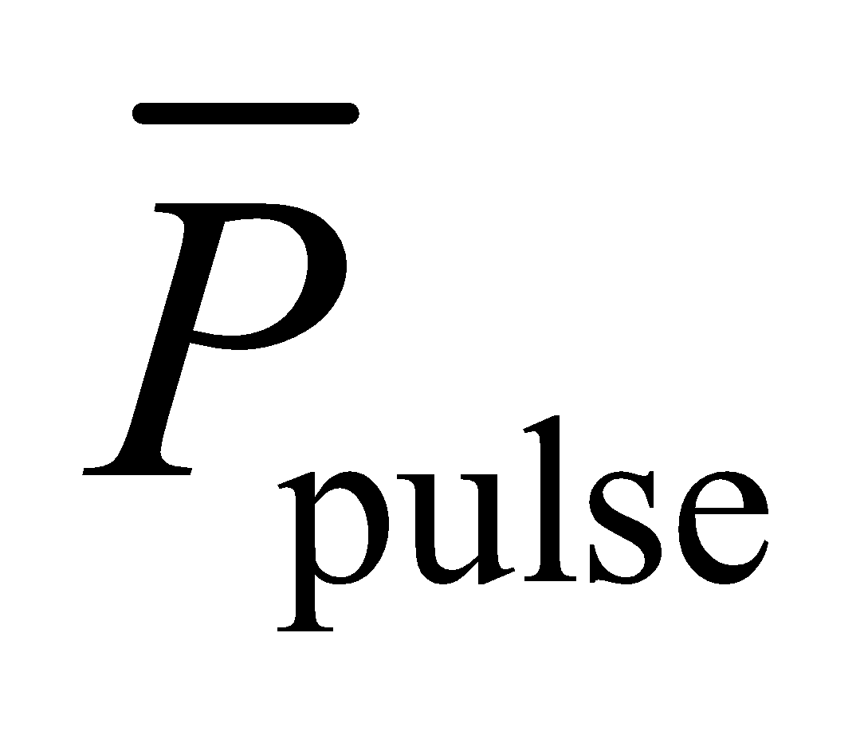 and 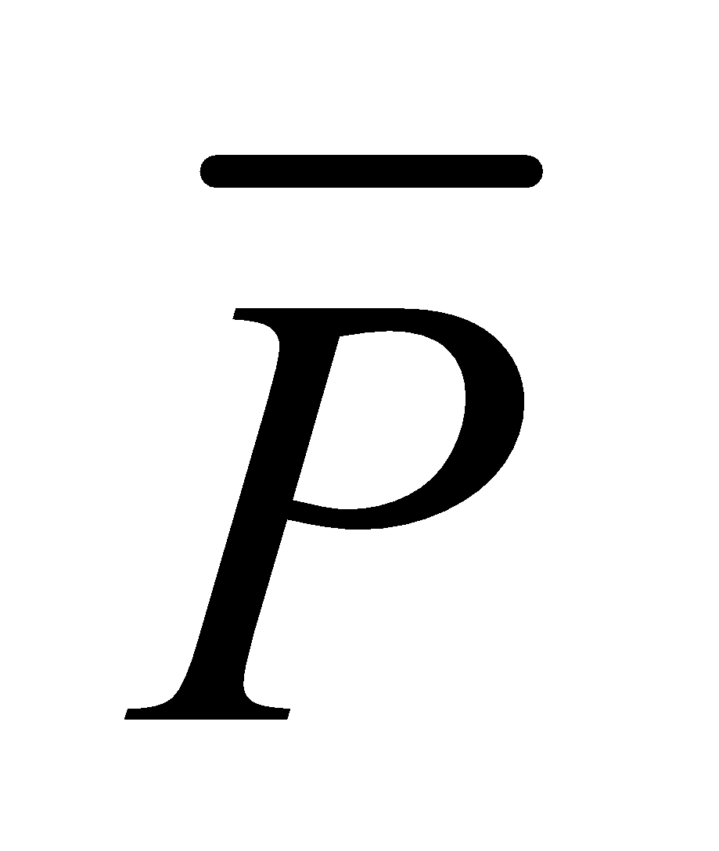.

**60.** **Interpret** In this problem, we explore the electric and magnetic fields in a cylindrical resistor and are to show that the Poynting vector averaged over the surface area is *I*2*R*.

**Develop** Consider the sketch below of the cylindrical resistor, where the hashed portion is the cross-section of the cylinder. Assume that the current is steady, and that the fields are independent of time. Ohm’s law gives 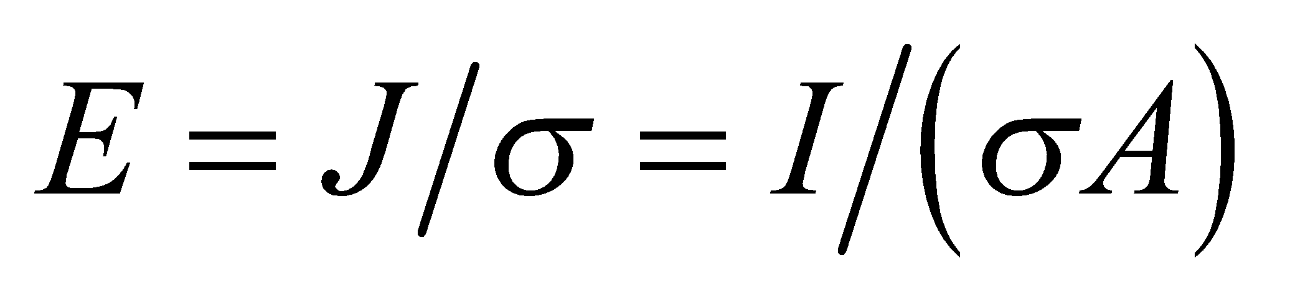 in the direction of the current (see Section 24.3). The magnetic field at the surface, 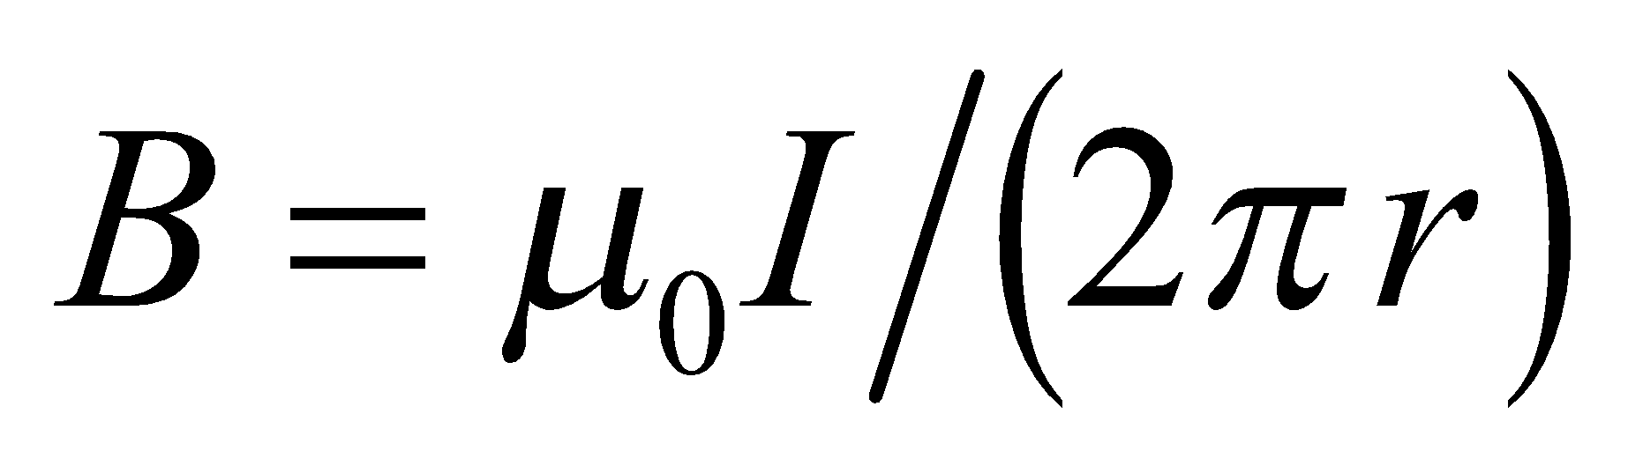, encircles the current in the direction of a right-hand screw. Thus  is perpendicular to 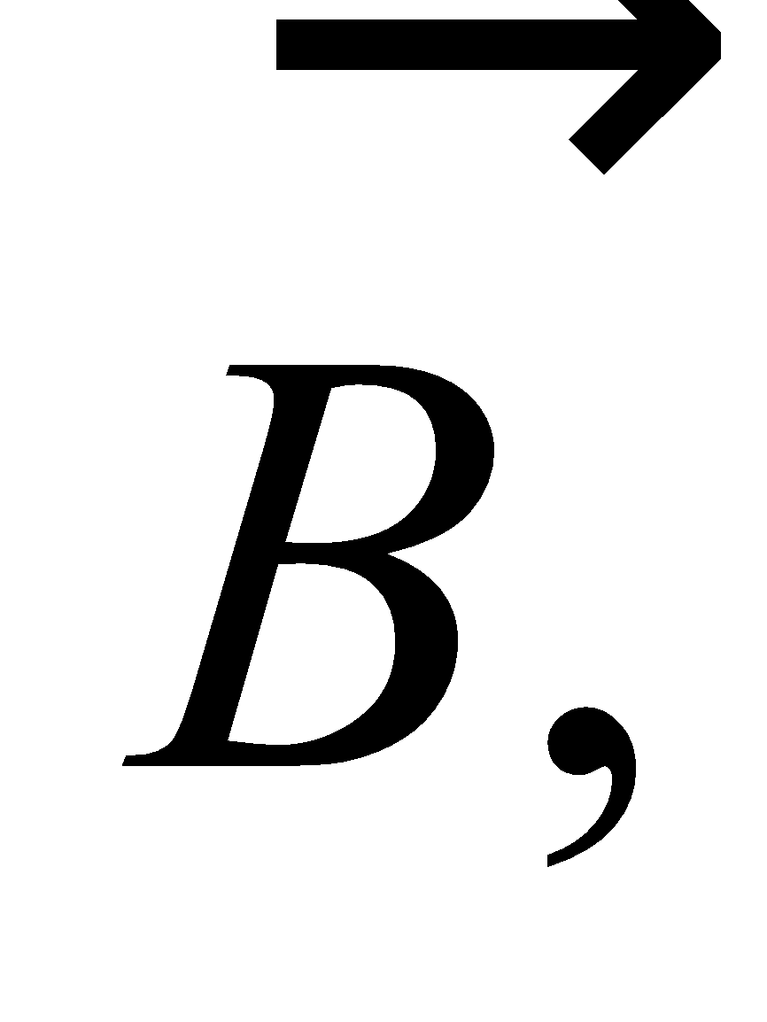 and 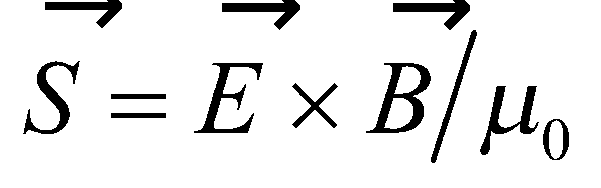 points radially into the resistor, as per the right-hand rule. Power flows from the fields into the resistor only through the curved portion of its cylindrical surface, so we can find the power by integrating the Poynting vector component parallel to the surface normal over the surface of the resistor.



**Evaluate** The power flowing into the resistor is

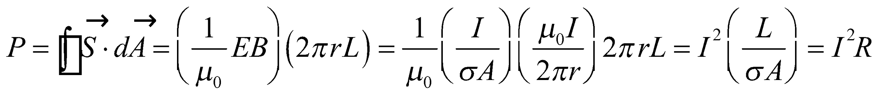

**Assess**  This is a special case of Poynting’s theorem applied to steady fields.

**61. Interpret** From the transmission percentage of a stack of polarizers, we are to determine how many polarizers the stack contains. We shall use the Law of Malus.

**Develop** The Law of Malus (Equation 29.18) is  where *θ* is the angle between the polarization of the impinging light beam and the polarization direction of the polarizer sheet. For this problem, *θ* = 14°. The first polarizer eliminates 50% of the initially unpolarized light, and each subsequent polarizer is equivalent to multiplying the amount of light remaining by 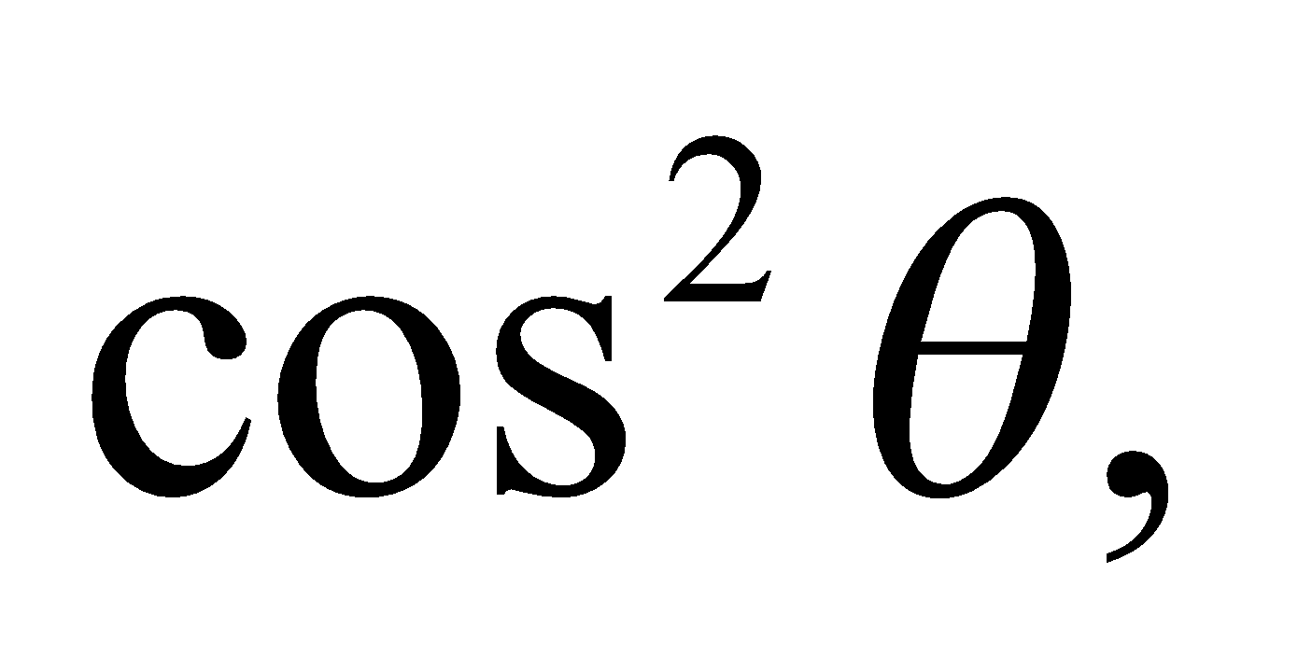 so the total percentage of the light that comes through the stack of *n* polarizers is 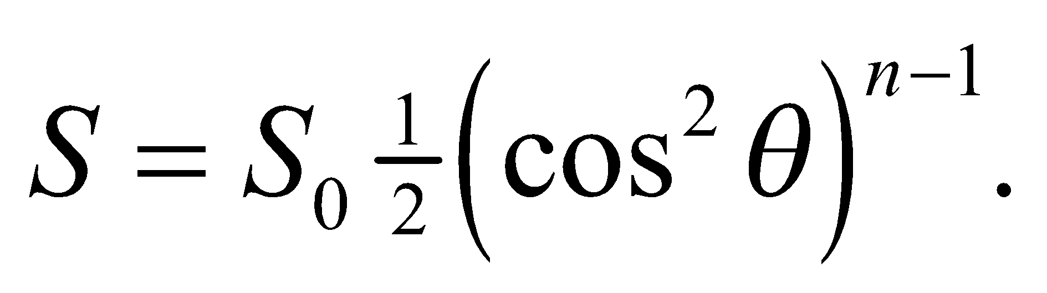 We are given that 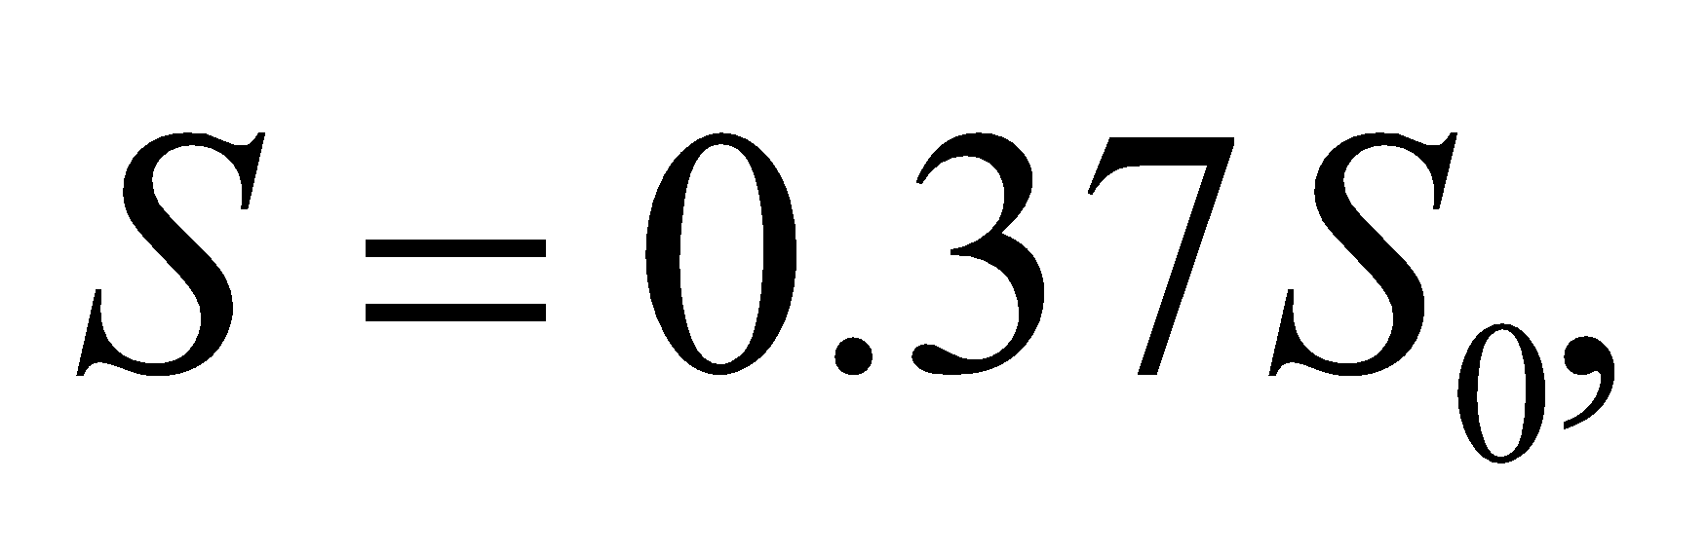 so we can solve for *n*.

**Evaluate** The number *n* of polarizer sheets is

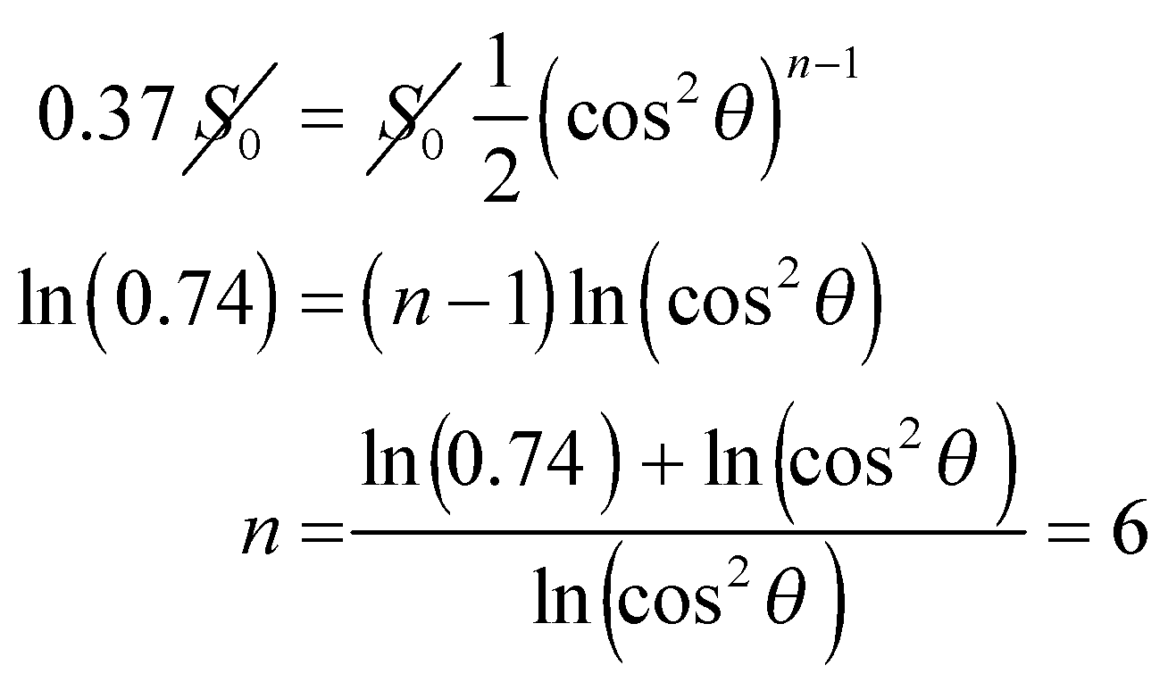

**Assess** The stack has six sheets. If you got 17.5 sheets, you probably forgot that the first sheet eliminates *half* the unpolarized incident light.

**62. Interpret** You want to evaluate an hypothesis that the sun’s radiation pressure cleared out small particles from the early solar system.

**Develop**The pressure applied by radiation is the intensity divided by the speed of light: 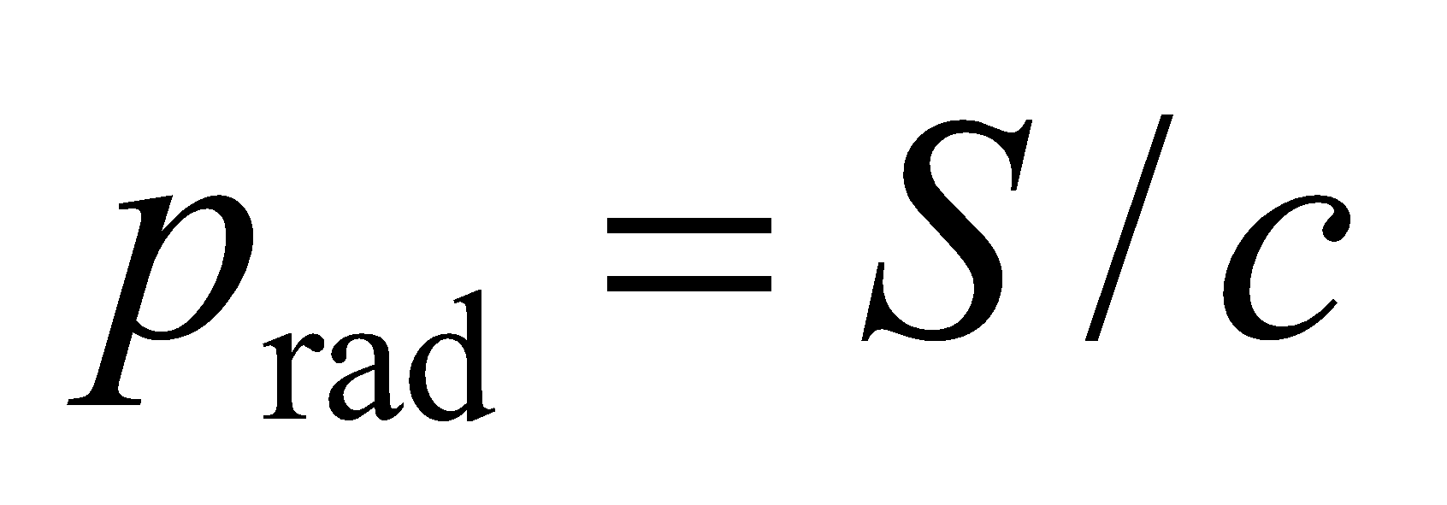 (Equation 29.22). The sun radiates uniformly in all directions (with 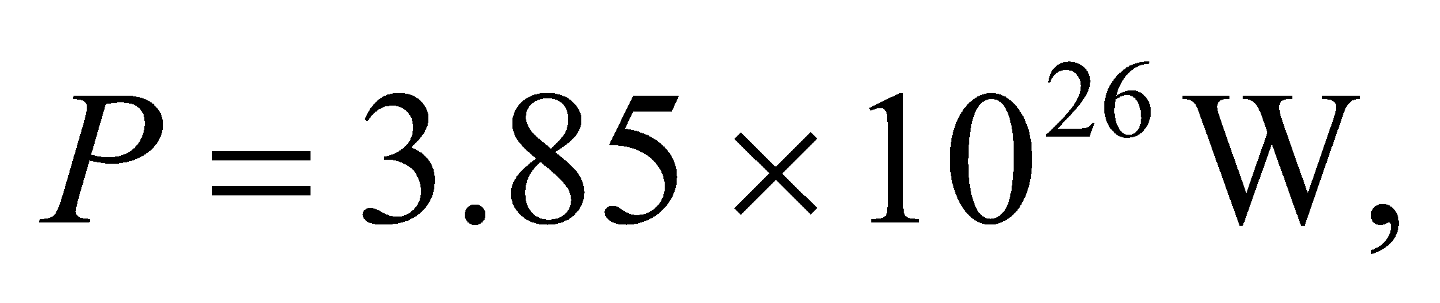from inside cover), so the radiation pressure decreases as one over the distance squared: 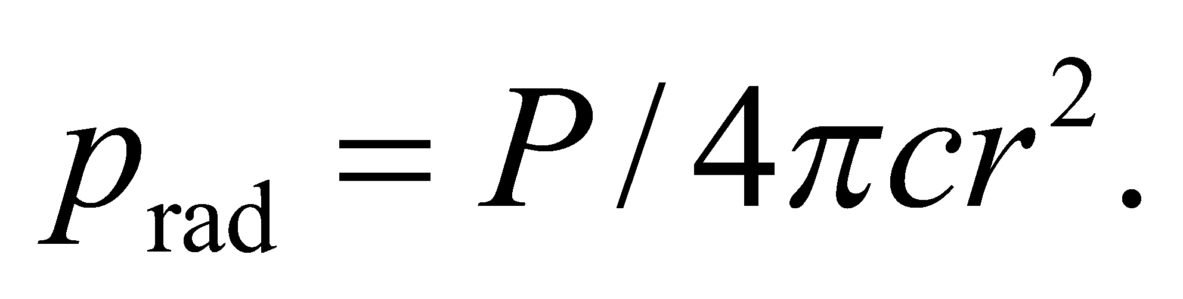 A small particle with radius *R* will have one face 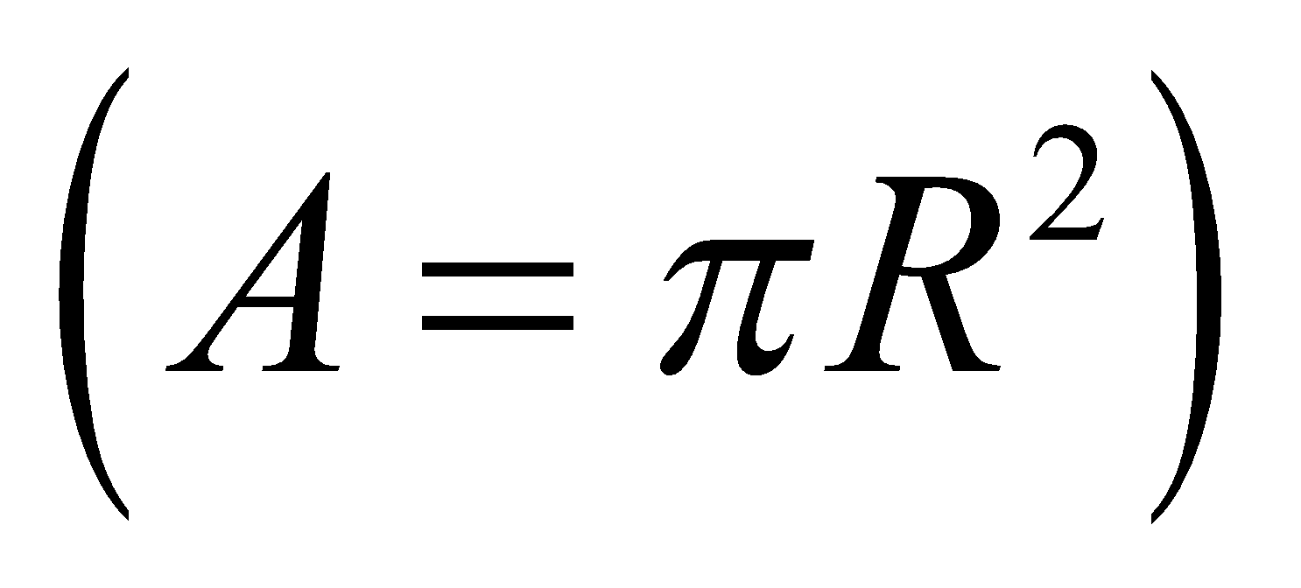exposed to this pressure. We assume that the particle absorbs the radiation, but does not reflect it, so it will absorb the momentum and thus experience a radiation force of

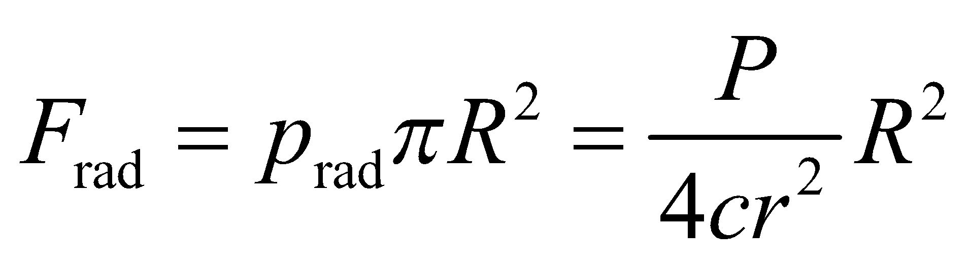

In comparison, the gravitational force on the same particle will be

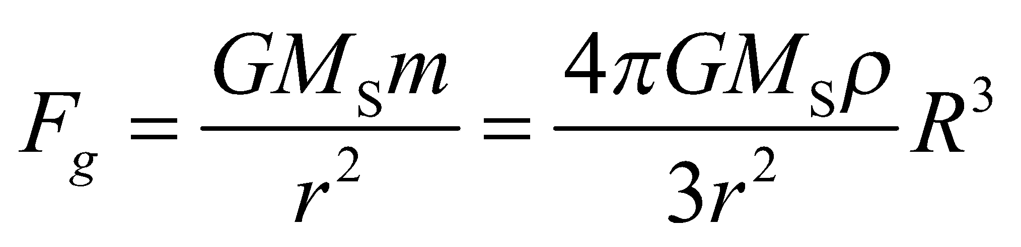

where we have used the density to write the mass as a function of the particle’s radius.

**Evaluate**The radiation force will point outwards, away from the sun, while the gravitational force will point inwards. You want to know at what particle radius will the two forces cancel each other:

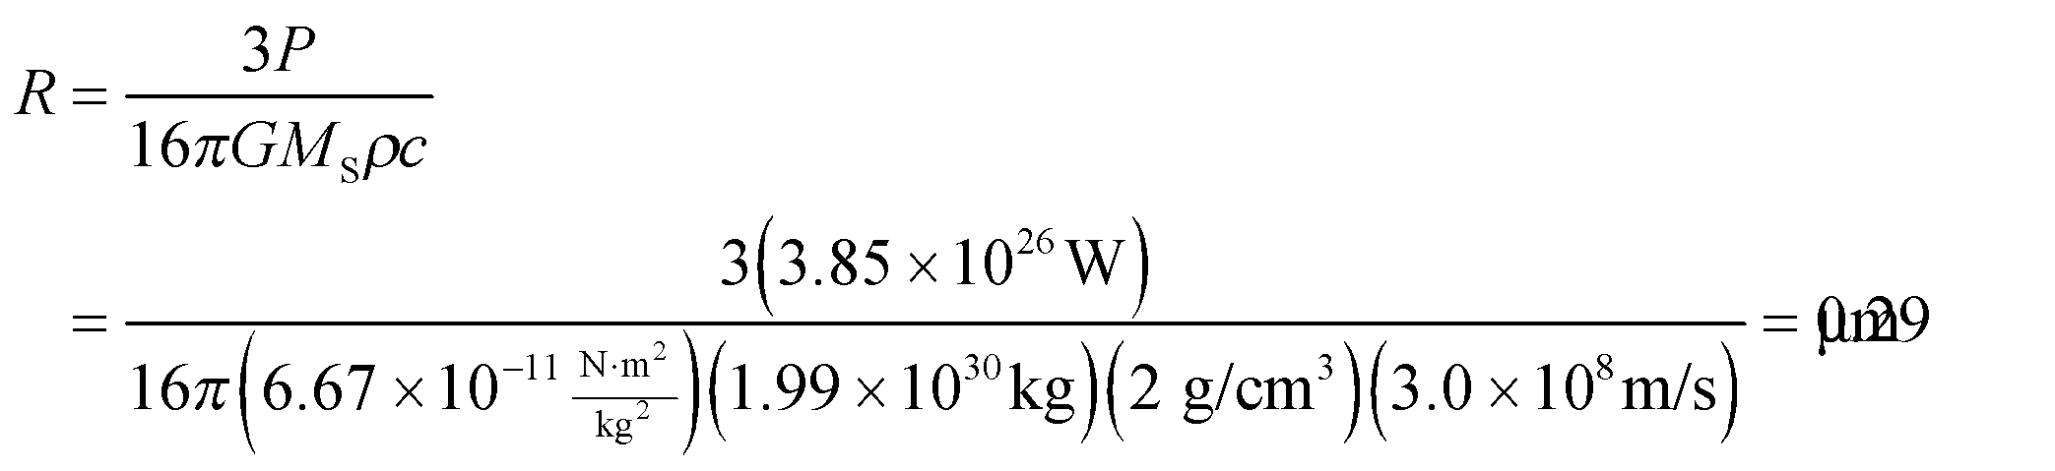

**Assess** Particles smaller than this radius would presumably have been blown out of the early solar system. Larger particles would have stuck around to form planets, comets and other solar system bodies. The particle size discrimination does not depend on the distance from the sun because both the radiation force and gravitational force are proportional to 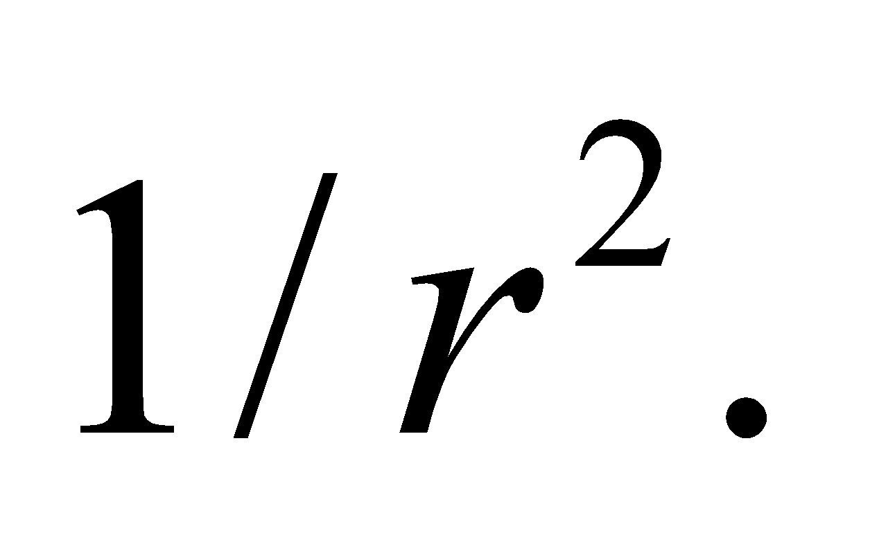

**63. Interpret** We will use Maxwell’s equations to derive the wave equation for electromagnetic radiation.

**Develop**We will start with the differential form of Faraday’s law: 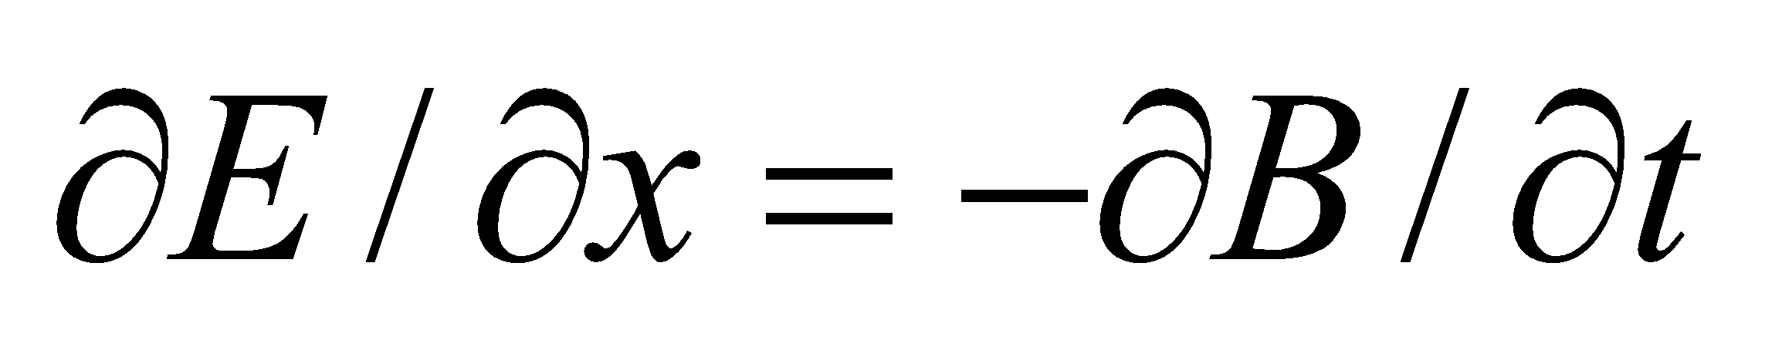 (Equation 29.12) and differentiate it with respect to *x*. Then we will take the differential form of Ampère’s law: 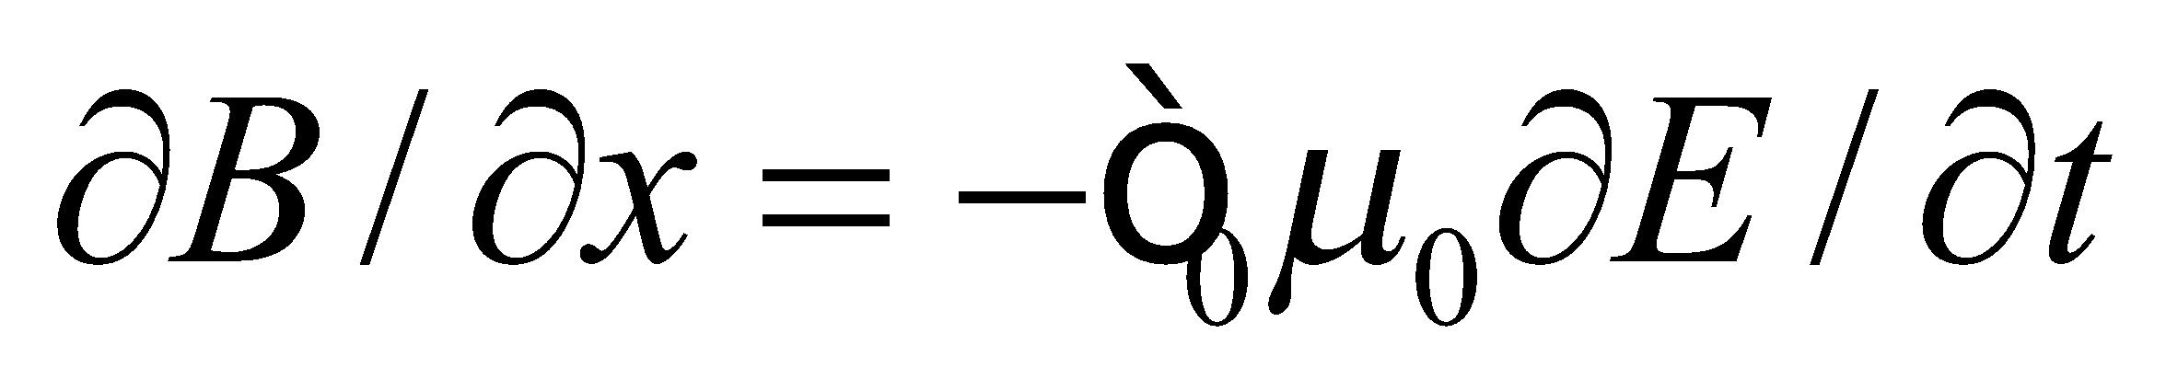 (Equation 29.13) and differentiate it with respect to *t*. The combination of these two equations should match that of the generic wave equation: 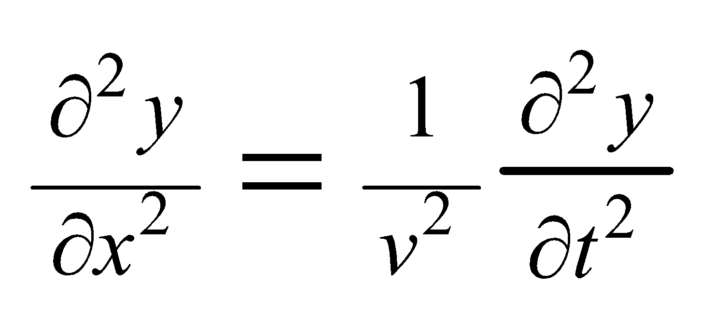 (Equation 14.5).

**Evaluate**Taking the derivatives specified above, we have

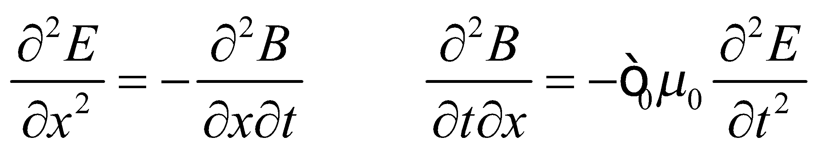

Since the order of the partial derivatives is irrelevant, the magnetic field derivatives in the two equations are equal, so we get

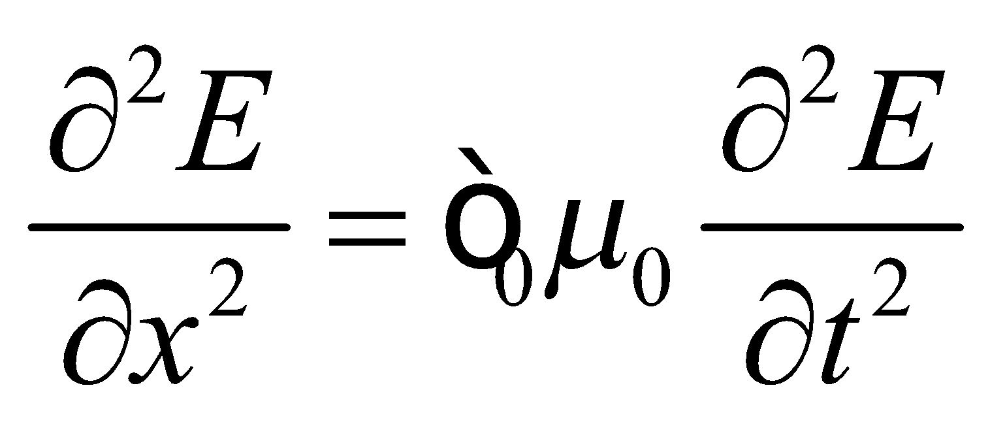

This has the same form as Equation 14.5, which implies the electric field behaves as a wave with speed 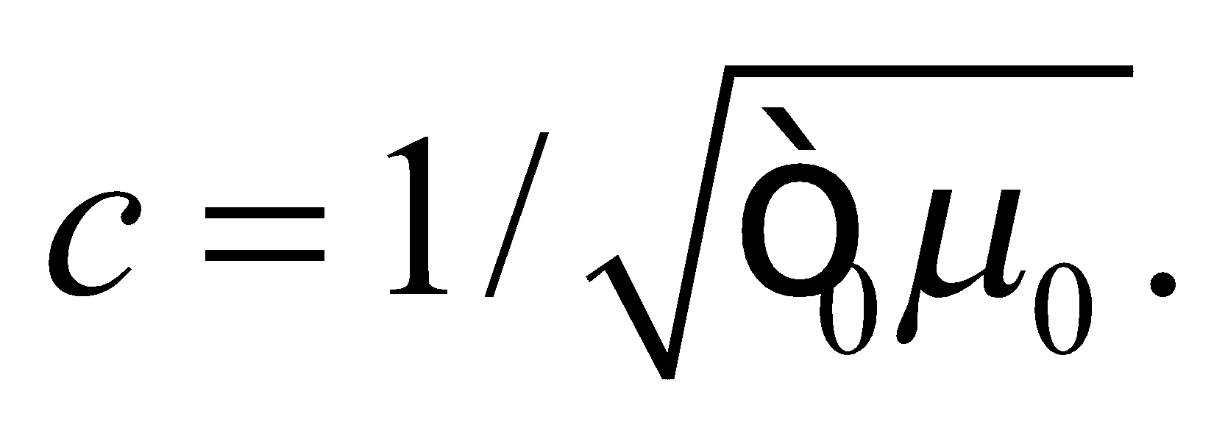By reversing the differentiations, we can show the exact same thing for the magnetic field.

**Assess** As described in Chapter 14, the solution to the wave equation is any function of the form 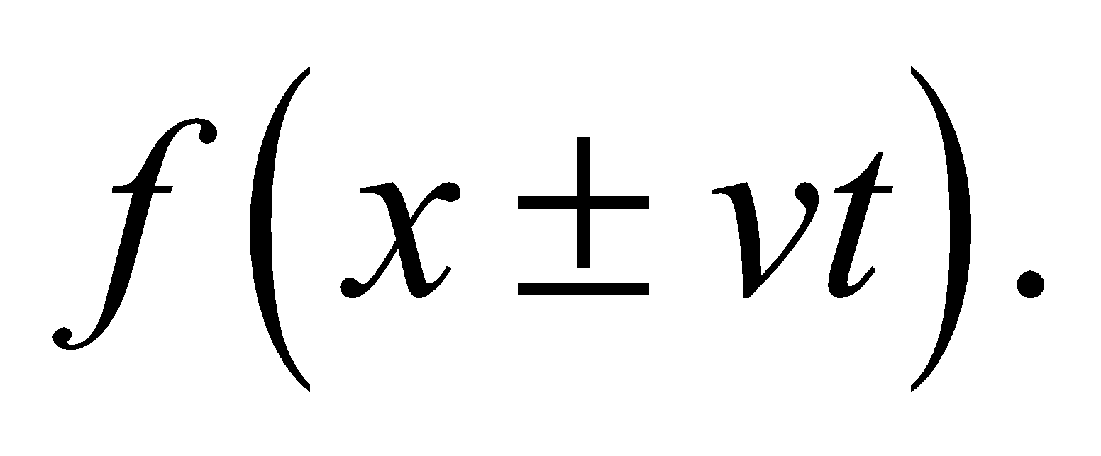 So electromagnetic waves do not necessarily have to be sine waves, but any shape of wave can be analyzed as the sum of individual sine waves (see Figure 14.18).

**64. Interpret** We are to find the speed of an electromagnetic wave in a medium of dielectric constant

**Develop** If we replace all instances of 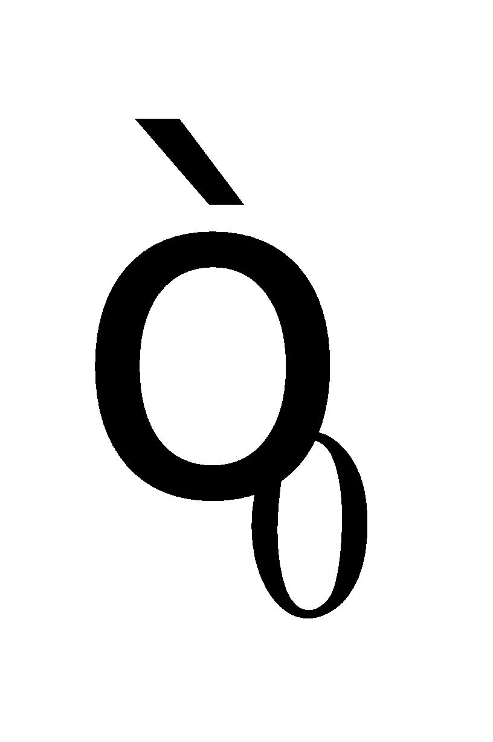 with , then our result will be the same as before but with 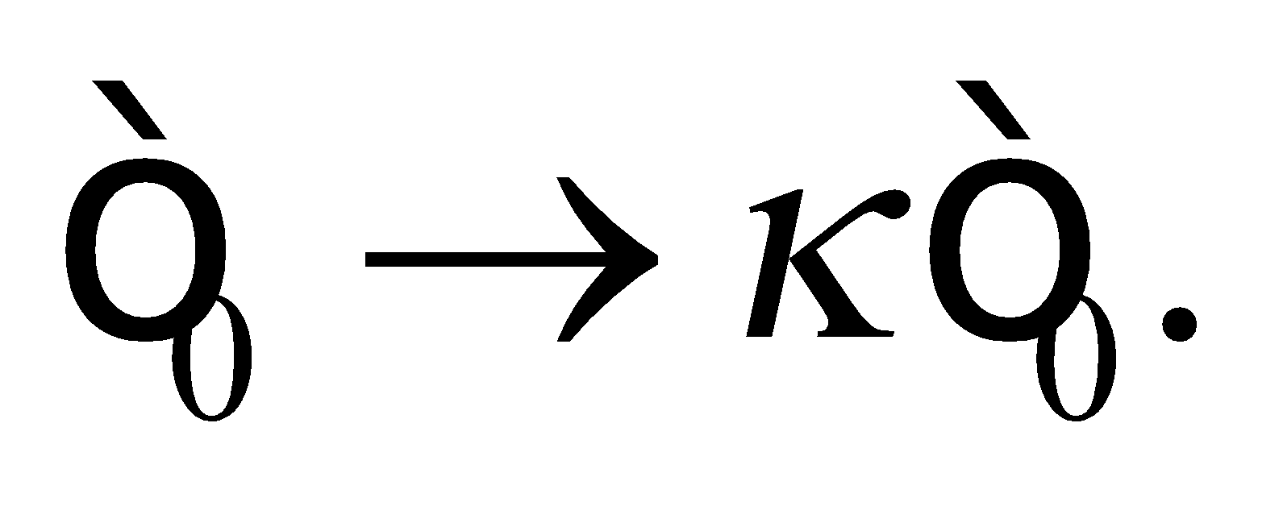

**Evaluate** The speed of light in a vacuum is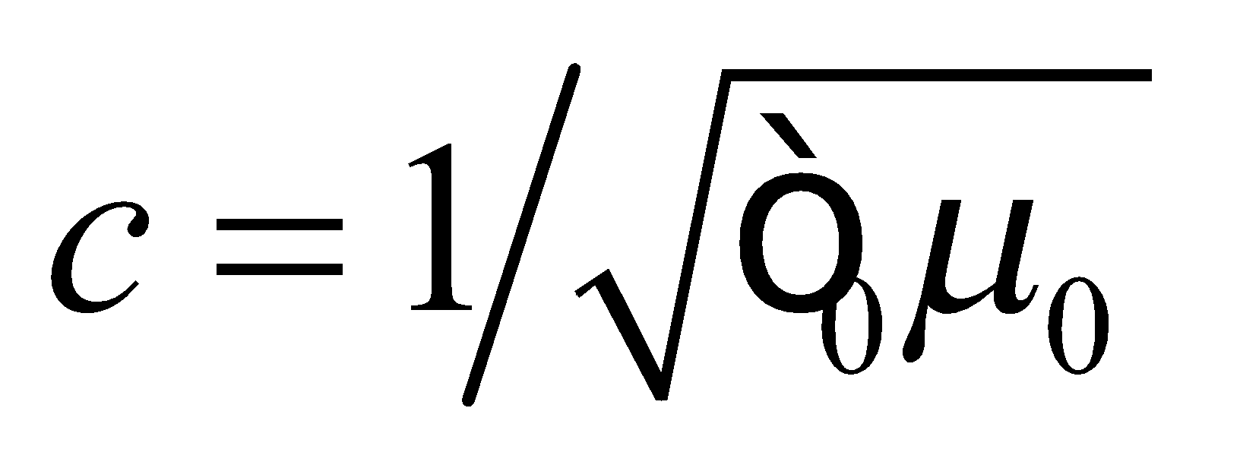. We make the substitution 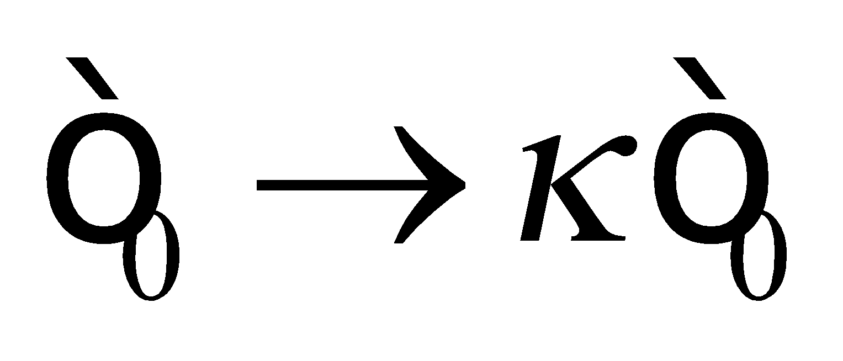 and obtain

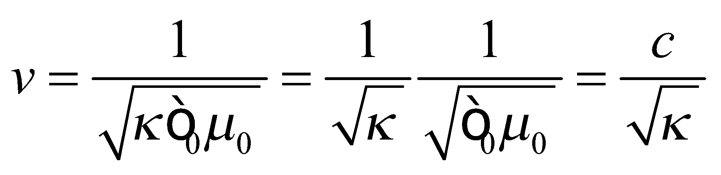

**Assess** We could obtain the same result with more effort by going through the whole derivation again, making the replacement  at each step.

**65. Interpret** We are to find the quarter wavelength of the given electromagnetic radiation.

**Develop** We use the relationship between frequency and wavelength (Equation 29.16c) 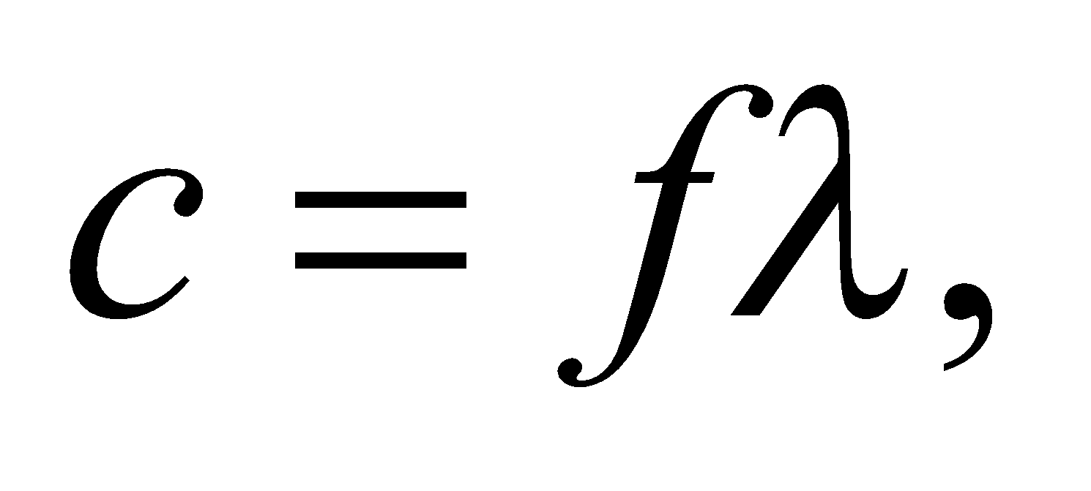 to find the wavelength of the signal, then divide by 4.

**Evaluate** The length of the antenna should be 

**Assess** This seems reasonable—it’s about the length of the long antennas typically seen on pickup trucks.

**66. Interpret** You want to show that solar power could potentially meet our energy needs.

**Develop**The total sunlight reaching the Earth’s surface will depend on clouds and other atmospheric effects, but for simplicity you can assume that all of the sun’s intensity within the cross-sectional area of the Earth reaches the ground. That means the total power that could potentially be tapped is 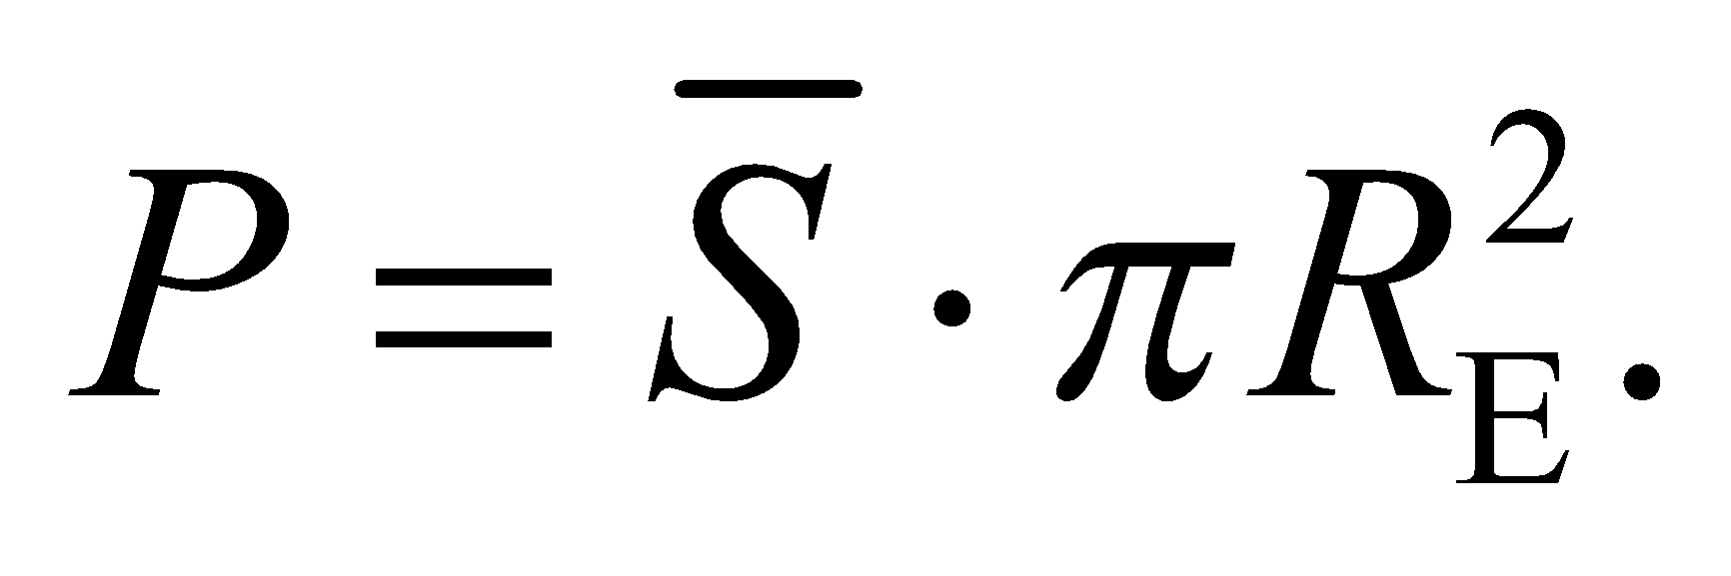

**Evaluate**The average solar intensity at Earth’s distance from the sun is

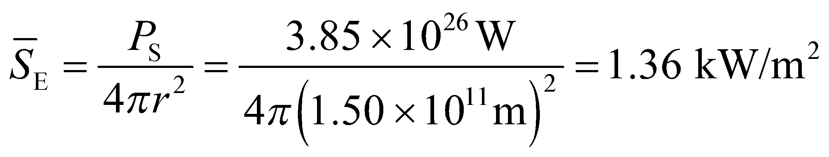

This quantity is called the "solar constant." Multiplying by the cross-sectional area of Earth, the total incident solar power is



This is over 10,000 times the current global power consumption of human beings. So there seems to be sufficient potential in solar power.

**Assess** If you take the total power and divide by the surface area of the Earth, you get a very rough estimate of the average solar intensity at a point on the Earth (i.e. accounting for day-night and seasonal effects):

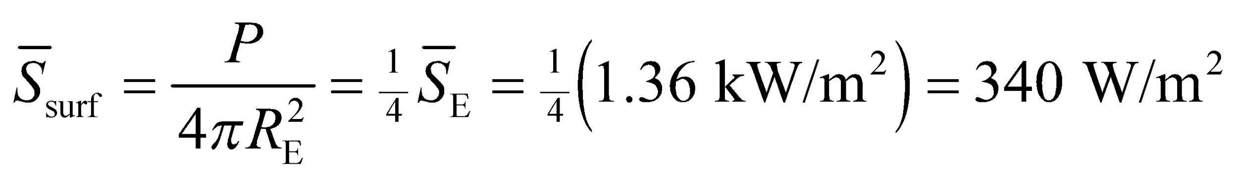

Let’s assume that current solar power collectors are about 10% efficient at converting solar radiation into electricity, in which case the amount of area you’d need to cover with solar collectors to meet global demand would be approximately

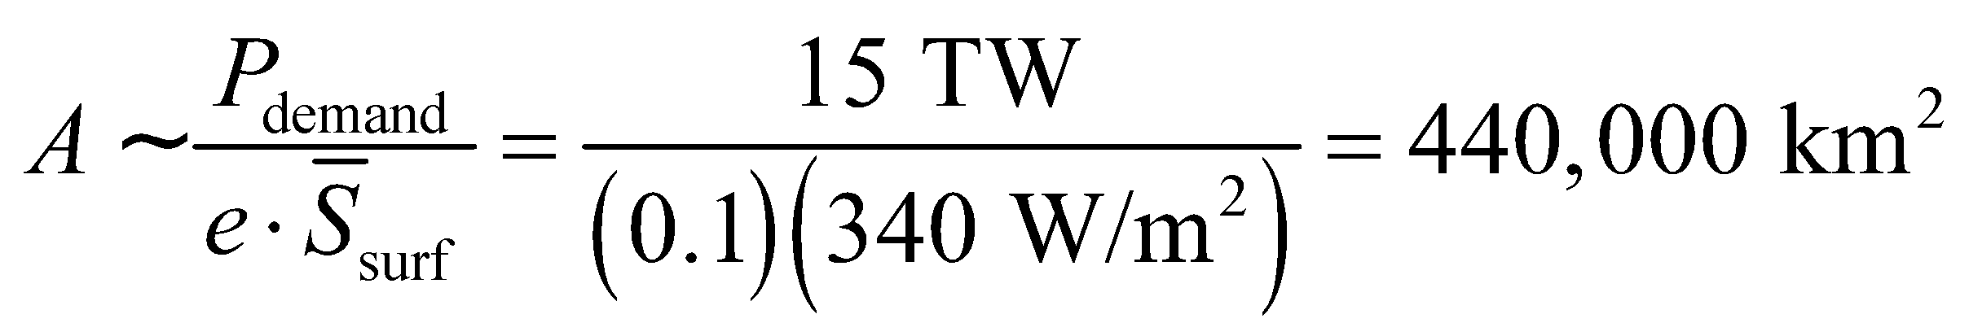

This is about the size of the state of California, although if such a grand project were realized, it would clearly be better to distribute the solar collectors evenly across the planet.

**67. Interpret** We’re asked what size of receiver dish will be needed to capture the Voyager 1 radio transmission in the future.

**Develop**If we assume that the spacecraft’s transmitter broadcasts its radio signal uniformly in all directions, then the intensity at Earth will be 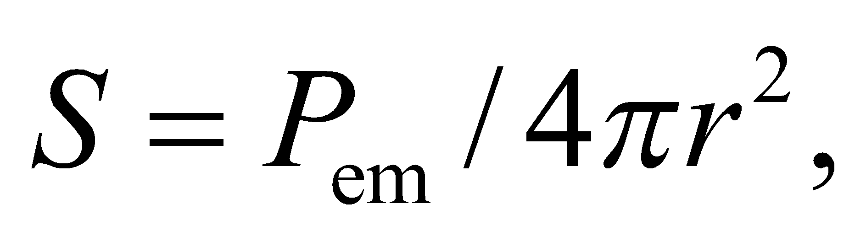where is the emitted power and *r* is the distance from Earth. An Earth-bound receiver of diameter, *d*, will be able to gather a signal with power 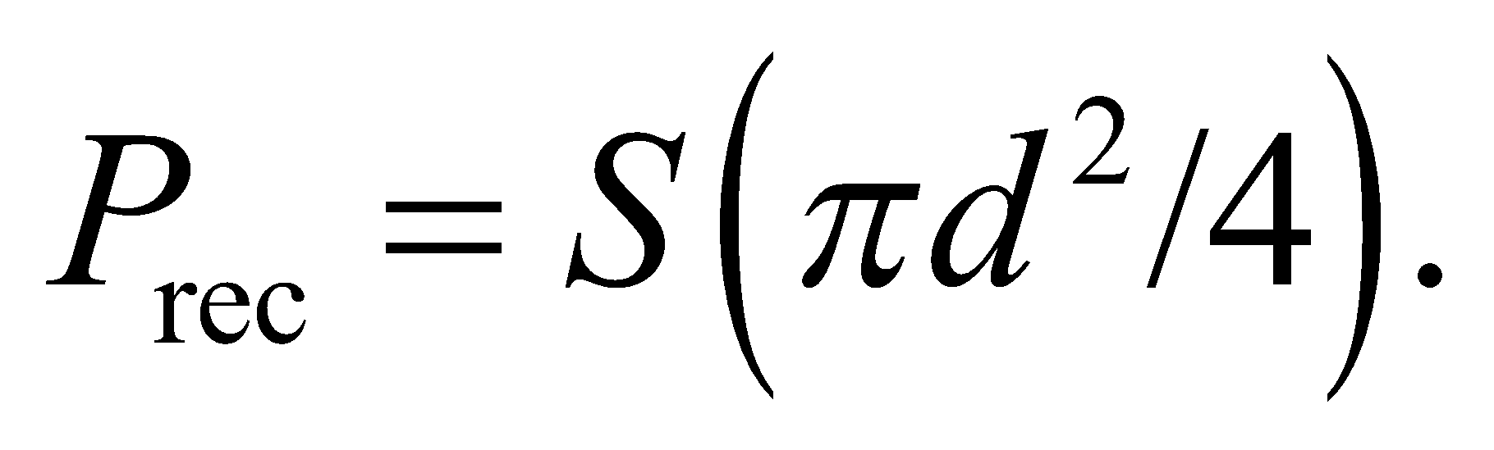

**Evaluate**Given the desired receiver signal, the receiver diameter will have to be

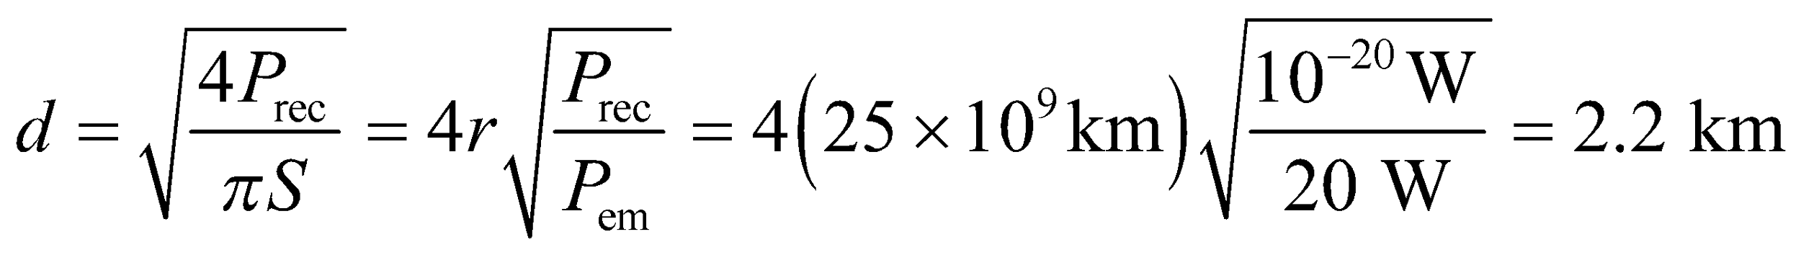

**Assess** There is no single dish of this size currently. The Arecibo observatory comes closest with its 305-m diameter dish. There are plans to build a 500-m diameter single dish telescope in China, but nothing spanning 2 kilometers is in the works. However, our assumption that Voyager 1 broadcasts in all directions is not correct. The transmitter is shaped like a parabola, and therefore beams its signal towards Earth, so a smaller receiver should be sufficient.

**68. Interpret** From a measurement of electric field at some distance from an antenna, we are to estimate the power radiated from the antenna. We will assume that the antenna radiates uniformly in all directions, and use the inverse-square law (see Equation 29.21).

**Develop** We are told that the electric field at a distance *R* = 4.6 km is *E* = 380 V/m. With the Poynting vector

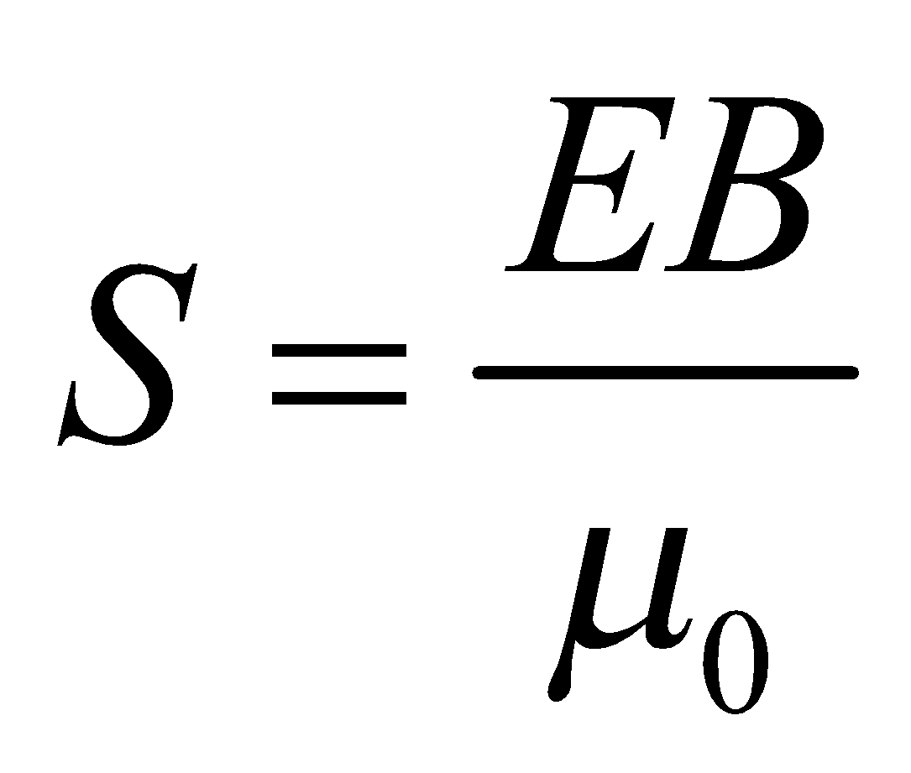 and *E* = *cB*

we can then find the intensity at this distance. From the area of the sphere at this distance and

the intensity, we can calculate the total power coming from the antenna.

**Evaluate** The total power coming from the antenna is



**Assess** One thing to consider is that the transmission antenna does *not* radiate uniformly in all directions, so the actual power may be somewhat different depending on the relative elevation difference between the measurement location and the antenna, assuming the antenna is vertical. However, this is probably a good estimate, and the actual power of the antenna is likely to be *lower* if the measurement point is at about the same elevation as the antenna. The station is broadcasting legally.

**69. Interpret** We’re asked to consider the potential of solar sail technology.

**Develop**The solar sail is accelerated by the radiation pressure from the sun: 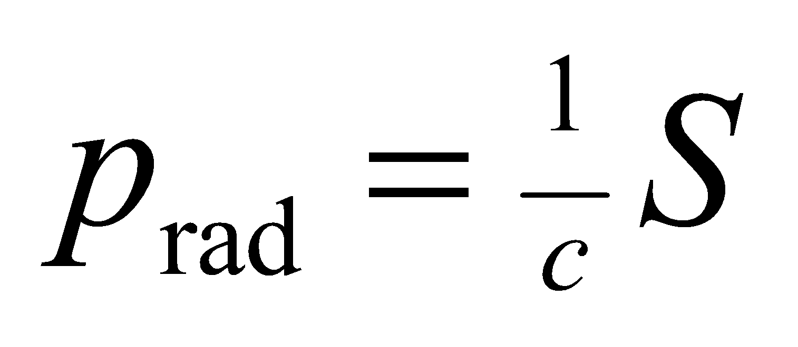 (Equation 29.22). We don’t know the area or the mass of the sail, but since the sun’s intensity decreases as one over the distance squared, so will the acceleration: 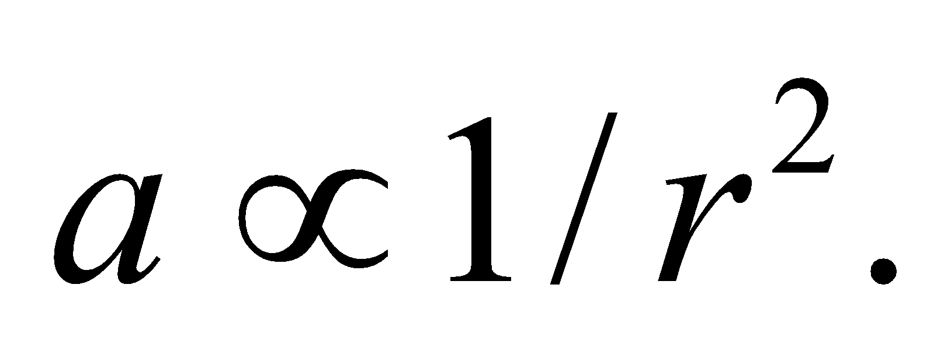

**Evaluate**The acceleration near Mars will be less than the acceleration near Earth. More specifically,

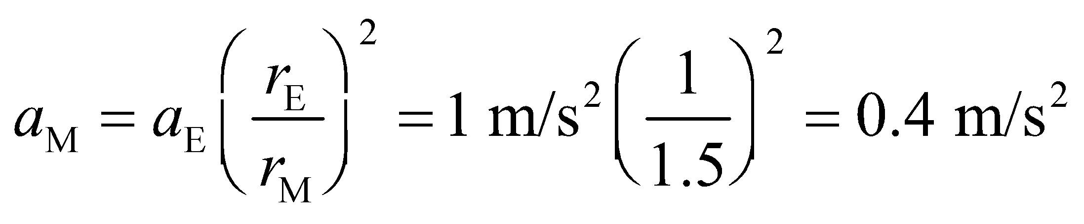

The answer is (b).

**Assess** The acceleration of the sail is not large, but it never "shuts off" like a rocket engine does, so the speed can build up over time. Using the fact that 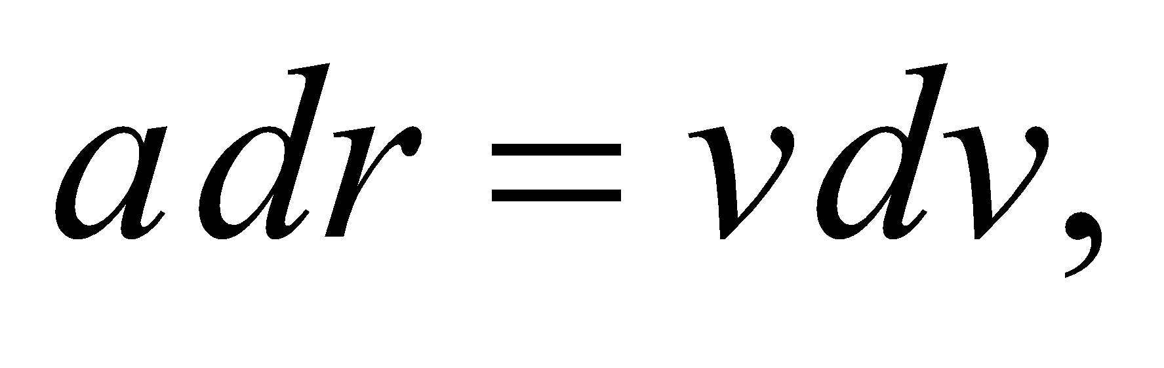we can integrate the sail’s acceleration from Earth’s orbital radius to that of Mars:

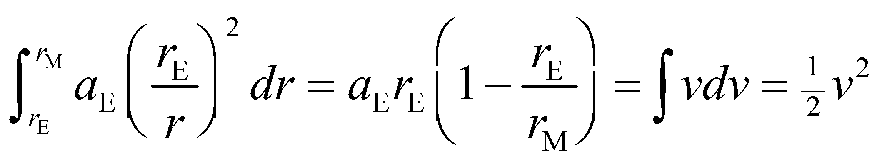

where we have assumed that the solar sail started at rest at Earth. Plugging in the values from above, the sail’s speed once it reaches Mars would be about 300 km/s.

**70. Interpret** We’re asked to consider the potential of solar sail technology.

**Develop**The rate at which light waves carry momentum per unit area is 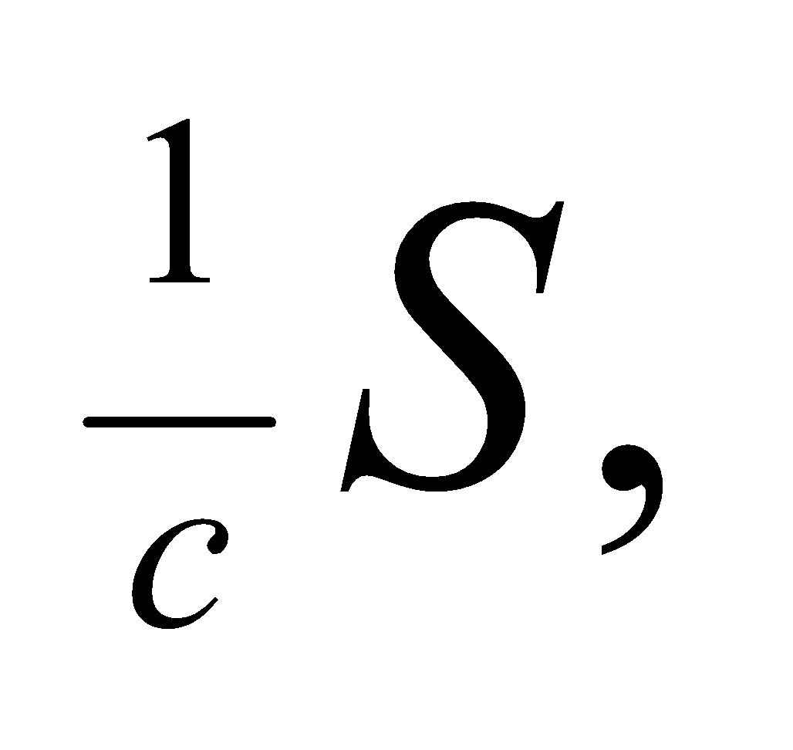 so an object that absorbs this light over an area *A* and during time 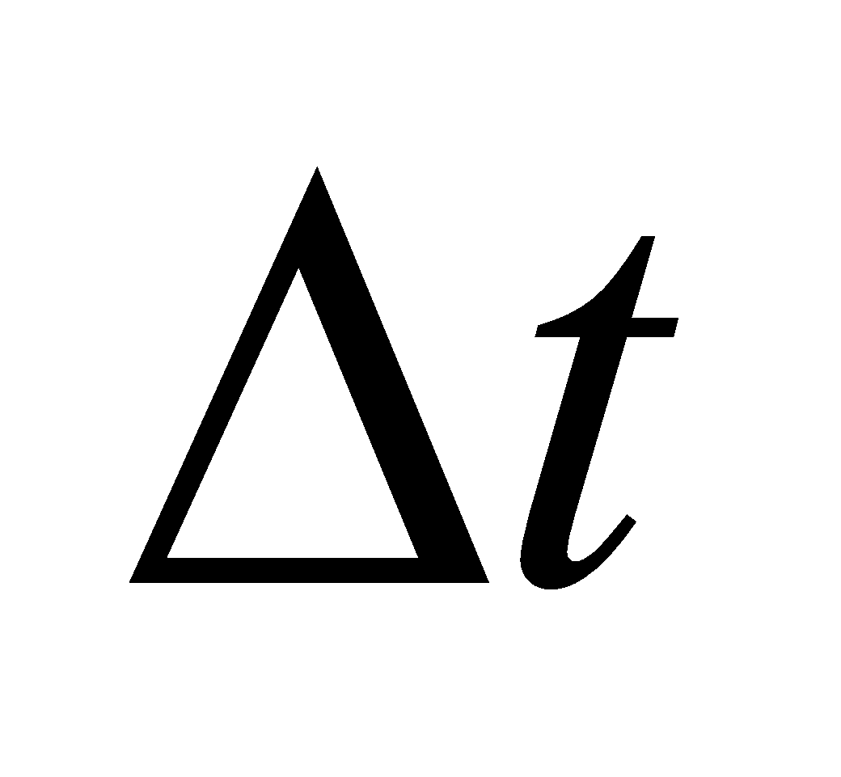 will gain in momentum by 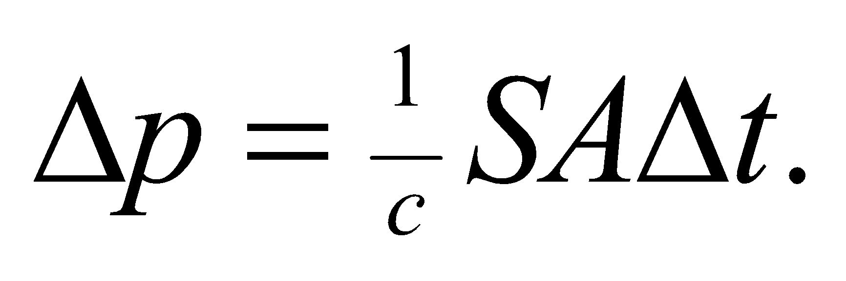However, if the light is reflected rather than absorbed, then the light’s momentum is reversed and the object’s gain in momentum will be double: 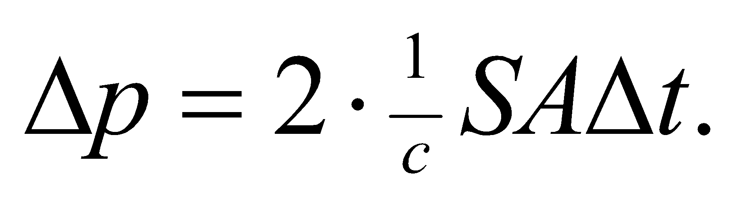

**Evaluate**Since the acceleration is proportional to the momentum change: 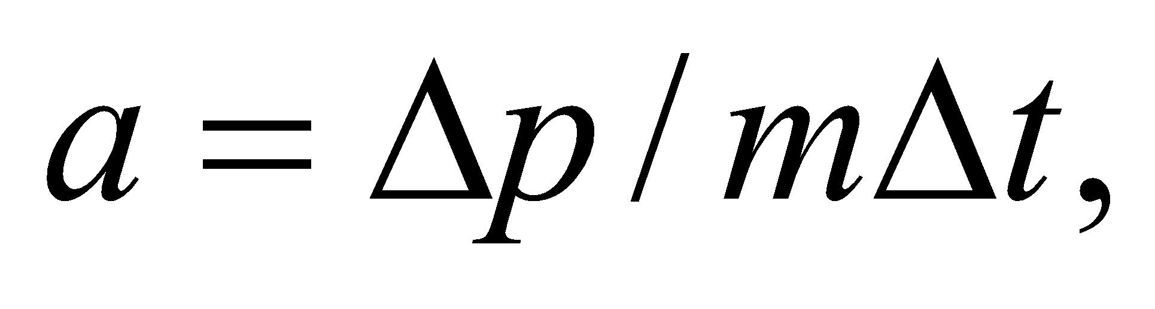 a reflective sail should have twice the acceleration of the absorptive sail.

The answer is (b).

**Assess** We’ve assumed here that the reflective sail is flat, and the incoming light is normal to its surface. If the sail happened to be curved or tilted, then the reflected light would not be directed back towards the sun, and the change in momentum would be less than twice that of the absorptive case.

**71. Interpret** We’re asked to consider the potential of solar sail technology.

**Develop**In the previous problems, we have argued that the radiation pressure and the force it applies to the sail are proportional to  This is also true of the gravitational force.

**Evaluate**Since Jupiter is roughly 5 times further from the sun than Earth, the sail force at Jupiter’s position will be 25 times smaller. However, the gravitational force from the sun will also be 25 times smaller, so the sail force will still be 20 times solar gravity.

The answer is (d).

**Assess** For the sail force to dominate gravity, the sail must be light-weight with a large surface area. We can write the ratio of the forces in terms of the area and the mass:

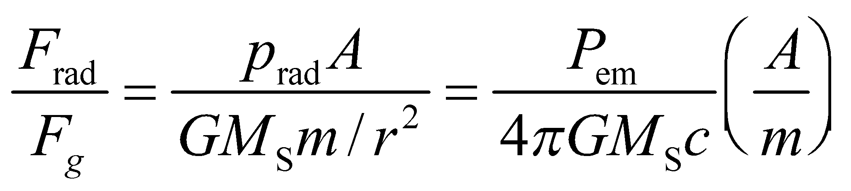

where we have written the sun’s intensity in terms of the emitted power: 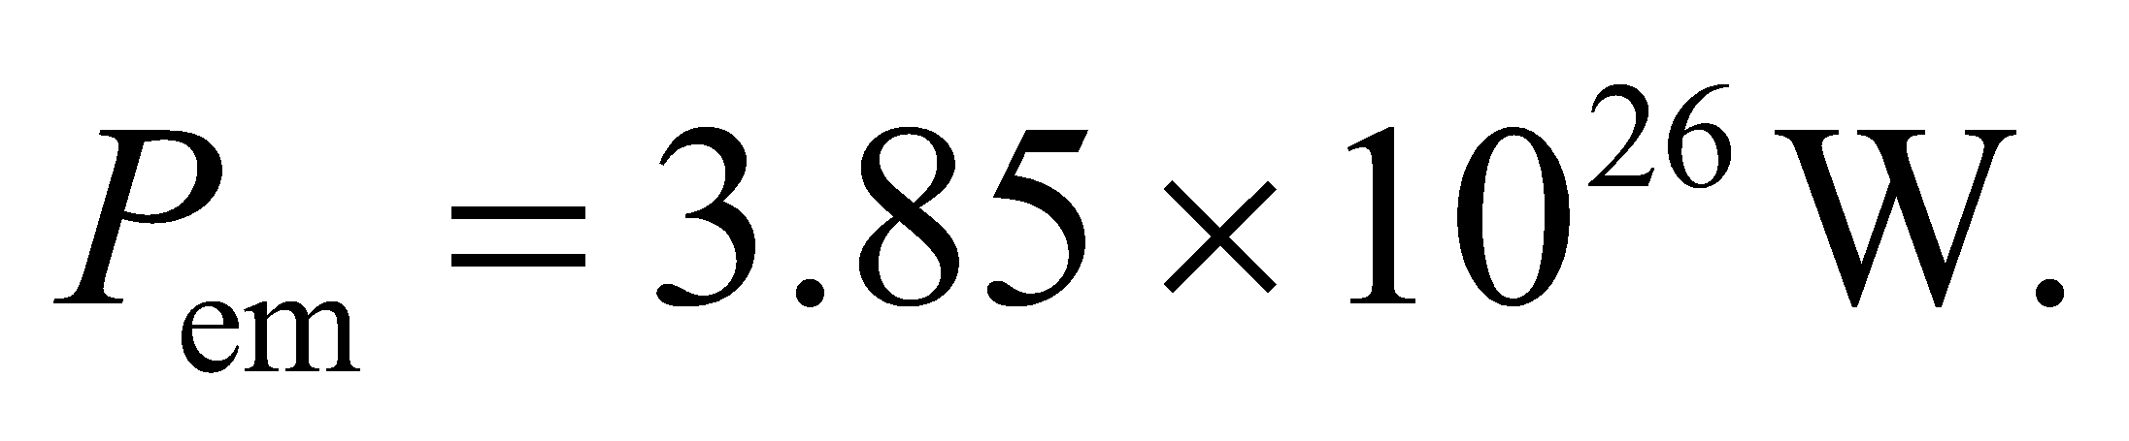 Plugging this in with the mass of the sun, 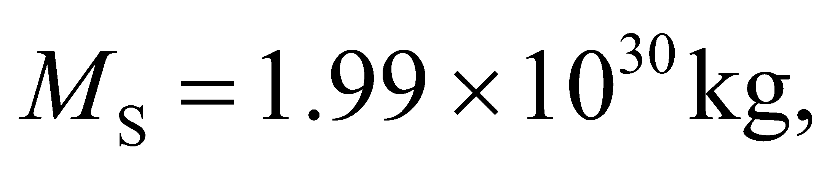we get

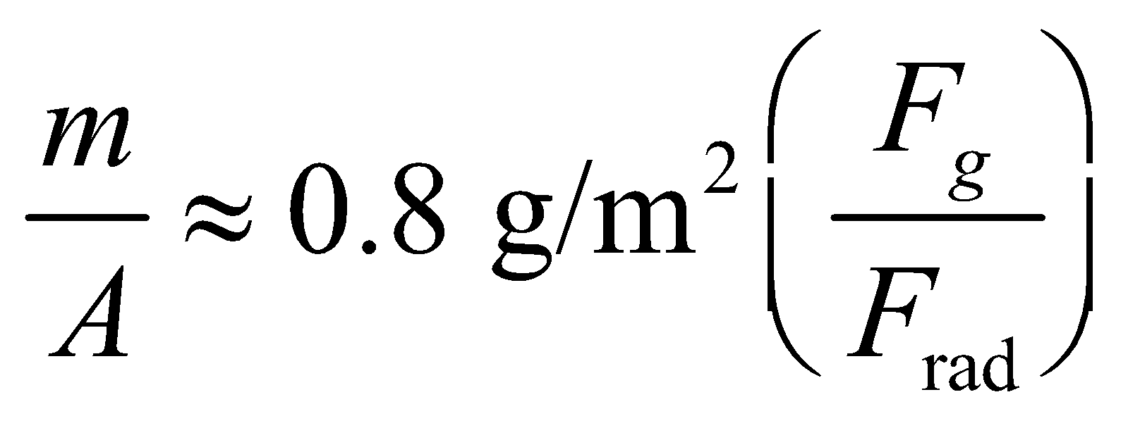

What this says is that each gram of spacecraft requires more than a square meter of sail if the radiation force is to overcome gravity.

**72. Interpret** We’re asked to consider the potential of solar sail technology.

**Develop**We’re given the sun’s intensity and the area of the sail, so the force from radiation is

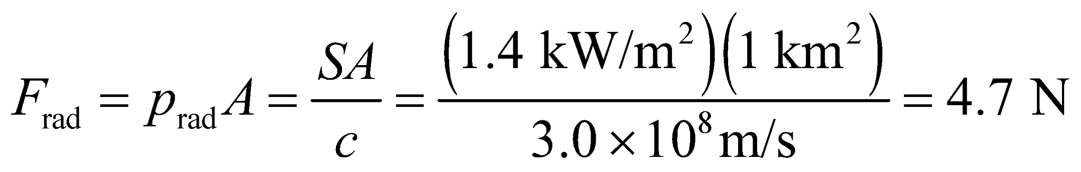

**Evaluate**For the given mass of 100 kg, the spacecraft should accelerate at about 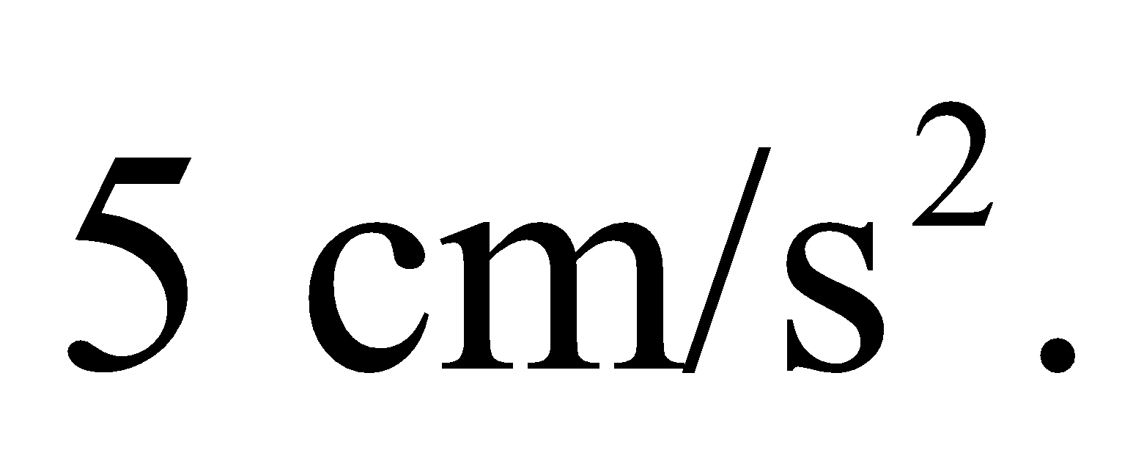

The answer is (b).

**Assess** The mass to area ratio of this sail is 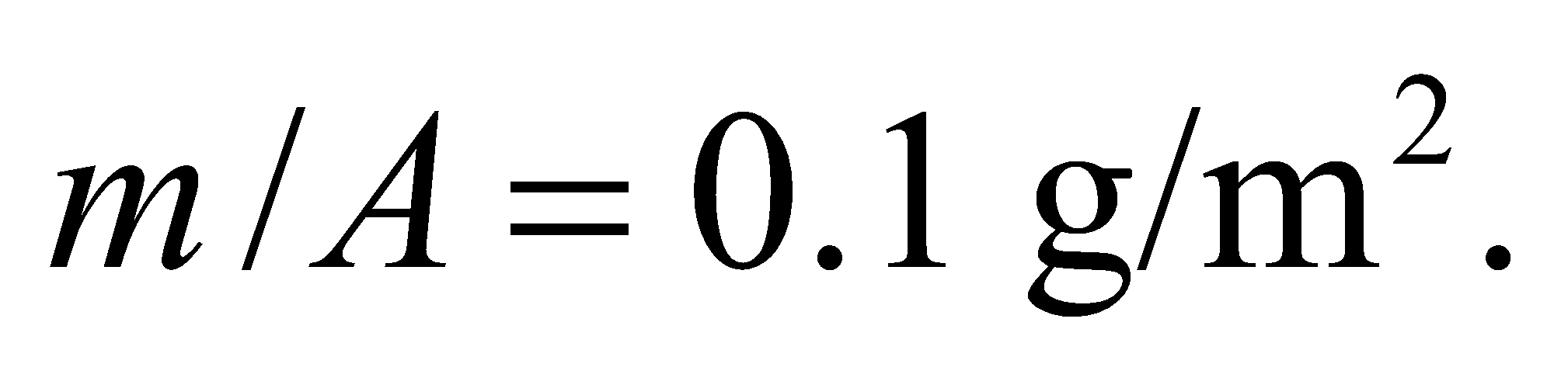 Plugging this into the equation we derived in the previous problem, we see that the gravitational force on the sail will be about 1/8th that of the radiation force.